

**DESIGNING AND DEVELOPING A WEBSITE**

**Programming Method**

**Module Title**

**NCC Aviation**

**Assignment Title**

**October 2021**

**Examination Cycle**

**YE THU HLAING**

**Candidate Name**

**00189893**

**Candidate No**

**KMD Computer Centre (Yangon)**

**Centre Name**

**October 2022**

**Submission Date:**

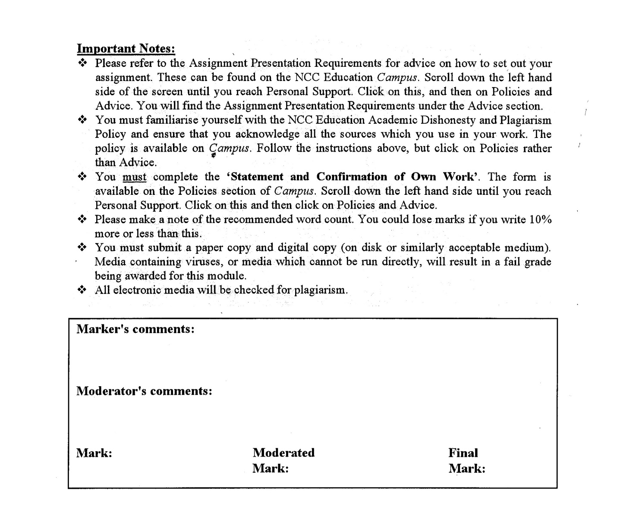



**Statement and Confirmation of Own Work**

**Programme/Qualification name: L4DC/L4DBIT**

*All NCC Education assessed assignments submitted by students must have this statement as the cover page or it will not be accepted for marking. Please ensure that this statement is either firmly attached to the cover of the assignment or electronically inserted into the front of the assignment.*

**Student declaration**

I have read and understood NCC Education’s Policy on Academic Dishonesty and Plagiarism.

I can confirm the following details:

**Student ID/Registration number:00189893**

**Name : YE THU HLAING**

**Centre Name : KMD Computer Centre (Yangon)**

**Module Name : DESIGNING AND DEVELOPING A WEBSITE**

**Module Leader : KHIN KHIN LAY KOON**

**Number of words : 1129**

I confirm that this is my own work and that I have not plagiarised any part of it. I have also noted the assessment criteria and pass mark for assignments.

**Due Date : 31 January 2022**

**Student Signature : Ye Thu Hlaing**

**Submitted Date : 31 January 2021**

Table of Contents

Introduction 5

Task-1 Web Design Print Screen 7

Task2- CSS Print Screen 19

Task-3 Test the website and write a test report 66

Testing the Website on W3C validation service (539) 66

How the website works for Disable users 69

Testing on Two Different Web Browsers 70

Test Report 84

Role of W3C 85

Task-4 Critical Evaluation (500) 87

Accessibility features of my own website. 87

Functional multimedia components the website have 100

Discussion on how the Internet and Web can be used for the Vintage Rally Club as a business tool 101

Further development for the website. 101

References 102

# Introduction

I was assigned to create the website for Mercy vintage car rally club which has been hosting rallies in Paris, Japan, Italy, America and China. The Mercy club wants to expand its business as online operable one in which customers can register online and ask information what they want to know through an online contact form. I have used Visual studio code for implementing HTML, CSS and JavaScript codes.

**Task 1**

**HTML**

# Task-1 Web Design Print Screen

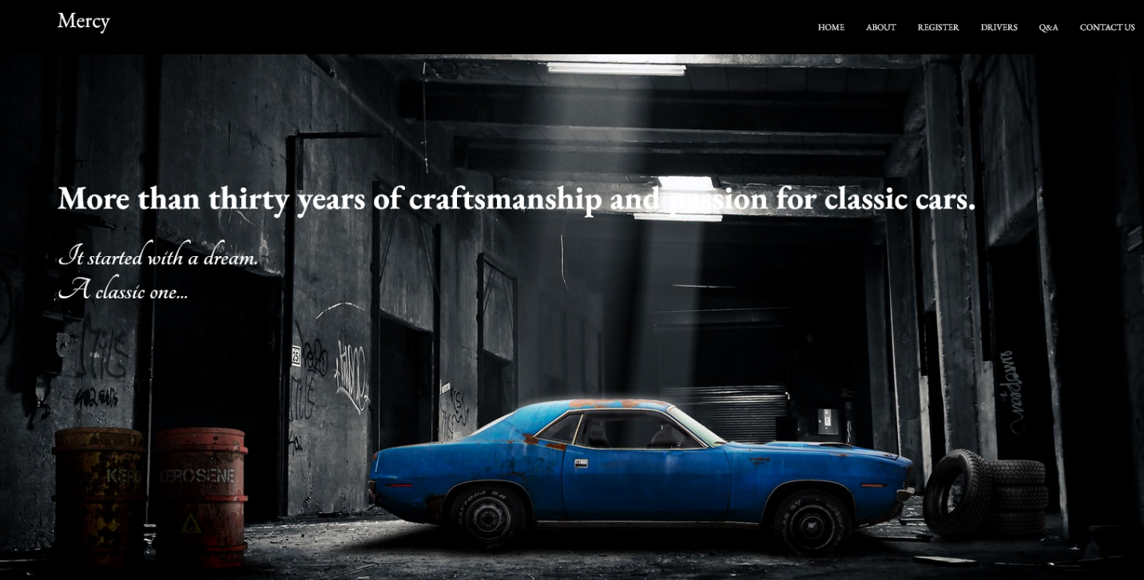

Figure 1

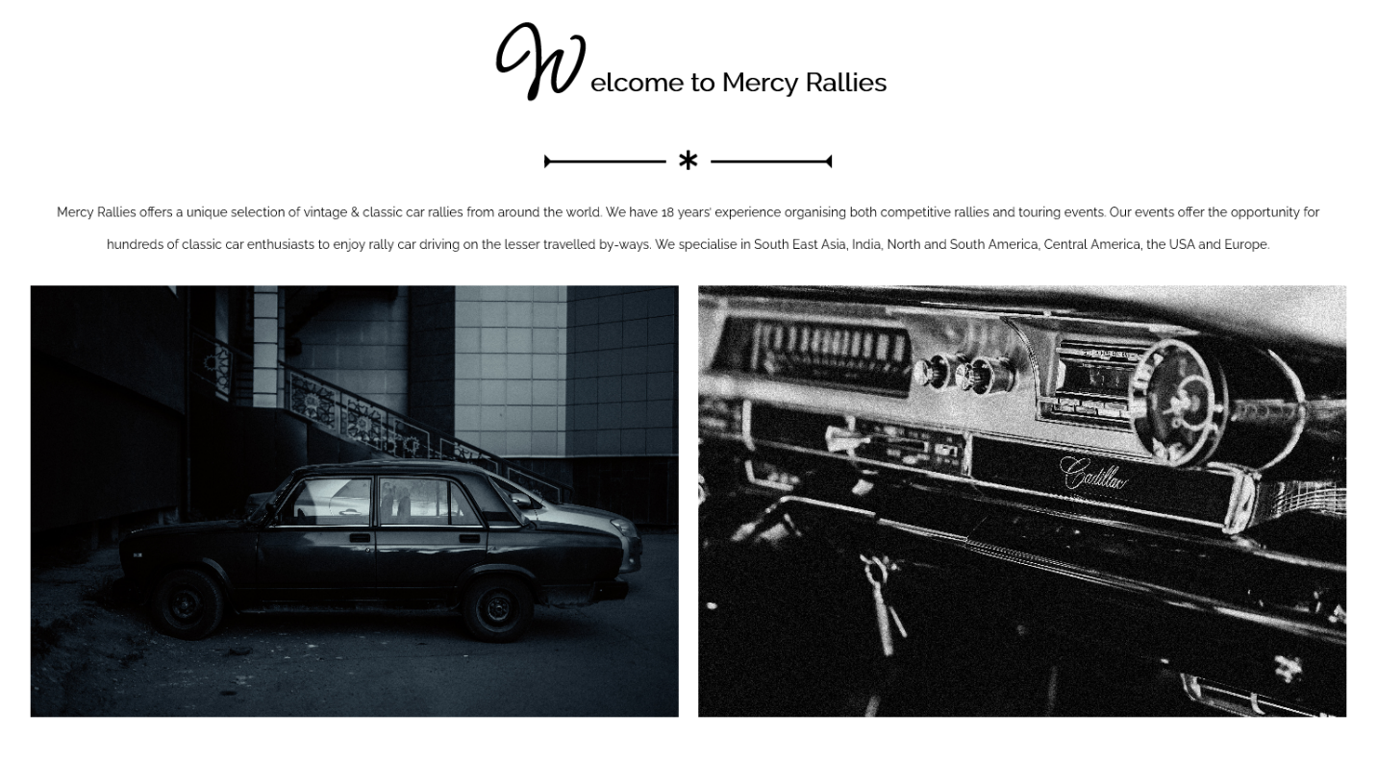

Figure 2

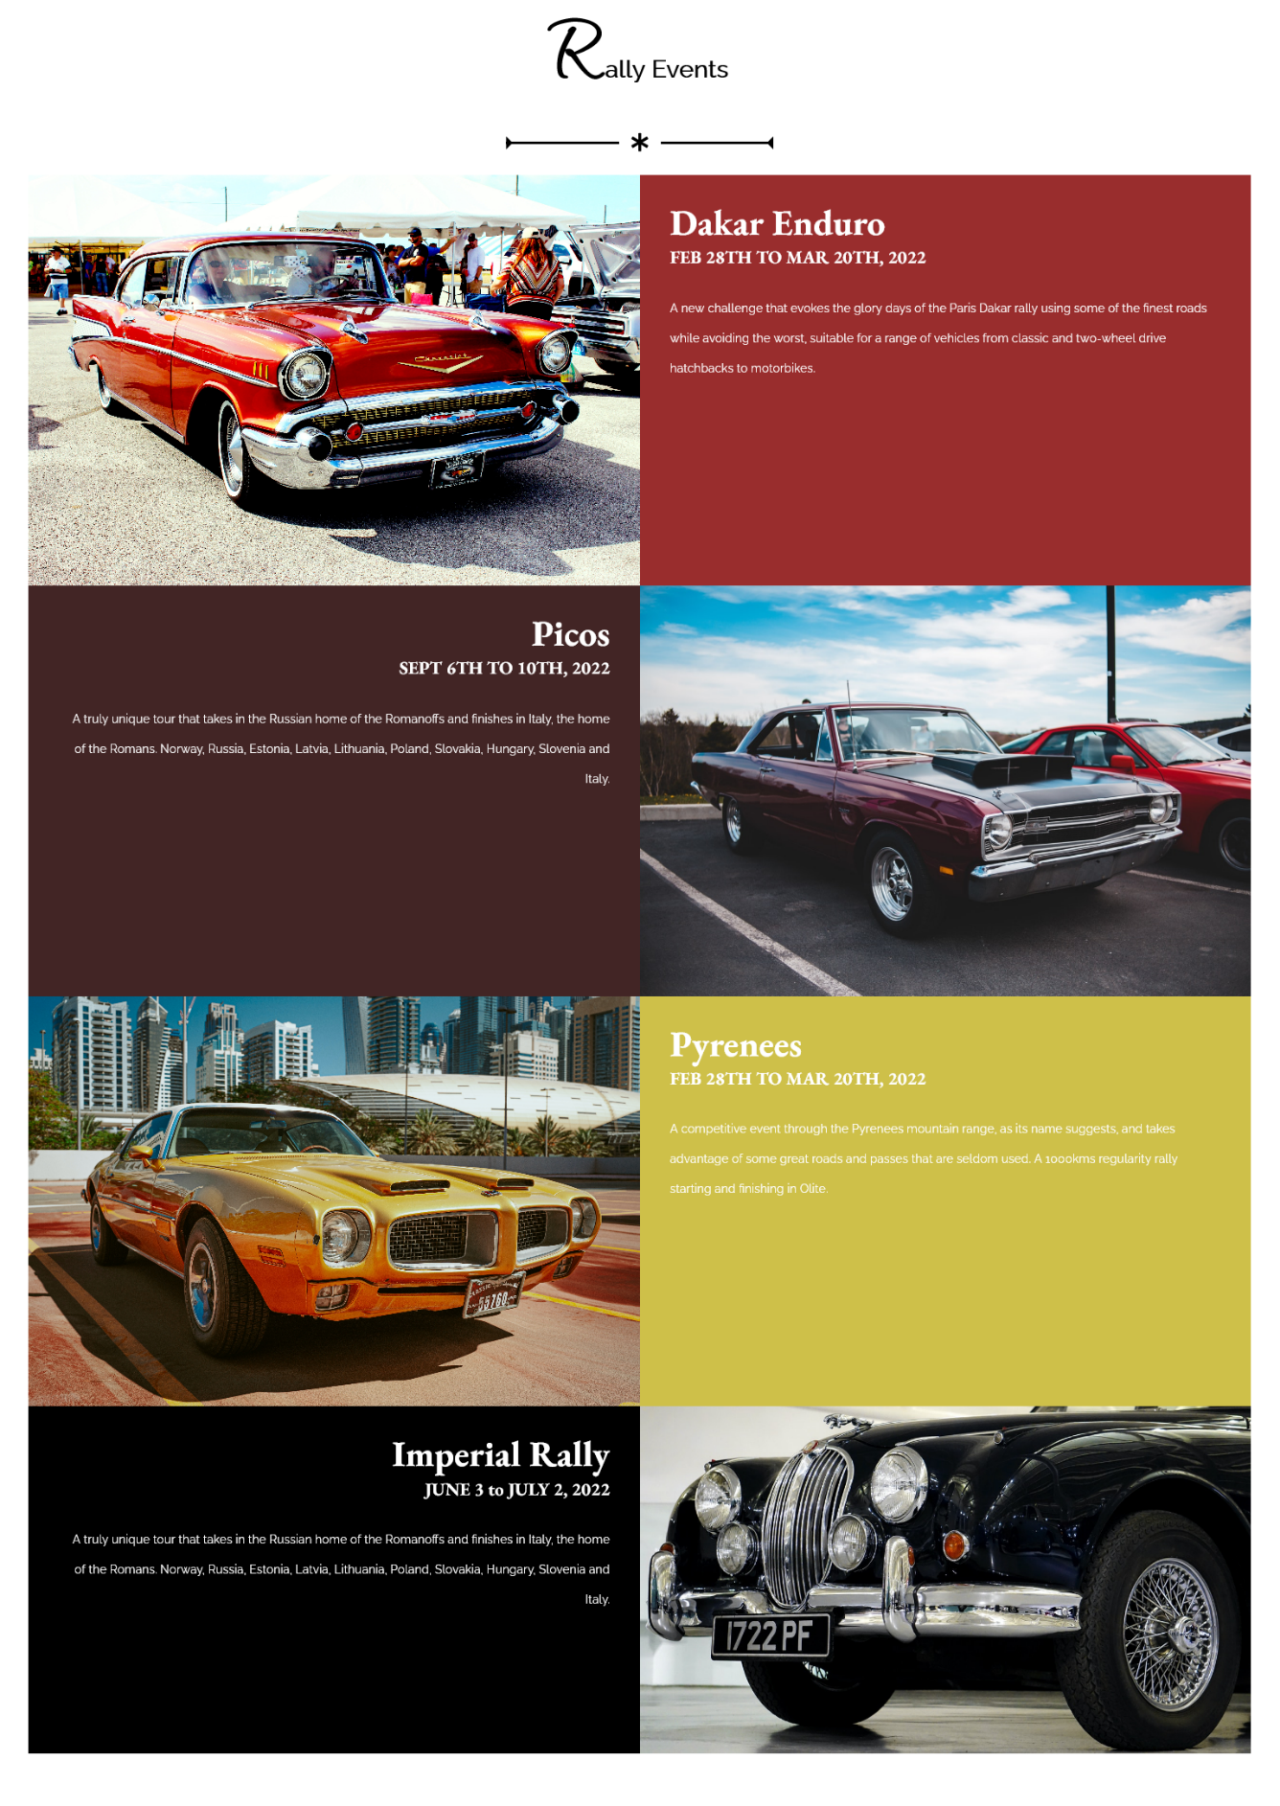

Figure 3

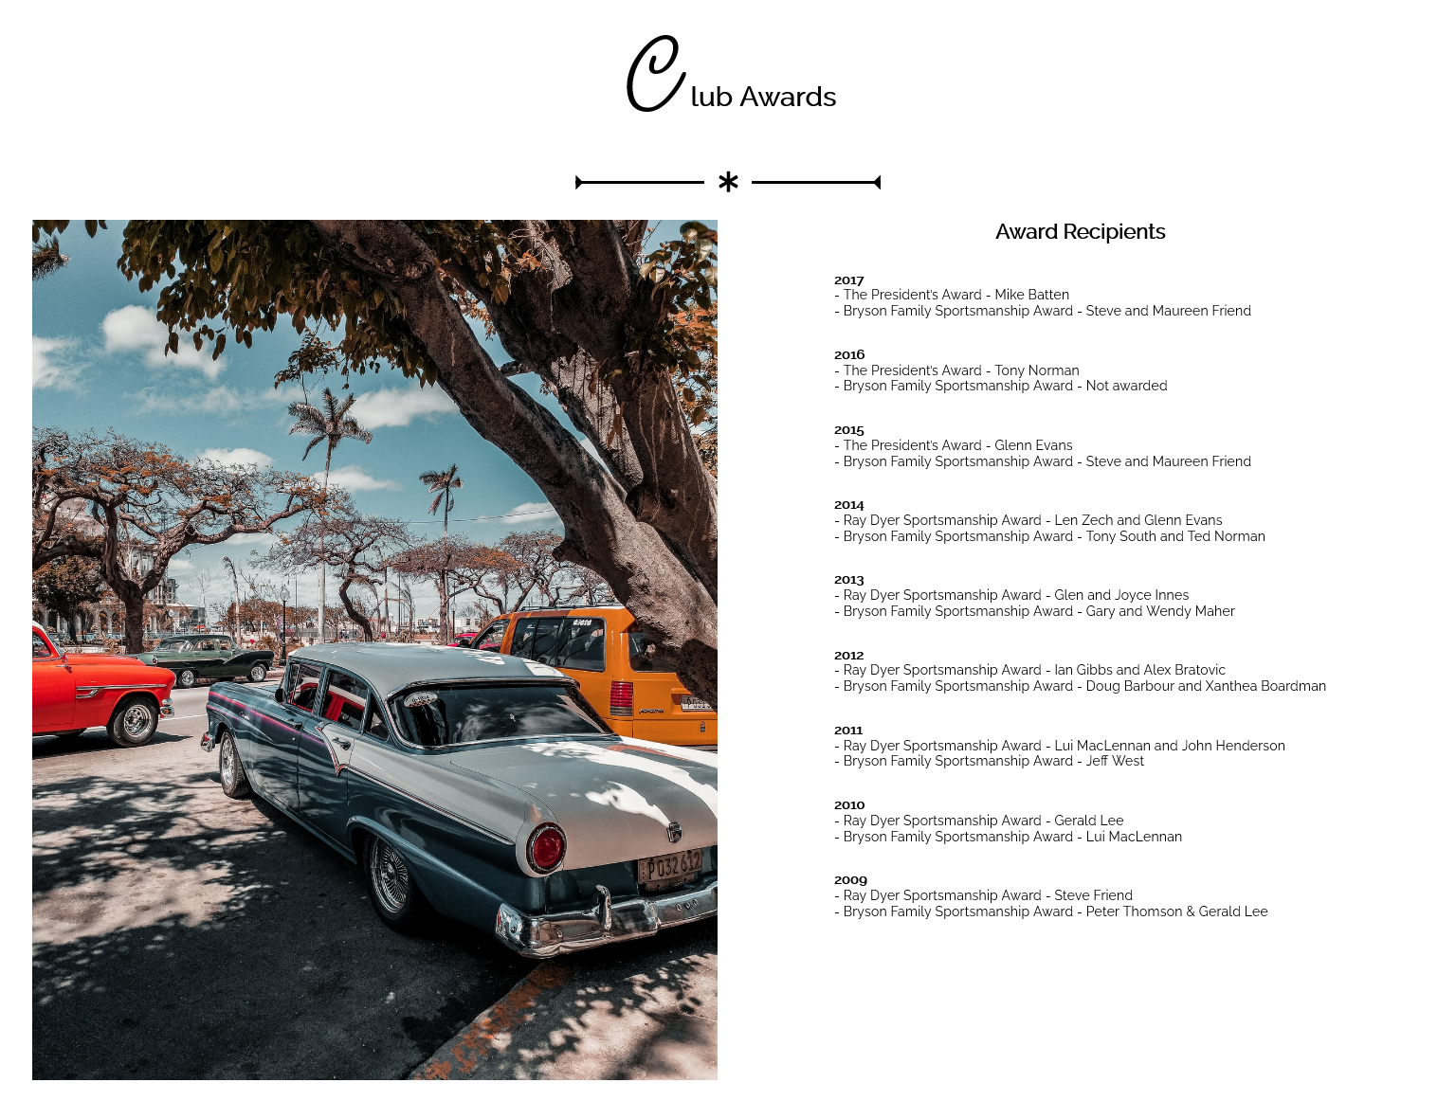

Figure 4

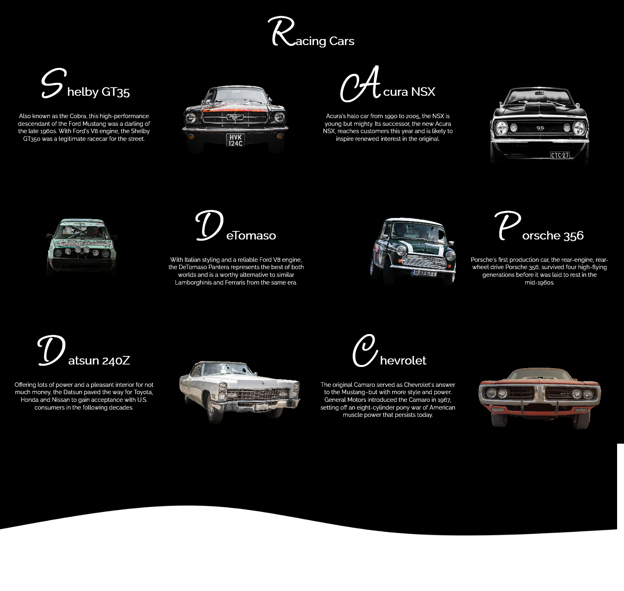

Figure 5

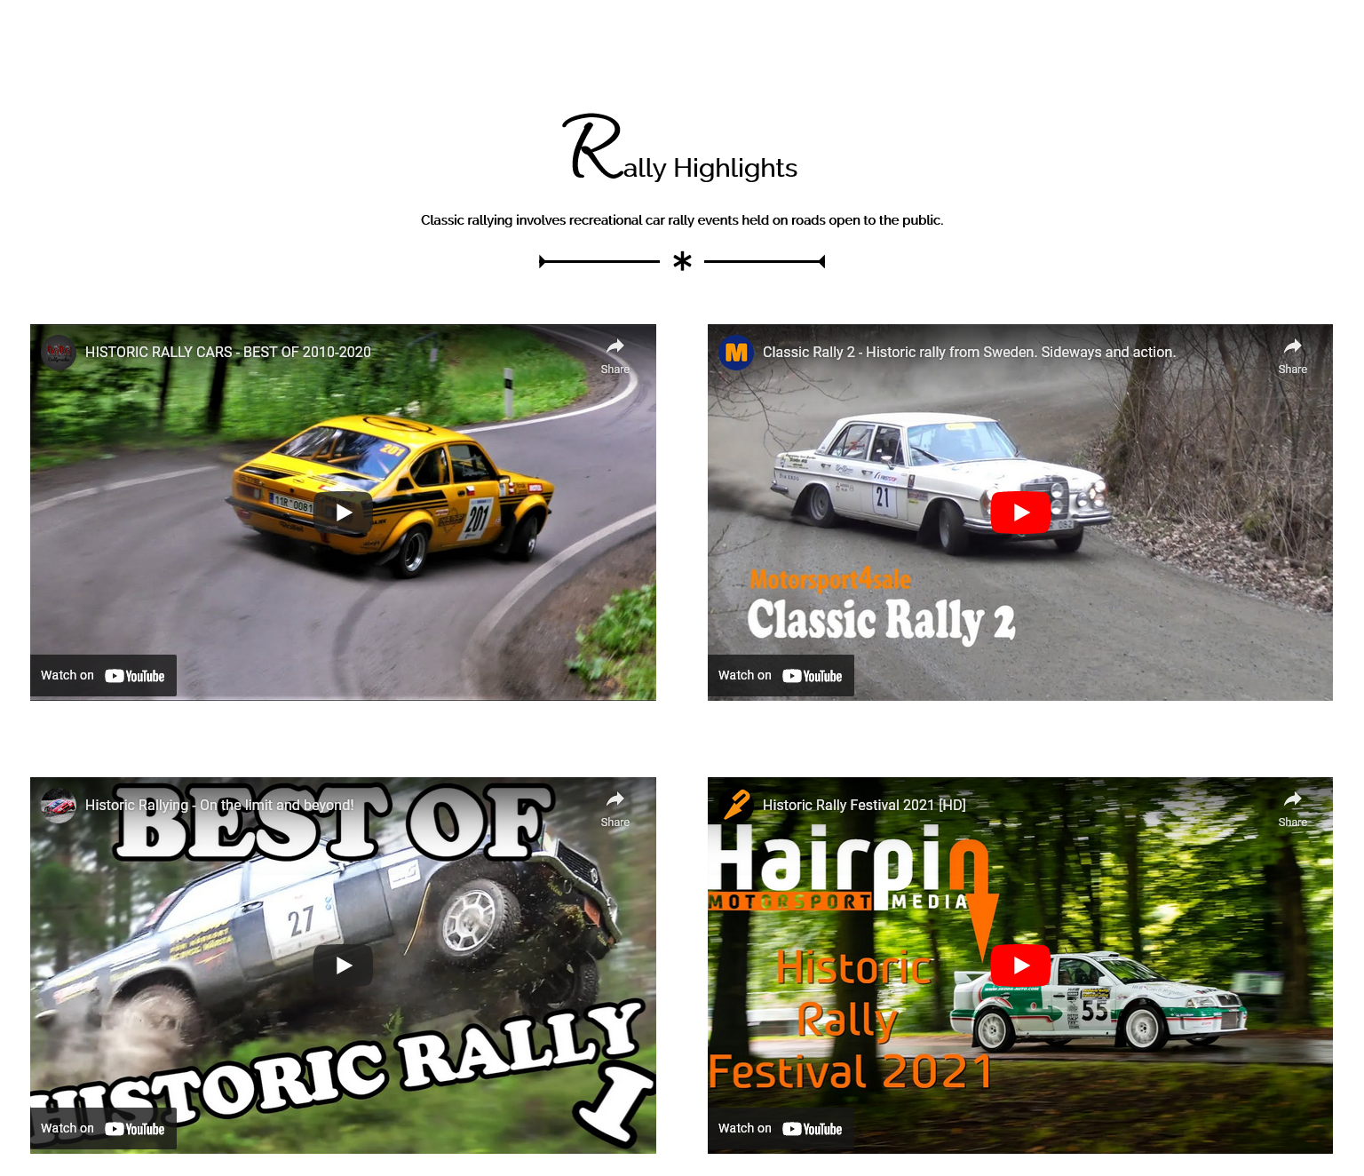

Figure 6

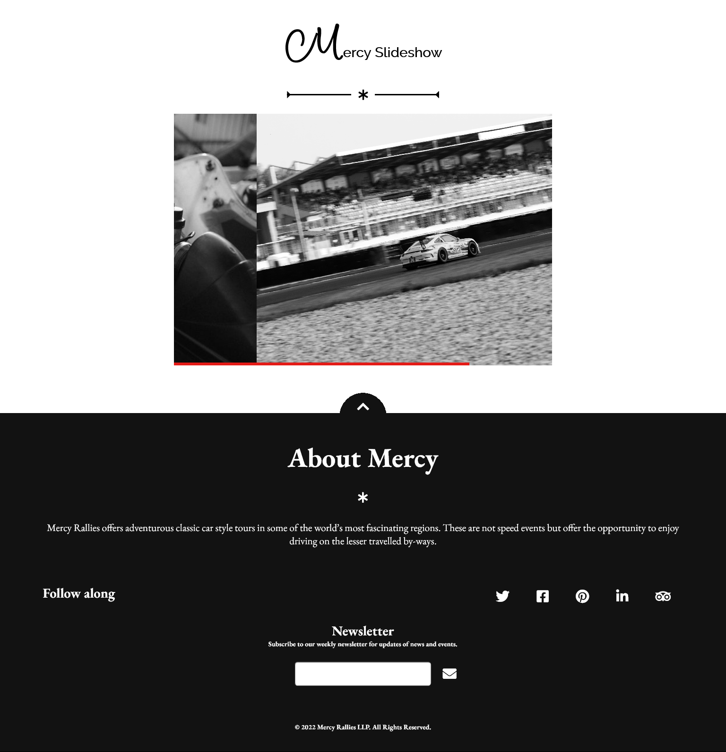

Figure 7

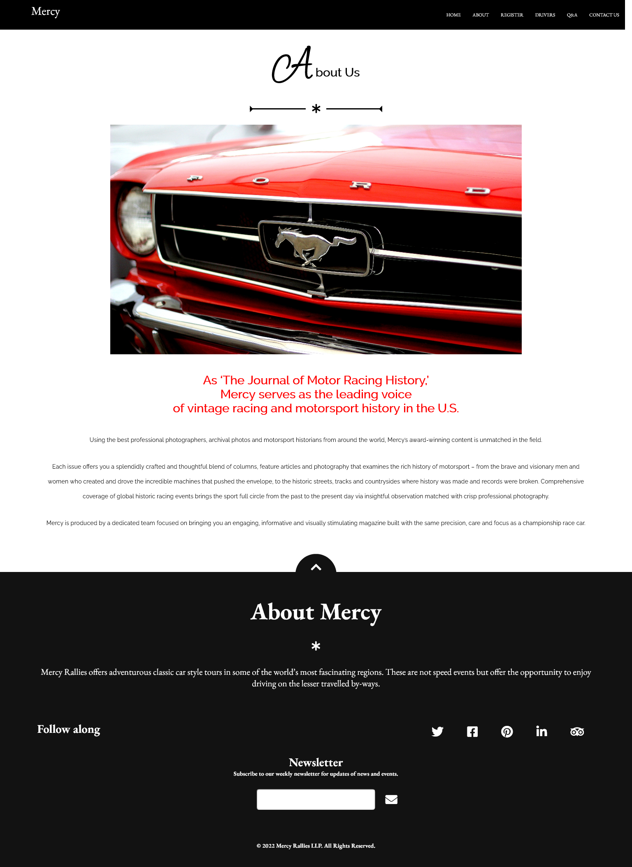

Figure 8

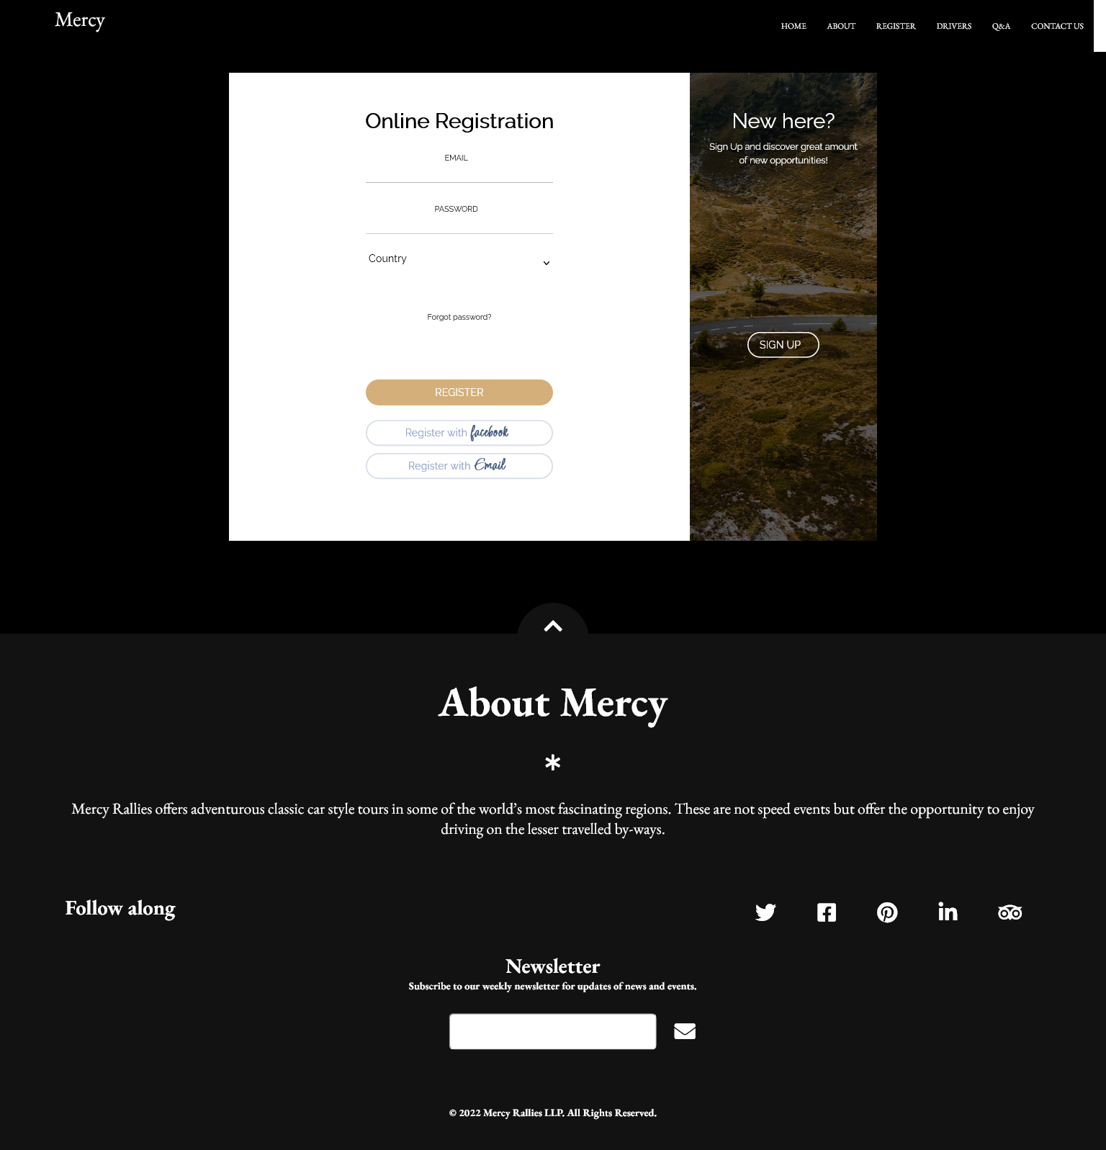

Figure 9

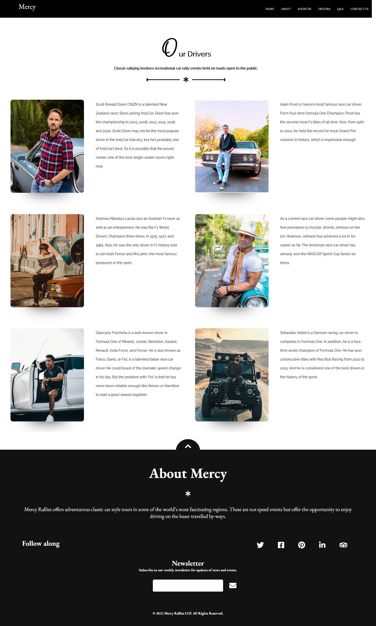

Figure 10

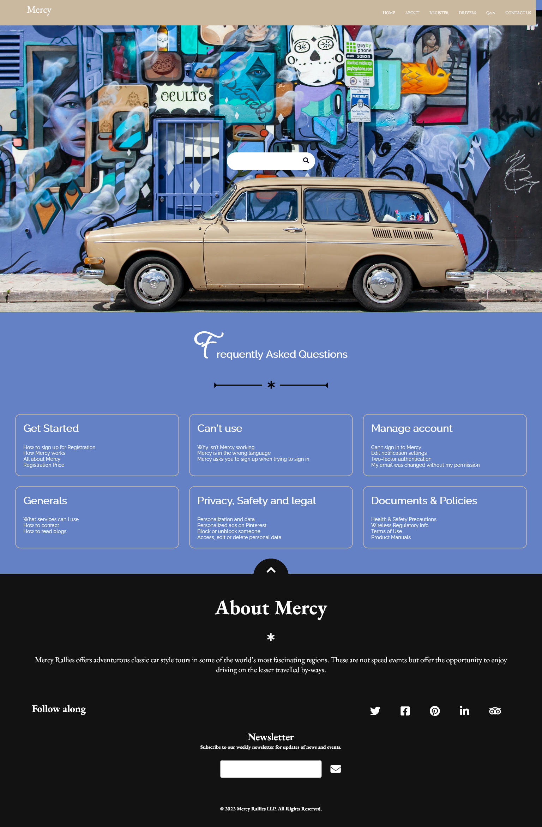

Figure 11

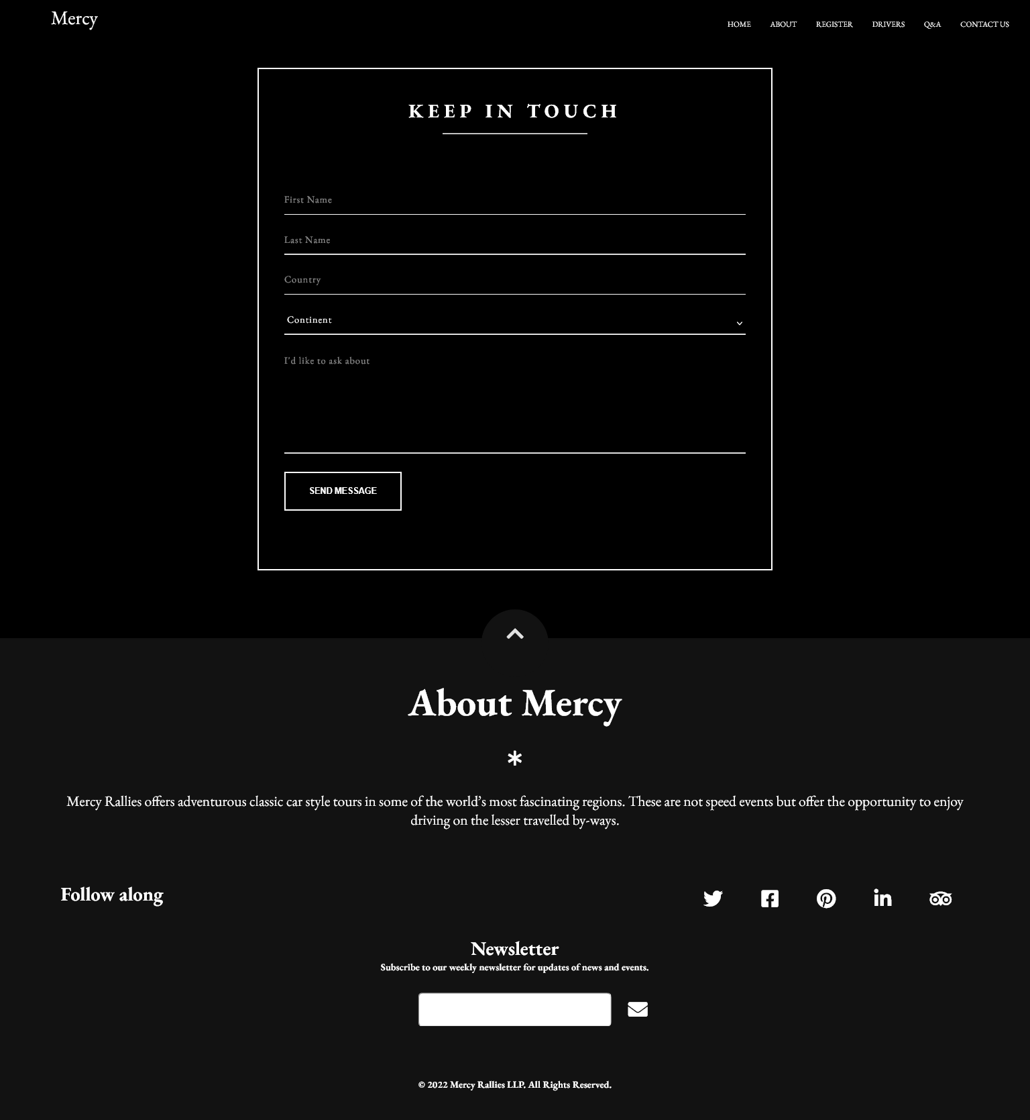

Figure 12

**Task 2**

**CSS**

# Task2- CSS Print Screen

@import url('https://fonts.googleapis.com/css2?family=EB+Garamond:ital,wght@0,400;0,500;0,600;0,700;0,800;1,400;1,500&family=Licorice&family=Raleway:ital,wght@0,100;0,200;0,300;0,400;1,100;1,200;1,300;1,400&family=Tangerine:wght@400;700&display=swap');

/* ------------------------------------------ Structures------------------------------------------*/

*,

*::before,

*::after{

   margin: 0;

   padding: 0;

   box-sizing: border-box;

}

:root{

   --main-font: 'EB Garamond', serif;

   --secondary-font: 'Tangerine', cursive;

   --tertiary-font:  'Licorice', cursive;

   --fourth-font:  'Raleway', sans-serif;

   --main-font-color-dark: #000000;

   --secondary-font-color: #ffffff;

}

html{

   text-rendering: optimizeLegibility;

   font-size: 16px;

   scroll-behavior: smooth;

   cursor: default;

}

body{

   font-size: 16px;

   font-family: 'EB Garamond', serif;

   overflow-x: hidden;

}

section{

   width: 100vw;

   padding: 2rem 0 ;

   overflow: hidden;

}

.container{

   width: 100%;

   margin: 0 auto;

   padding: 0 2.4rem;

}

img{

   width: 100%;

   height: 100%;

}

a{

   text-decoration: none;

   color: var(--main-font-color-dark);

}

h1{

   font-size: 4rem;

}

h2{

   font-size: 3rem;

}

h3{

   font-size: 2rem;

}

h4{

   font-size: 1.5rem;

}

h5{

   font-size: 1rem;

}

p{

   font-size: 1rem;

   line-height: 2.5rem;

   padding-bottom: 2rem;

   font-family: var(--fourth-font);

}

.margin-top-5rem{

   margin-top: 5rem;

}

.margin-top-7rem{

   margin-top: 7rem;

}

.margin-top-10rem{

   margin-top: 10rem;

}

/* ------------------------------------------ Header------------------------------------------*/

header{

   width: 100vw;

   overflow: hidden;

}

.menu-toggle{

   display: none;

}

.logo{

   position: absolute;

   top: 10%;

   left: 5%;

   color: var(--secondary-font-color);

   font-size: 2rem;

}

.nav{

   display: flex;

   width: 100%;

   height: 5rem;

   position: fixed;

   top: 0;

   left: 0;

   z-index: 9000;

   background-color: black;

}

.nav-list{

   width: 100%;

   list-style-type: none;

   display: flex;

   align-items: center;

   justify-content: flex-end;

   float: right;

}

.nav-item{

   margin: 0 1rem;

   border: none;

}

.active{

   position: relative;

}

.active::before{

   content: " ";

   position: absolute;

   width: 100%;

   height: 2px;

   background-color: rgb(255, 255, 255);

   left: 0;

   bottom: -3px;

}

.nav-link{

   font-size: 0.8rem;

   color: var(--secondary-font-color);

   display: block;

   text-transform: uppercase;

   transition: color .5s;

}

.nav-link:hover{

   color: var(--secondary-font-color);

   border-bottom: 0.1rem solid white;

}

/* -------------------------------------------------------------------- Asterisk--------------------------------------------------------------------*/

.separator{

   display: flex;

   align-items: center;

   justify-content: center;

   margin: 1.8rem 0;

}

.line{

   width: 100%;

   max-width: 9.4rem;

   height: 0.20rem;

   background-color: rgb(0, 0, 0);

   position: relative;

   opacity: 0;

   animation: grow 2s forwards;

   animation-delay: .9s;

}

.line-right::before,

.line-left::before{

   content: " ";

   position: absolute;

   top: 50%;

   transform: translateY(-50%);

   border: .6rem solid transparent;

   opacity: 0;

   animation: grow .5s forwards;

   animation-delay: 1.2s;

}

.line-right::before{

   border-right-color: var(--main-font-color-dark);

   right: 0;

}

.line-left::before{

   border-left-color: var(--main-font-color-dark);

   left: 0;

}

.asterisk{

   font-size: 1.5rem;

   color: black;

   opacity: 0;

   animation: spin 1s forwards;

   animation-delay: .7s;

   margin: 0rem 1rem;

}

/* -------------------------------------------------------------------- hero--------------------------------------------------------------------*/

.hero{

   width: 100%;

   height: 100vh;

   background: url(/images/hero.jpg) center no-repeat;

   background-size: cover;

   display: flex;

   color: var(--secondary-font-color);

}

.global-headline{

   font-family: var(--main-font);

}

.global-headline h3{

   margin-top: 2rem;

   font-family: var(--secondary-font);

   font-size: 3rem;

}

span{

   font-family: var(--tertiary-font);

   font-size: 7rem;

   padding-right: 0.6rem;

}

.sub-headline{

   font-family: var(--fourth-font);

   text-align: center;

}

.color-white{

   color: white;

}

.headline{

   position: absolute;

   top: 30%;

   left: 5%;

}

/* -------------------------------------------------------------------- Welcome--------------------------------------------------------------------*/

.welcome{

   width: 100vw;

}

.welcome-group{

   display: grid;

   grid-template-columns: repeat(2, 1fr);

   grid-gap: 1.5rem;

}

/* -------------------------------------------------------------------- Events--------------------------------------------------------------------*/

.event-group{

   display: grid;

   grid-template-columns: repeat(2 , 1fr);

   grid-template-rows: repeat(3,1fr);

}

.event{

   display: flex;

   flex-direction: column;

   padding: 2rem 2.5rem;

   color: var(--secondary-font-color);

}

.event p{

   margin-top: 2rem;

}

.event-1-description{

   background-color: rgb(153, 45, 45);

}

.event-2-description{

   background-color: rgb(66, 37, 37);

   text-align: right;

}

.event-3-description{

   background-color: rgb(206, 192, 73);

}

.event-4-description{

   background-color: rgb(0, 0, 0);

   text-align: right;

}

/* -------------------------------------------------------------------- award--------------------------------------------------------------------*/

.award-group{

   display: grid;

   grid-template-columns: repeat(2, 1fr);

   grid-column-gap: 1.5rem;

}

.award-description{

   font-family: var(--fourth-font);

   display: flex;

   flex-direction: column;

   align-items: center;

}

.award-description dt{

   font-weight: bolder;

   padding-top: 2rem;

}

/* -------------------------------------------------------------------- racing-cars--------------------------------------------------------------------*/

.racing-cars{

   color: var(--secondary-font-color);

   font-family: var(--tertiary-font);

   background-color: var(--main-font-color-dark);

}

.racing-cars-group{

   display: grid;

   grid-template-columns: repeat(4, 1fr);

   grid-row-gap: 5rem;

   grid-column-gap: 2rem;

}

.racing-cars p{

   line-height: 1.3rem;

}

:focus {

   outline: 3px solid red;

   padding: 8px;

}

/* -------------------------------------------------------------------- video-highlight--------------------------------------------------------------------*/

.highlight-group{

   margin-top: 4rem;

   height: 120vh;

   display: grid;

   grid-template-columns: repeat(2, 1fr);

   grid-column-gap: 4rem;

   grid-row-gap: 6rem;

}

iframe{

   border-style: none;

   width: 100%;

   height: 100%;

}

/* --------------------------------------------------------------------slideshow--------------------------------------------------------------------*/

.car-slide-show{

   width: 100vw;

   margin-bottom: 5rem;

}

.auto-slider{

   position: relative;

   box-sizing: content-box;

   max-width: 800px;

   overflow: hidden;

   margin: 0 auto;

}

div#slider { overflow: hidden; }

div#slider figure img { width: 20%; float: left; }

div#slider figure {

   position: relative;

   width: 500%;

   margin: 0;

   left: 0;

   text-align: left;

   font-size: 0;

   animation: 25s sliding ease infinite;

}

.indicator{

   width: 100%;

   max-width: 800px;

   height: 6px;

   background: #e41b17;

   position: absolute;

   bottom: 0;

   animation: indicating 5s ease infinite;

}

/* --------------------------------------------------------------------About--------------------------------------------------------------------*/

.about-us-description{

   margin: 0 auto;

   max-width: 1000px;

}

.about-us-content{

   padding: 3rem 5rem;

   color: red;

   text-align: center;

}

.about-us-content blockquote{

   font-family: var(--fourth-font);

   margin-bottom: 3rem;

}

.about-us-content p{

   color: black;

}

/* --------------------------------------------------------------------Form--------------------------------------------------------------------*/

.register-from{

   margin-top: 5rem;

   background-color: black;

   font-family: var(--fourth-font);

}

.black{

   background-color: black;

}

.register-from input,

button {

  border: none;

  outline: none;

  background: none;

  font-family: var(--fourth-font);

}

.cont {

  overflow: hidden;

  position: relative;

  width: 900px;

  height: 650px;

  margin: 0 auto 100px;

  background: #fff;

}

.register-from .form {

  position: relative;

  width: 640px;

  height: 100%;

  transition: transform 1.2s ease-in-out;

  padding: 50px 30px 0;

}

.sub-cont {

  overflow: hidden;

  position: absolute;

  left: 640px;

  top: 0;

  width: 900px;

  height: 100%;

  padding-left: 260px;

  background: #fff;

  transition: transform 1.2s ease-in-out;

}

.cont.s--signup .sub-cont {

  transform: translate3d(-640px, 0, 0);

}

.register-from button {

  display: block;

  margin: 0 auto;

  width: 260px;

  height: 36px;

  border-radius: 30px;

  color: #fff;

  font-size: 1rem;

  cursor: pointer;

}

.register-from .img {

  overflow: hidden;

  z-index: 2;

  position: absolute;

  left: 0;

  top: 0;

  width: 260px;

  height: 100%;

  padding-top: 360px;

}

.register-from .img:before {

  content: "";

  position: absolute;

  right: 0;

  top: 0;

  width: 900px;

  height: 100%;

  background-image: url("images/Register-image.jpg");

  background-size: cover;

  transition: transform 1.2s ease-in-out;

}

.register-from .img:after {

  content: "";

  position: absolute;

  left: 0;

  top: 0;

  width: 100%;

  height: 100%;

  background: rgba(0, 0, 0, 0.6);

}

.cont.s--signup .img:before {

  transform: translate3d(640px, 0, 0);

}

.img__text {

  z-index: 2;

  position: absolute;

  left: 0;

  top: 50px;

  width: 100%;

  padding: 0 20px;

  text-align: center;

  color: #fff;

  transition: transform 1.2s ease-in-out;

}

.img__text h3 {

  margin-bottom: 10px;

  font-weight: normal;

}

.img__text p {

  font-size: 14px;

  line-height: 1.5;

}

.cont.s--signup .img__text.m--up {

  transform: translateX(520px);

}

.img__text.m--in {

  transform: translateX(-520px);

}

.cont.s--signup .img__text.m--in {

  transform: translateX(0);

}

.img__btn {

  overflow: hidden;

  z-index: 2;

  position: relative;

  width: 100px;

  height: 36px;

  margin: 0 auto;

  background: transparent;

  color: #fff;

  text-transform: uppercase;

  font-size: 15px;

  cursor: pointer;

}

.img__btn:after {

  content: "";

  z-index: 2;

  position: absolute;

  left: 0;

  top: 0;

  width: 100%;

  height: 100%;

  border: 2px solid #fff;

  border-radius: 30px;

}

.img__btn span {

   font-family: var(--fourth-font);

   font-size: 1rem;

  position: absolute;

  left: 0;

  top: 0;

  display: flex;

  justify-content: center;

  align-items: center;

  width: 100%;

  height: 100%;

  transition: transform 1.2s;

}

.img__btn span.m--in {

  transform: translateY(-72px);

}

.cont.s--signup .img__btn span.m--in {

  transform: translateY(0);

}

.cont.s--signup .img__btn span.m--up {

  transform: translateY(72px);

}

.register-from h3 {

  width: 100%;

  text-align: center;

}

.register-from select{

   color: black;

   letter-spacing: 0;

   font-family: var(--fourth-font);

   border-bottom: 1px solid black;

}

.register-from label, option{

  display: block;

  width: 260px;

  margin: 25px auto 0;

  text-align: center;

  color: #cfcfcf;

}

.register-from label span {

   font-family: var(--fourth-font);

  font-size: 12px;

  color: black;

  text-transform: uppercase;

}

.register-from input {

  display: block;

  width: 100%;

  margin-top: 5px;

  padding-bottom: 5px;

  font-size: 16px;

  border-bottom: 1px solid rgba(0, 0, 0, 0.4);

  text-align: center;

  color: black;

}

.forgot-pass {

  margin-top: 15px;

  text-align: center;

  font-size: 12px;

  color: black;

}

.register-from .submit {

   margin-top: 40px;

   margin-bottom: 20px;

   background: #d4af7a;

   text-transform: uppercase;

}

.register-from .fb-btn {

   margin-bottom: 10px;

   border: 2px solid #d3dae9;

   color: #8fa1c7;

}

.register-from .fb-btn span {

   font-size: 1.5rem;

   font-weight: bold;

   color: #455a81;

}

.register-from .sign-in {

   transition-timing-function: ease-out;

}

.cont.s--signup .sign-in {

   transition-timing-function: ease-in-out;

   transition-duration: 1.2s;

   transform: translate3d(640px, 0, 0);

}

.register-from .sign-up {

   transform: translate3d(-900px, 0, 0);

}

.cont.s--signup .sign-up {

   transform: translate3d(0, 0, 0);

}

/* ------------------------------searchbox------------------------------- */

.AskQue{

   background-color: #6481c5;

}

.searchbox{

   width: 100%;

   height: 110vh;

   background-image: url(images/question.jpg);

   background-position: center;

   background-size: cover;

}

.searchbox form{

   position: relative;

   top: 50%;

   left: 50%;

   transform: translate(-50%,-50%);

   transition: all 1s;

   width: 250px;

   height: 50px;

   background: white;

   box-sizing: border-box;

   border-radius: 25px;

   border: 4px solid white;

   padding: 5px;

}

.searchbox input{

   position: absolute;

   top: 0;

   left: 0;

   width: 100%;;

   height: 42.5px;

   line-height: 30px;

   outline: 0;

   border: 0;

   display: none;

   font-size: 1em;

   border-radius: 20px;

   padding: 0 20px;

   color: black;

}

.searchbox .fa{

   box-sizing: border-box;

   padding: 10px;

   width: 42.5px;

   height: 42.5px;

   position: absolute;

   top: 0;

   right: 0;

   border-radius: 50%;

   color: #07051a;

   text-align: center;

   font-size: 1.2em;

   transition: all 1s;

}

.searchbox form:hover,

form:valid{

   width: 600px;

   cursor: pointer;

}

.searchbox form:hover input,

form:valid input{

   display: block;

}

.searchbox form:hover .fa,

form:valid .fa{

   background: #07051a;

   color: white;

}

.gold{

   background-color: #cbb99f;

}

.question-page{

   height: auto;

   font-family: var(--fourth-font);

}

.question-page .sub-headline{

   padding-top: 3rem;

   color: white;

}

.questions{

   display: grid;

   grid-template-columns: repeat(3, 1fr);

   grid-gap: 2rem;

   padding: 3rem 3rem;

   cursor: pointer;

}

.questionbox{

   padding: 1.5rem;

   text-align: left;

   color: white;

   border: 2px solid #cbb99f;

   border-radius: 1rem;

}

.questionbox ul{

   list-style-type: none;

}

.questionbox h3{

   margin-bottom: 2rem;

}

.questionbox li:hover,

li:active{

   color: #cbb99f;

}

/* ------------------------------Drivers------------------------------- */

.Drivers {

   padding: 3rem;

   width: 100vw;

   display: grid;

   grid-template-columns: repeat(2, 1fr);

   grid-row-gap: 6rem;

   grid-column-gap: 4rem;

   margin-bottom: 5rem;

}

.DriverBio{

   display: grid;

   grid-template-columns: repeat(2, 1fr);

}

.border {

  height: 369px;

  width: 290px;

  background: transparent;

  border-radius: 10px;

  transition: border 1s;

  position: relative;

}

.border:hover {

  border: 1px solid #fff;

}

.card {

  height: 379px;

  width: 300px;

  background: #808080;

  border-radius: 10px;

  transition: background 0.8s;

  overflow: hidden;

  background: #000;

  box-shadow: 0 70px 63px -80px #000;

  display: flex;

  justify-content: center;

  align-items: center;

  position: relative;

}

.card0 {

  background: url("images/p1.jpg") center center no-repeat;

  background-size: 300px;

}

.card0:hover {

  background: url("images/p1.jpg") left center no-repeat;

  background-size: 600px;

}

.card0:hover h2 {

  opacity: 1;

}

.card1 {

   background: url("images/p2.jpg") left center no-repeat;

   background-size: 300px;

}

.card1:hover {

   background: url("images/p2.jpg") left center no-repeat;

  background-size: 600px;

}

.card1:hover h2 {

  opacity: 1;

}

.card2 {

   background: url("images/p3.jpg") left center no-repeat;

   background-size: 300px;

}

.card2:hover {

   background: url("images/p3.jpg") left center no-repeat;

  background-size: 600px;

}

.card2:hover h2 {

  opacity: 1;

}

.card3 {

   background: url("images/p4.jpg") left center no-repeat;

   background-size: 300px;

}

.card3:hover {

   background: url("images/p4.jpg") left center no-repeat;

   background-size: 600px;

}

.card3:hover h2 {

   opacity: 1;

}

.card4 {

   background: url("images/p5.jpg") left center no-repeat;

   background-size: 300px;

 }

 .card4:hover {

   background: url("images/p5.jpg") left center no-repeat;

   background-size: 600px;

 }

 .card4:hover h2 {

   opacity: 1;

 }

.card5{

   background: url("images/p6.jpg") left center no-repeat;

   background-size: 300px;

}

.card5:hover {

   background: url("images/p6.jpg") left center no-repeat;

   background-size: 600px;

}

.card5:hover h2 {

   opacity: 1;

}

.Drivers h2 {

  font-family: var(--secondary-font);

  font-weight: bolder;

  color: black;

  margin: 20px;

  opacity: 0;

  transition: opacity 1s;

}

/* --------------------------------------------------------------------Contact--------------------------------------------------------------------*/

.contact{

   position: relative;

   background-color: black;

}

#container button {

  overflow: visible;

}

#container button, select {

  text-transform: none;

}

#container button,input, select, textarea {

  color: white;

  font: inherit;

  margin: 0;

}

#container input {

  line-height: normal;

}

#container textarea {

  overflow: auto;

}

#container {

  border: solid 3px white;

  max-width: 768px;

  margin: 5rem auto;

  position: relative;

}

#container form {

  padding: 37.5px;

  margin: 50px 0;

}

#container h2 {

  color: white;

  font-size: 32px;

  font-weight: 700;

  letter-spacing: 7px;

  text-align: center;

  text-transform: uppercase;

  margin-top: 3rem;

}

.underline {

  border-bottom: solid 2px white;

  margin: 1rem auto;

  width: 15rem;

}

#container .email {

  float: right;

  width: 45%;

}

#container input[type="text"],

[type="email"],

select,

textarea {

   background: none;

   border: none;

   border-bottom: solid 2px white;

   color: white;

   font-size: 1em;

   font-weight: 400;

   letter-spacing: 1px;

   margin: 0em 0 1.875em 0;

   padding: 0 0 0.875em 0;

   width: 100%;

   box-sizing: border-box;

   transition: all 0.3s;

}

#container input[type="text"]:focus,

#container textarea:focus {

  outline: none;

  padding: 0 0 0.875em 0;

  color: white;

}

#container .message {

   float: none;

}

#container select{

   outline: none;

}

#container option {

  color: black;

}

#container select::-ms-expand {

  display: none;

}

.subject {

  width: 100%;

}

.country {

  width: 100%;

}

.contact textarea {

  line-height: 150%;

  height: 150px;

  resize: none;

  width: 100%;

}

#container input::placeholder{

   color: white;

}

#container textarea::placeholder{

   color: white;

}

#form_button {

  background: none;

  border: solid 2px white;

  color: white;

  cursor: pointer;

  display: inline-block;

  font-family: "Helvetica", Arial, sans-serif;

  font-size: 0.875em;

  font-weight: bold;

  outline: none;

  padding: 20px 35px;

  text-transform: uppercase;

  -webkit-transition: all 0.3s;

  -moz-transition: all 0.3s;

  -ms-transition: all 0.3s;

  -o-transition: all 0.3s;

  transition: all 0.3s;

}

#form_button:hover {

  background: white;

  color: black;

}

/* --------------------------------------------------------------------footer--------------------------------------------------------------------*/

footer{

   padding: 3.9rem 3.9rem 0 3.9rem;

   background-color: #121212;

   color: #fff;

   text-align: center;

   position: relative;

   width: 100vw;

   margin: auto;

}

.footer-content-media{

   margin-bottom: 2rem;

}

.footer-content-media{

   display: flex;

   justify-content: space-between;

}

.back-to-top{

   width: 7rem;

   height: 7rem;

   background-color: #121212;

   position: absolute;

   top: -3rem;

   left: 50%;

   transform: translateX(-50%);

   border-radius: 50%;

}

.back-to-top i{

   display: block;

   color: #fff;

   font-size: 2rem;

   padding: 2rem;

   animation: up 2s infinite;

}

.footer-content{

   width: 100%;

   margin: 0 auto 5.4rem;

   overflow: hidden;

}

.footer-content h4{

   font-weight: 100;

   margin-bottom: 3rem;

}

.footer-content .asterisk{

   margin: 2.4rem 0;

   color: white;

}

.footer-content-about{

   margin-bottom: 5.4rem;

}

.footer-content-about p{

   line-height: 2;

}

footer .social-icons{

   list-style: none;

   margin-bottom: 5.4rem;

   display: flex;

   justify-content: center;

   width: 100%;

   max-width: 27.3rem;

   margin: 0 1rem;

}

footer .social-icons i{

   font-size: 2rem;

   color: #fff;

   padding: .8rem 2rem;

   transition: color .5s;

   opacity: 1;

}

footer .social-icons i:hover,

footer .social-icons i:focus{

   color: #d4af7a;

   opacity: 1.5;

}

footer .newsletter-form{

   margin-top: 2rem;

   width: 100%;

   position: relative;

   display: flex;

   justify-content: center;

}

footer .newsletter-input{

   width: 100%;

   max-width: 20rem;

   padding: 1rem;

   border-radius: .4rem;

   color: white;

}

footer .newsletter-btn{

   background-color: transparent;

   border: none;

   color: var(--main-font-color-dark);

   cursor: pointer;

   padding: 1px .6rem;

   position: absolute;

   top: 50%;

   transform: translateY(-50%);

   margin-left: 25.5rem;

   color: #fff;

   font-size: 2rem;

}

footer .copyright{

   padding-bottom: 3rem;

}

/* --------------------------------------------------------------------Animation--------------------------------------------------------------------*/

@keyframes fadeUp{

   0%{

      transform: translateY(4rem);

   }

   100%{

      opacity: 1;

      transform: translateY(0);

   }

}

@keyframes grow{

   0%{

      width: 0;

   }

   100%{

      opacity: 1;

      width: 100%;

   }

}

@keyframes spin{

   0%{

      transform: rotate(0);

   }

   100%{

      opacity: 1;

      transform: rotate(-360deg);

   }

}

@keyframes fadeDown{

   0%{

      transform: translateY(-1rem);

   }

   100%{

      opacity: 1;

      transform: translateY(0);

   }

}

@keyframes up{

   0%{

      opacity: 0;

   }

   50%{

      opacity: 1;

   }

   100%{

      opacity: 1;

      transform: translateY(-1rem);

   }

}

@keyframes sliding{

   0%{left: 0%; }

   20%{left: -100%;}

   40%{left: -200%;}

   60%{left: -300%;}

   80%{left: -400%;}

   100%{left: 0%;}

}

@keyframes indicating{

   from{

       left: -100%;

   }

   to{

       left: 0;

   }

}

/* --------------------------------------------------------------------Media-queries--------------------------------------------------------------------*/

@media screen and (max-width: 800px){

   h1{

      font-size: 1.7rem;

   }

   h2{

      font-size: 1.5rem;

   }

   h3{

      font-size: 1rem;

   }

   h4{

      font-size: 1rem;

   }

   h5{

      font-size: 1rem;

   }

   p{

      font-size: 1rem;

   }

   .global-headline h3{

      margin-top: 1rem;

      font-size: 2rem;

   }

   .menu-toggle{

      display: initial;

   }

   .nav{

      height: 10.2rem;

      display: flex;

      align-items: center;

      justify-content: center;

      background-color: black;

   }

   .menu-toggle{

      color: rgb(255, 255, 255);

      font-size: 2.2rem;

      position: absolute;

      top: 50%;

      transform: translateY(-50%);

      right: 2.5rem;

      cursor: pointer;

      z-index: 1500;

   }

   .fa-times::before{

      display: none;

   }

   .nav-list{

      list-style: none;

      position: fixed;

      top: 0;

      left: 0;

      width: 80%;

      height: 100vh;

      background-color: var(--main-font-color-dark);

      padding: 4.4rem;

      display: flex;

      flex-direction: column;

      justify-content: space-around;

      z-index: 1250;

      transform: translateX(-100%);

      transition: transform .5s;

   }

   .nav::before{

      content: " ";

      position: fixed;

      top: 0;

      left: 0;

      width: 100vw;

      height: 100vh;

      background-color: rgba(0,0,0, .8);

      z-index: 1000;

      opacity: 0;

      transform: scale(0);

      transition: opacity .5s;

   }

   .open .fa-times::before{

      display: initial;

   }

   .open .fa-bars{

      display: none;

   }

   .open .nav-list{

      transform: translateX(0);

   }

   .open .nav::before{

      opacity: 1;

      transform: scale(1)

   }

   .nav-item{

      border-bottom: 2px solid rgba(255, 255, 255, .3);

   }

   .nav-link{

      display: block;

      color: #fff;

      text-transform: uppercase;

      font-size: 1rem;

      letter-spacing: 2px;

      margin-right: -2px;

      transition: color .5s;

   }

   .nav-link:hover{

      color: #cbb99f;

   }

   .register-from{

      margin-top: 7rem;

   }

   .event-group{

      grid-template-columns: repeat(1 , 1fr);

   }

   .award-group{

      grid-template-columns: repeat(1, 1fr);

   }

   .award-description{

      margin-top: 3rem;

   }

   .racing-cars-group{

      grid-template-columns: repeat(2, 1fr);

      grid-row-gap: 3rem;

      grid-column-gap: 1.5rem;

   }

   .highlight-group{

      place-items: center;

      height: 130vh;

      grid-template-columns: repeat(1, 1fr);

      grid-gap: 0rem;

   }

   .about{

      margin-top: 10rem;

   }

   .about-us-description image{

      max-width: 600px;

   }

   .questions{

      display: grid;

      height: auto;

      grid-template-columns: repeat(1, 6fr);

   }

   .questionbox{

      text-align: center;

   }

   .searchbox form{

      width: 50px;

   }

   .searchbox form:hover,

   form:valid{

      width: 200px;

   }

   .contact {

      margin-top: 7rem;

    }

   #container{

      max-width: 400px;

    }

    footer .newsletter-input{

      width: 50%;

      max-width: 10rem;

      padding: .5rem;

      border-radius: .2rem;

      color: white;

   }

   footer{

      padding: 5.9rem 3.9rem 0 3.9rem;

      color: white;

   }

   .back-to-top{

      width: 7rem;

      height: 7rem;

      position: absolute;

      top: -3rem;

      left: 50%;

      transform: translateX(-50%);

      border-radius: 50%;

   }

   .back-to-top i{

      color: white;

   }

   .footer-content{

      width: 100%;

      margin: 0 auto 5.4rem;

      overflow: hidden;

   }

   .footer-content h4{

      font-weight: 100;

      letter-spacing: 2px;

   }

    .footer-content .asterisk{

      color: white;

   }

   .footer-content-about{

      margin-bottom: 6.4rem;

   }

   footer .social-icons i{

      font-size: 1.5rem;

      padding: .2rem 1rem;

   }

   footer .newsletter-form{

      margin-top: 2rem;

      width: 100%;

      position: relative;

      display: flex;

      justify-content: center;

   }

   footer .newsletter-btn{

      padding: 1px .6rem;

      margin-right: 1.5rem;

      color: white;

      font-size: 1rem;

   }

   .DriverBio{

      display: grid;

      grid-template-columns: repeat(1, 1fr);

      grid-gap: 3rem;

   }

   .Drivers {

      display: grid;

      grid-template-columns: repeat(1, 1fr);

      grid-gap: 3rem;

   }

   .register-from{

      margin-top: 10rem;

   }

   .cont {

     max-width: 600px;

     height: 75vh;

   }

   .register-from .form {

     position: relative;

     width: 350px;

     height:100% ;

   }

   .sub-cont {

     left: 350px;

     top: 0;

     width: 100%;

     padding-left: 0px;

     background: #fff;

     transition: transform 1.2s ease-in-out;

   }

   .cont.s--signup .sub-cont {

     transform: translate3d(-350px, 0, 0);

   }

   .cont.s--signup .sign-up {

      transform: translate3d(250px, 0, 0);

   }

}

/* -----Contact---- */

@media screen and (max-width: 768px) {

   #container {

     margin: 20px auto;

     width: 95%;

   }

 }

@media screen and (max-width: 480px) {

   h1 {

     font-size: 26px;

   }

   .underline {

     width: 68px;

   }

   #form_button {

     padding: 15px 25px;

   }

 }

 @media screen and (max-width: 420px) {

   h1 {

     font-size: 18px;

   }

   .icon {

     height: 35px;

     width: 35px;

   }

   .underline {

     width: 53px;

   }

   input[type="text"],

   [type="email"],

   select,

   textarea {

     font-size: 0.875em;

   }

}

**Task 3**

# Task-3 Test the website and write a test report

## Testing the Website on W3C validation service (539)

I checked all my project files with W3C validator and rectified the error.

**Check Index page**

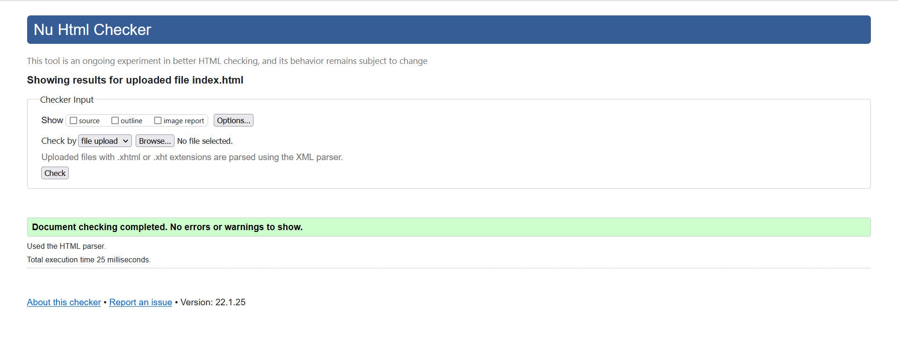 Figure 13

**Check Home page**

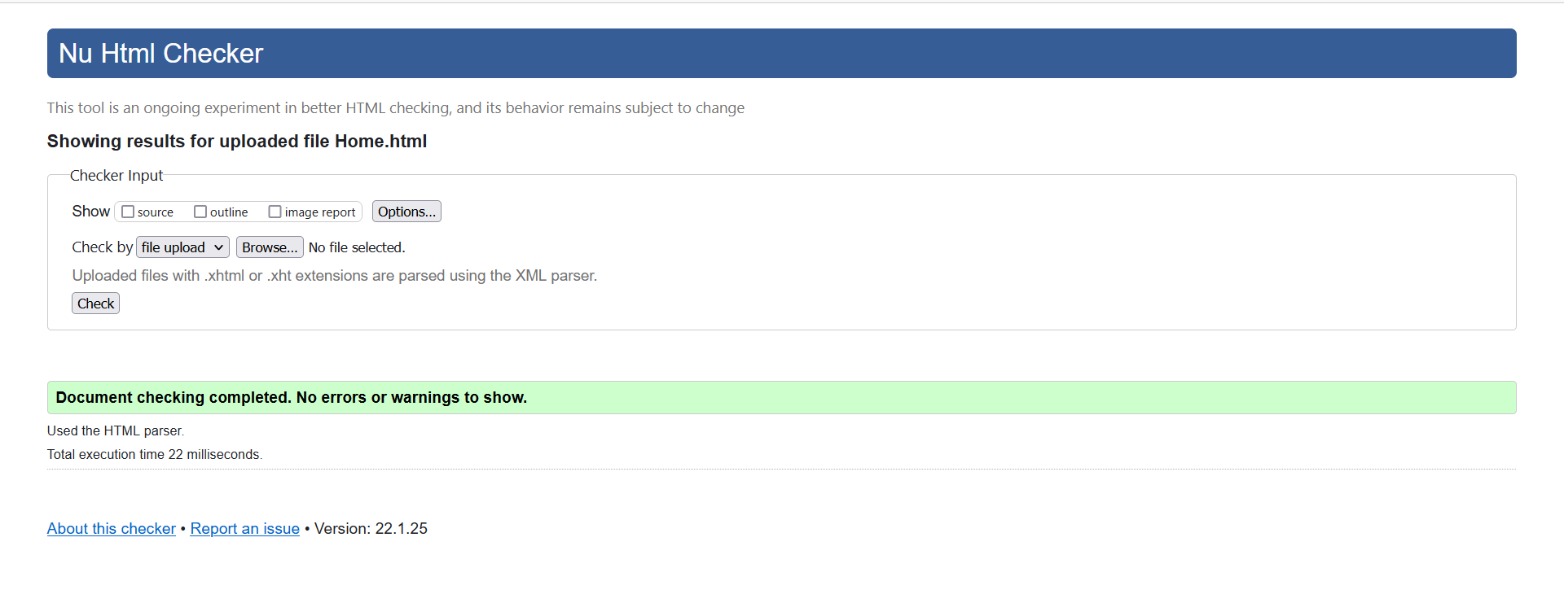

Figure 14

**Check About page**

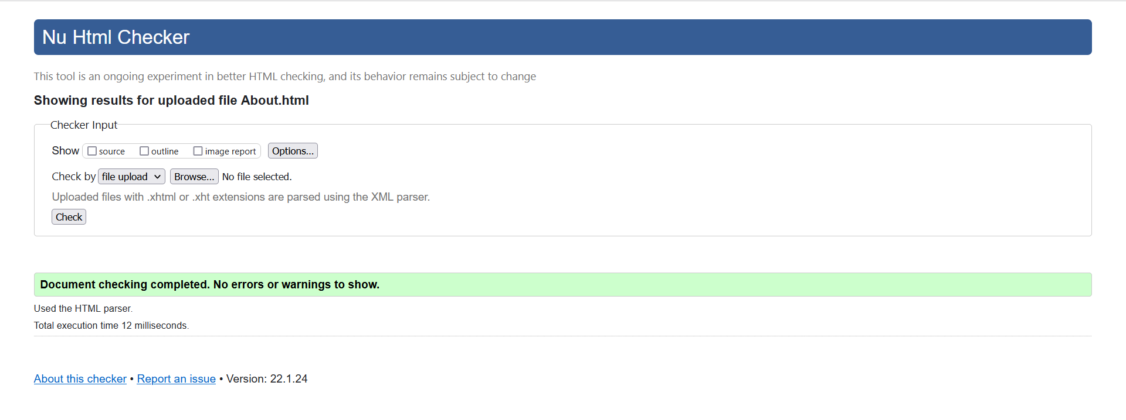

Figure 15

**Check Register page**

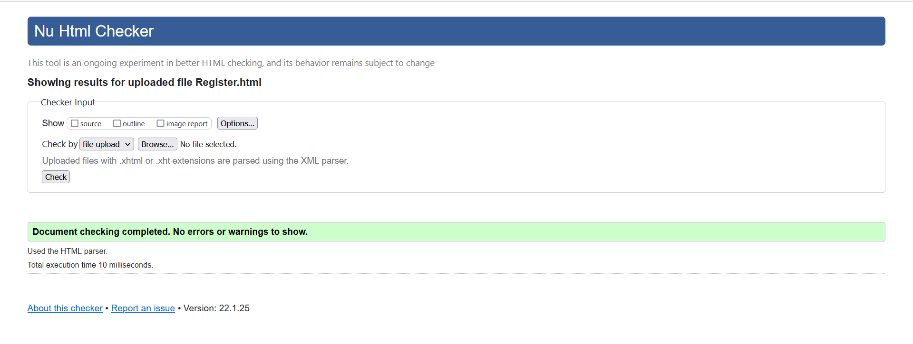

Figure 16

**Check Drivers page**

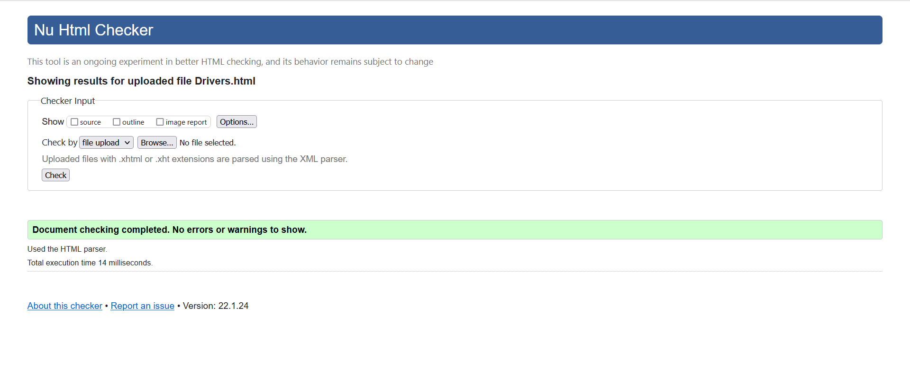

Figure 17

**Check Q&A page**

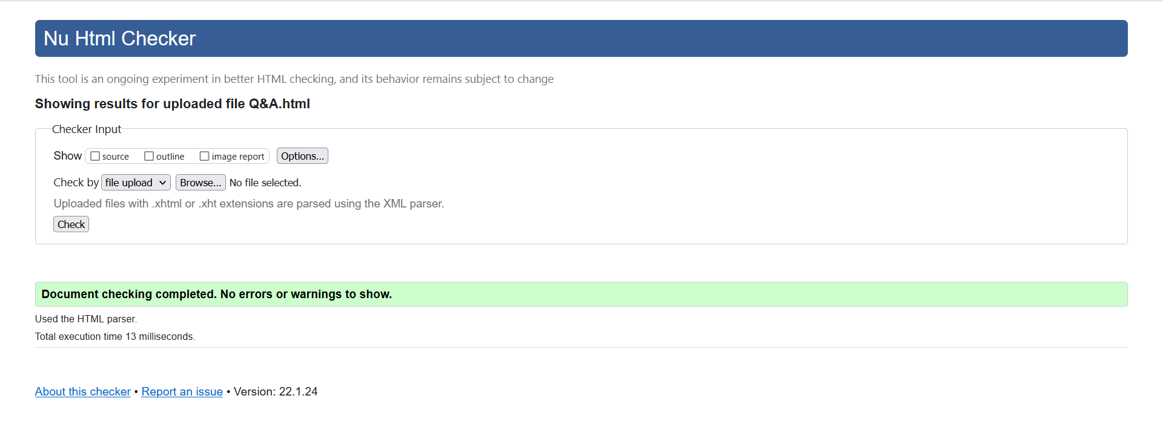 Figure 18

**Check Contact page**

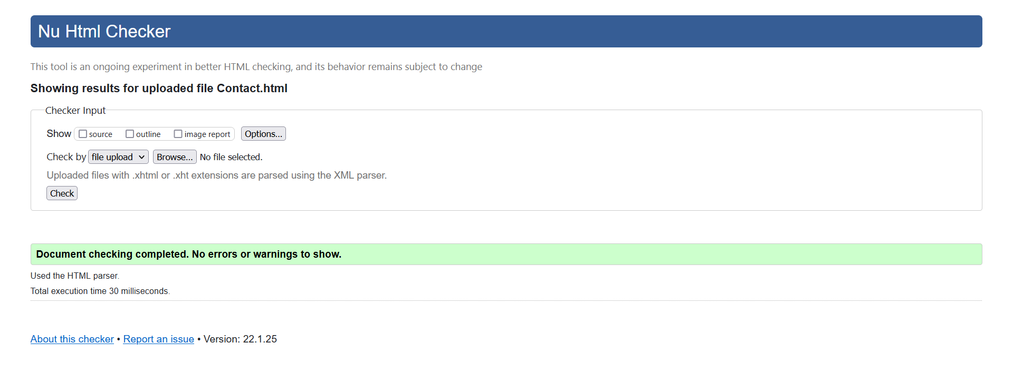

Figure 19

## How the website works for Disable users

My website is also specially designed for the disabled and supports popular screen readers. Visual elements are at a disadvantage to the blind users. In this case, the alt texts are inserted into images for descriptiveness when the blind uses screen readers using a synthesizer or Braille display. The motor-disabled individuals who are difficult to use mouse or touch devices can use keyboard Tab key for navigation links instead of mouse pointer. The website is compatible with Windows browsers and Mac browsers, which means the individuals with low vision can zoom into all or portion of the visuals. I also took into account for those with low color contrast sensitivity and designed my website with high color contrast between the foreground and background such as black letters on white background and vice versa. For the sake of deaf users, I utilized our rally club’ transcribed YouTube videos (Siteimprove, no date) (Monus, 2018) (Dudharejia, 2020).

## Testing on Two Different Web Browsers

There is no difference when testing the website on two different browsers.

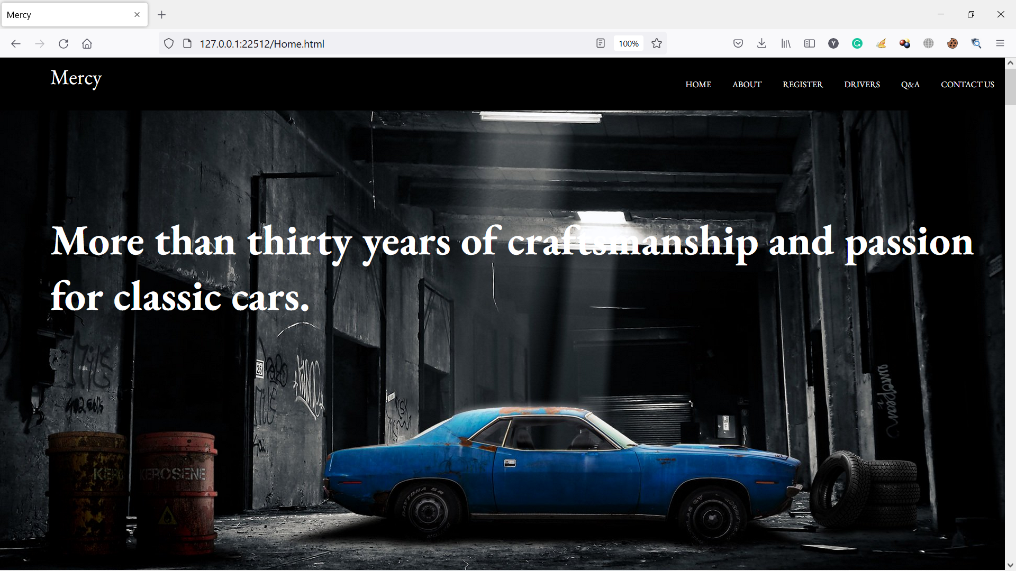

Figure 20 Home page in Firefox

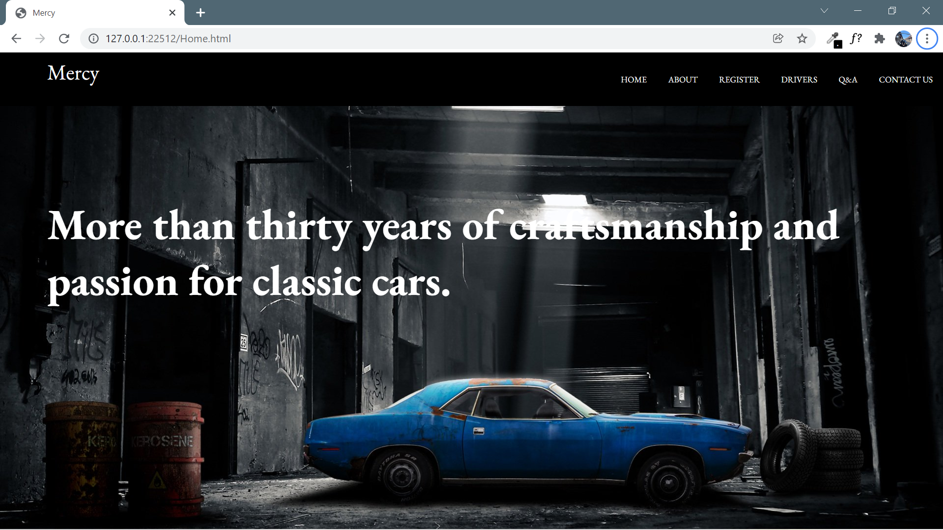

Figure 21 Home page in Chrome

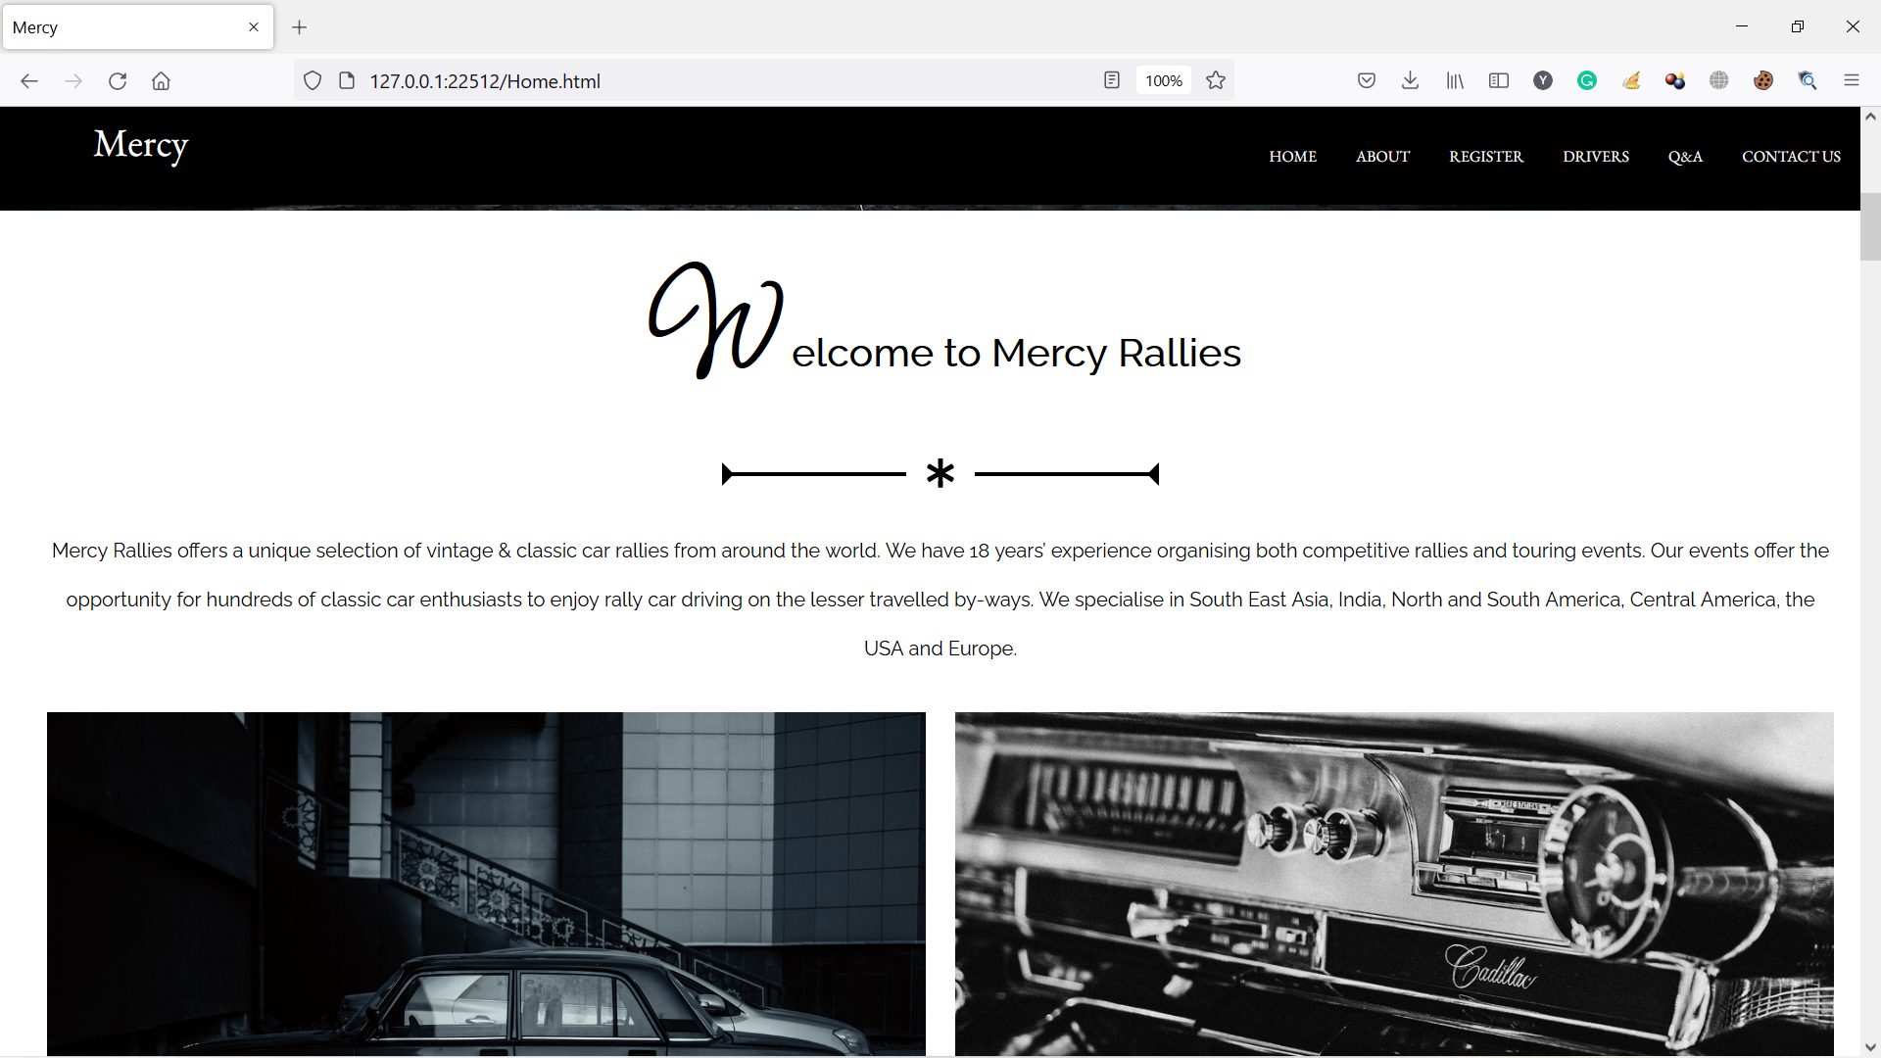

Figure 22 Home page in Firefox

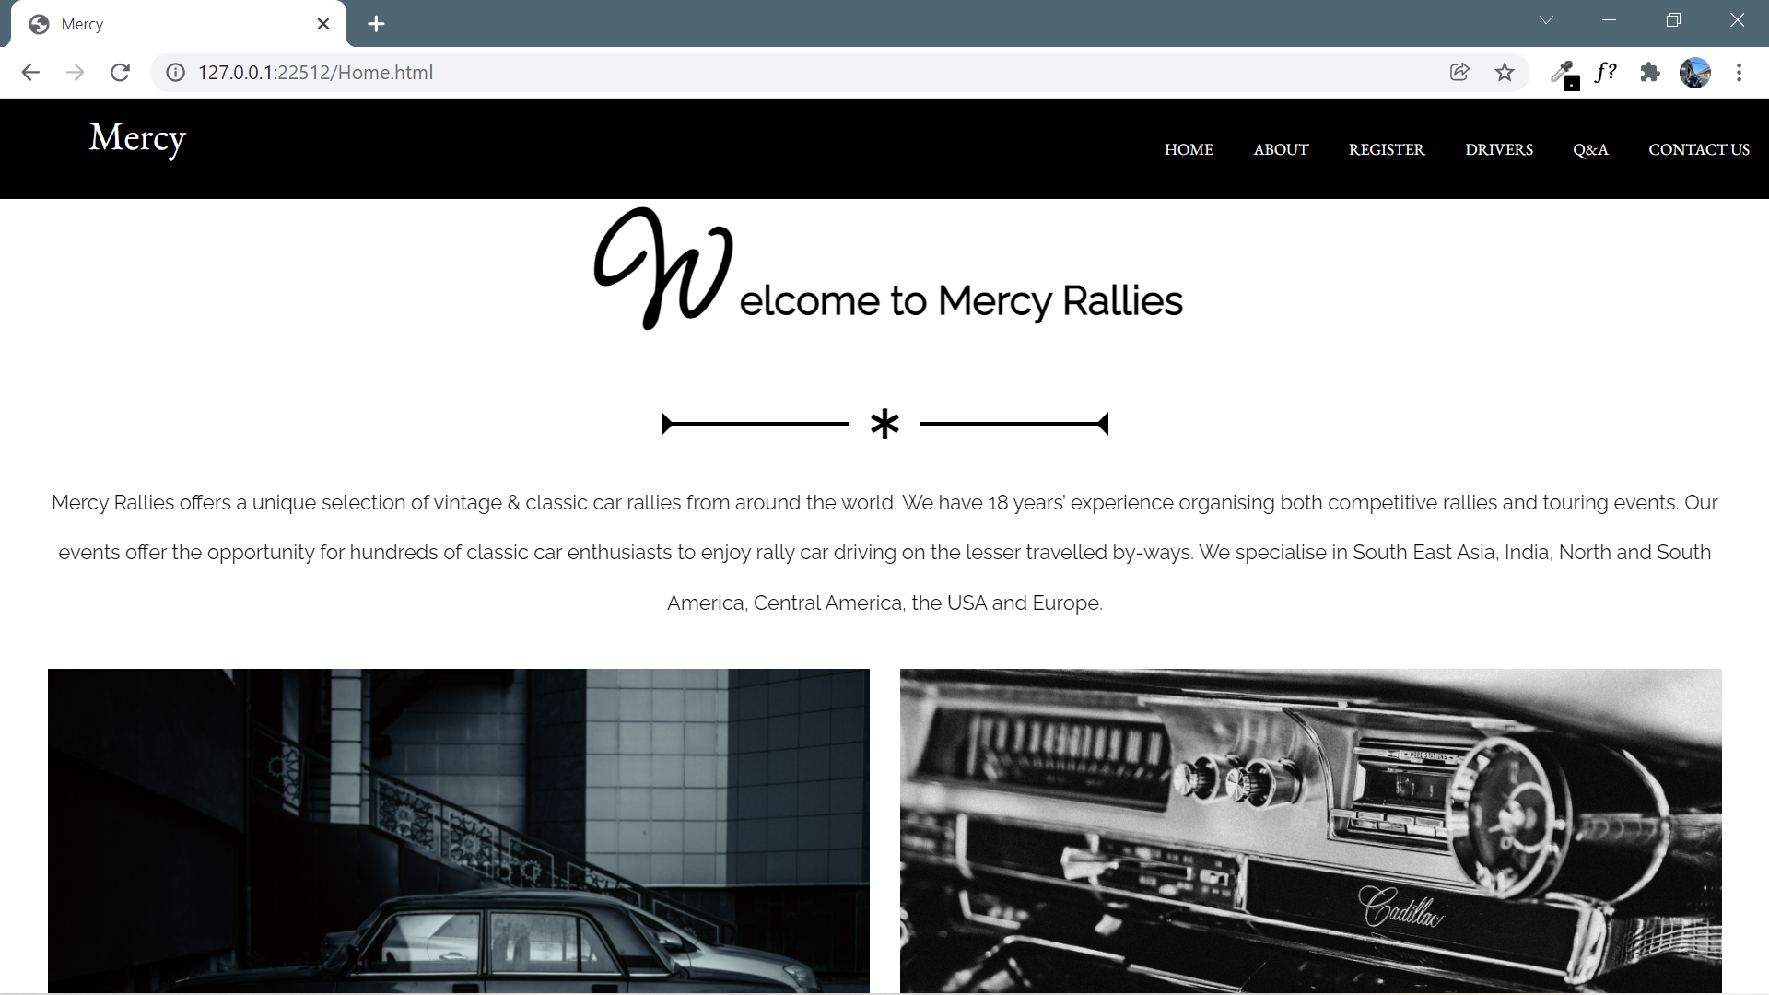

Figure 23 Home page in Chrome

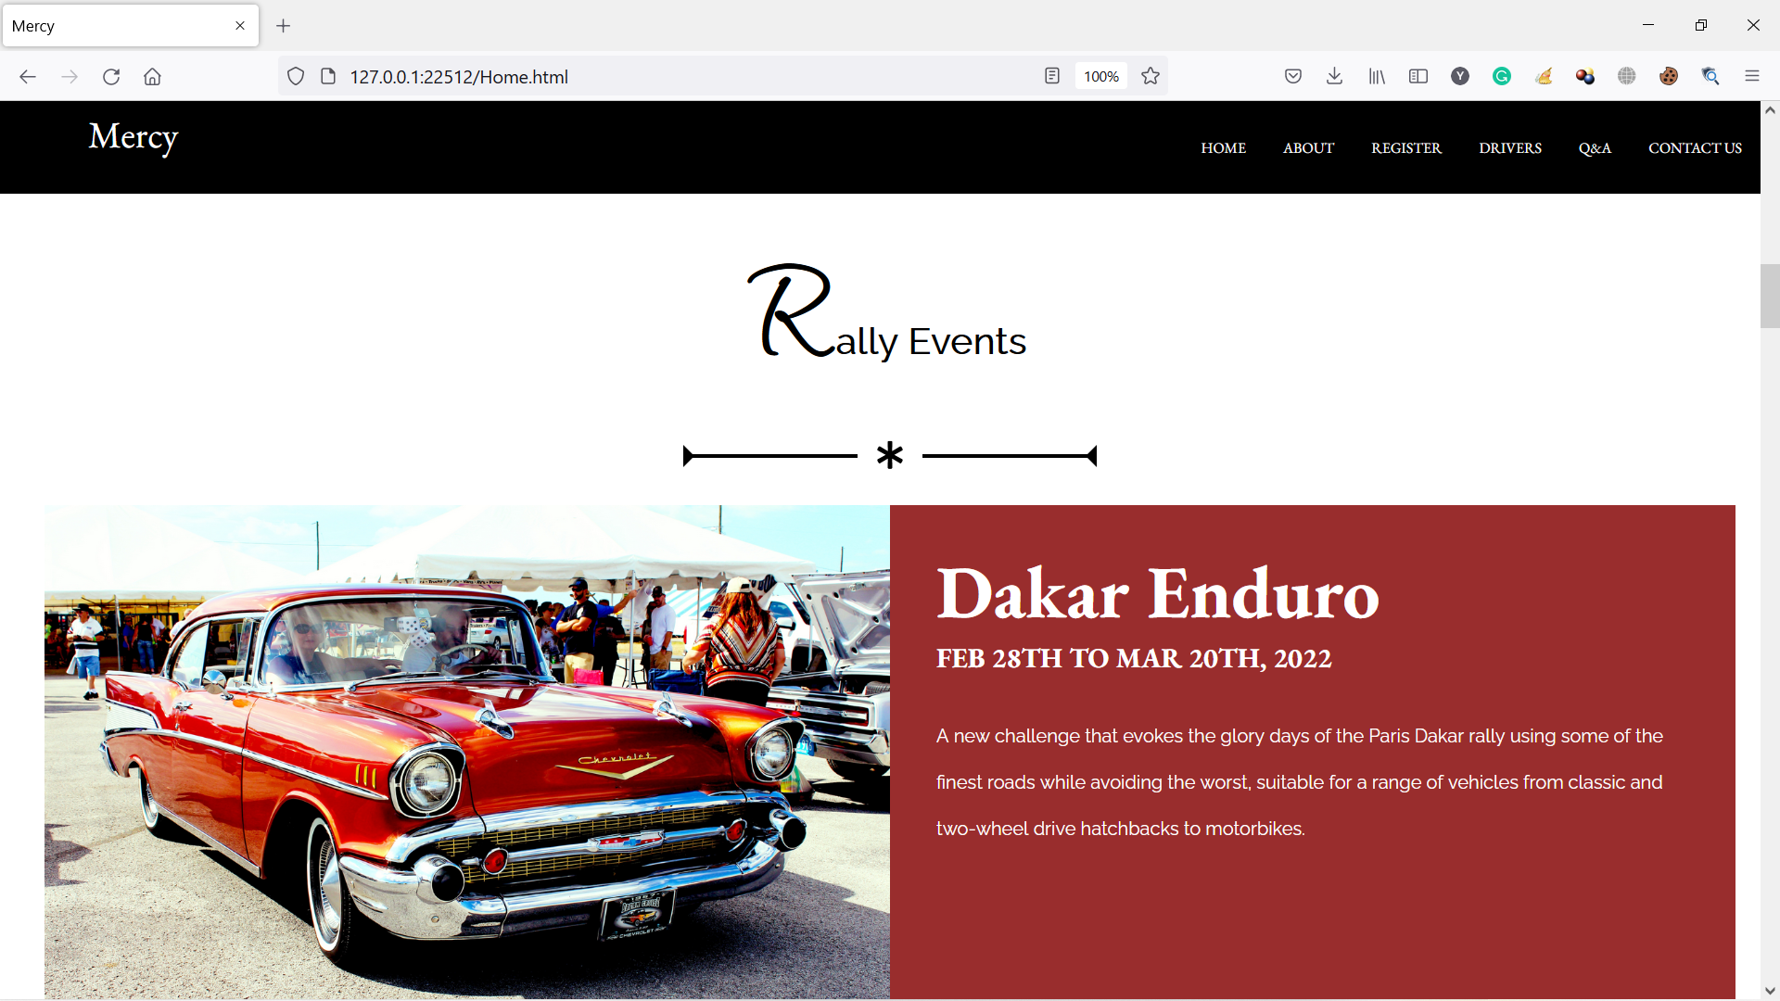

Figure 24 Home page in Firefox

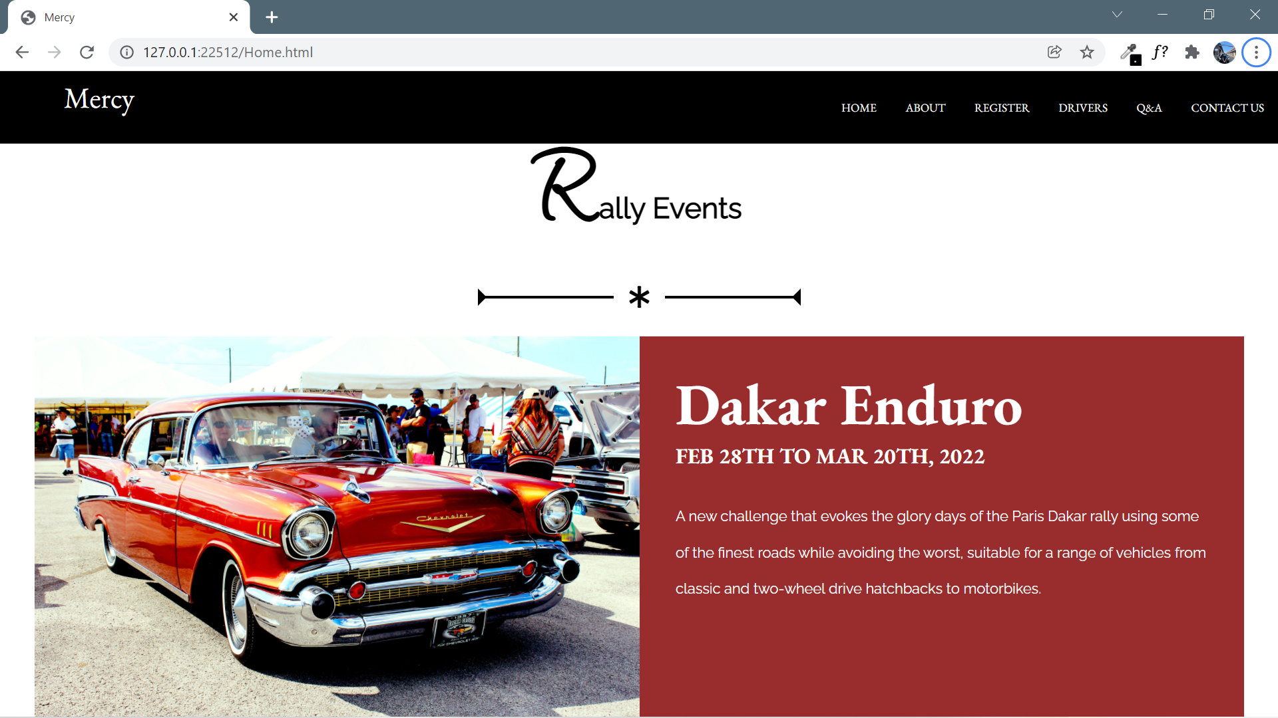

Figure 25 Home page in Chrome

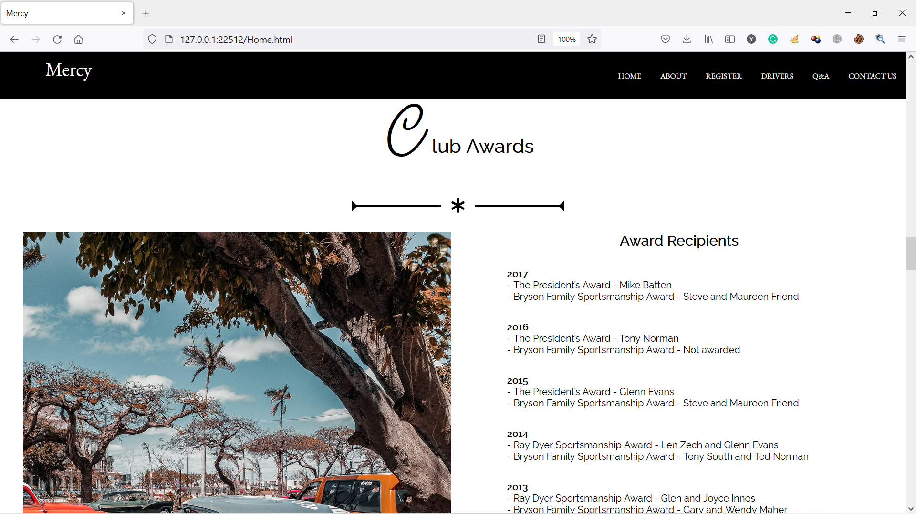

Figure 26 Home page in Firefox

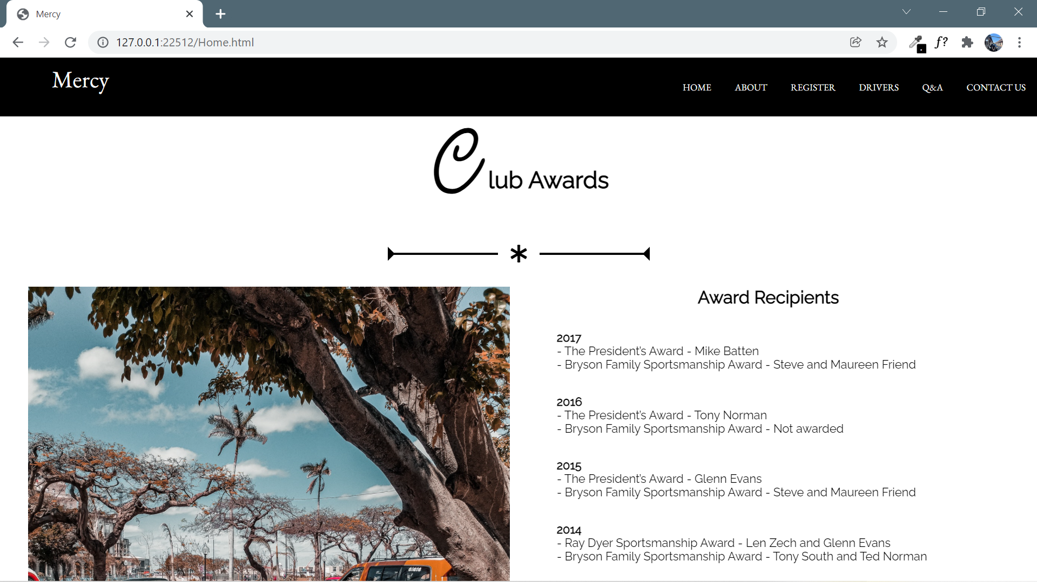

Figure 27 Home page in Chrome

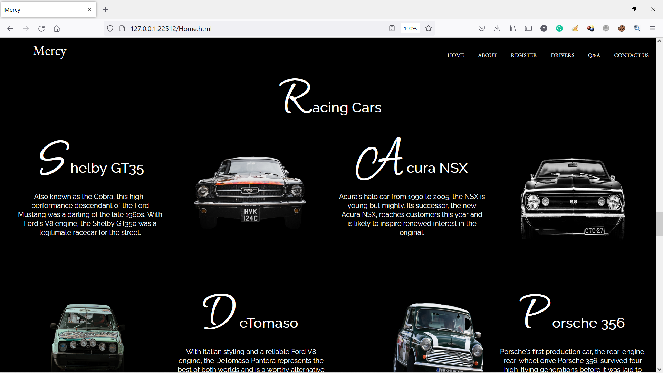

Figure 28 Home page in Firefox

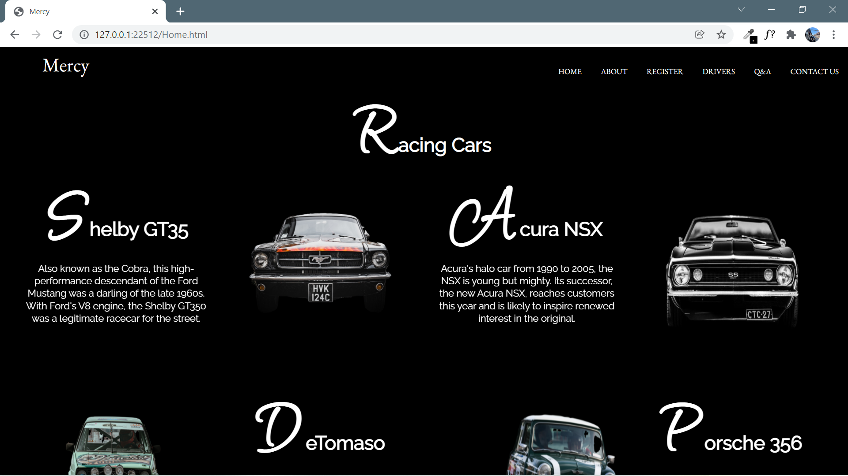

Figure 29 Home page in Chrome

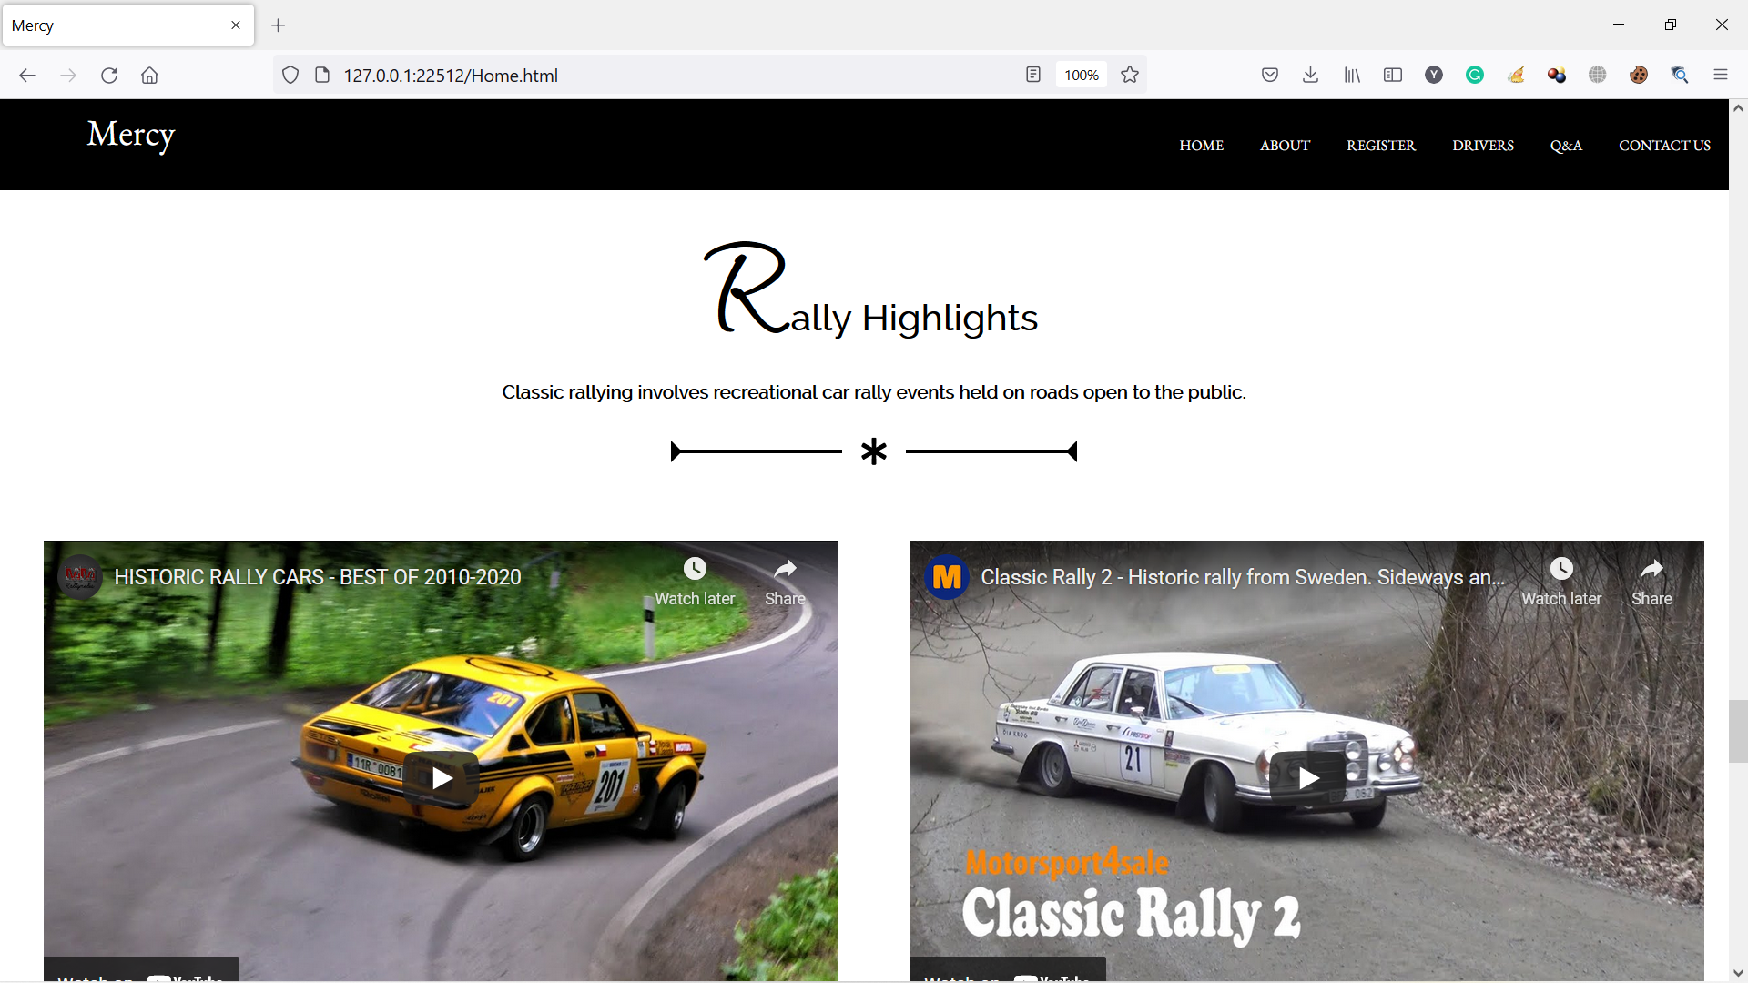

Figure 30 Home page in Firefox

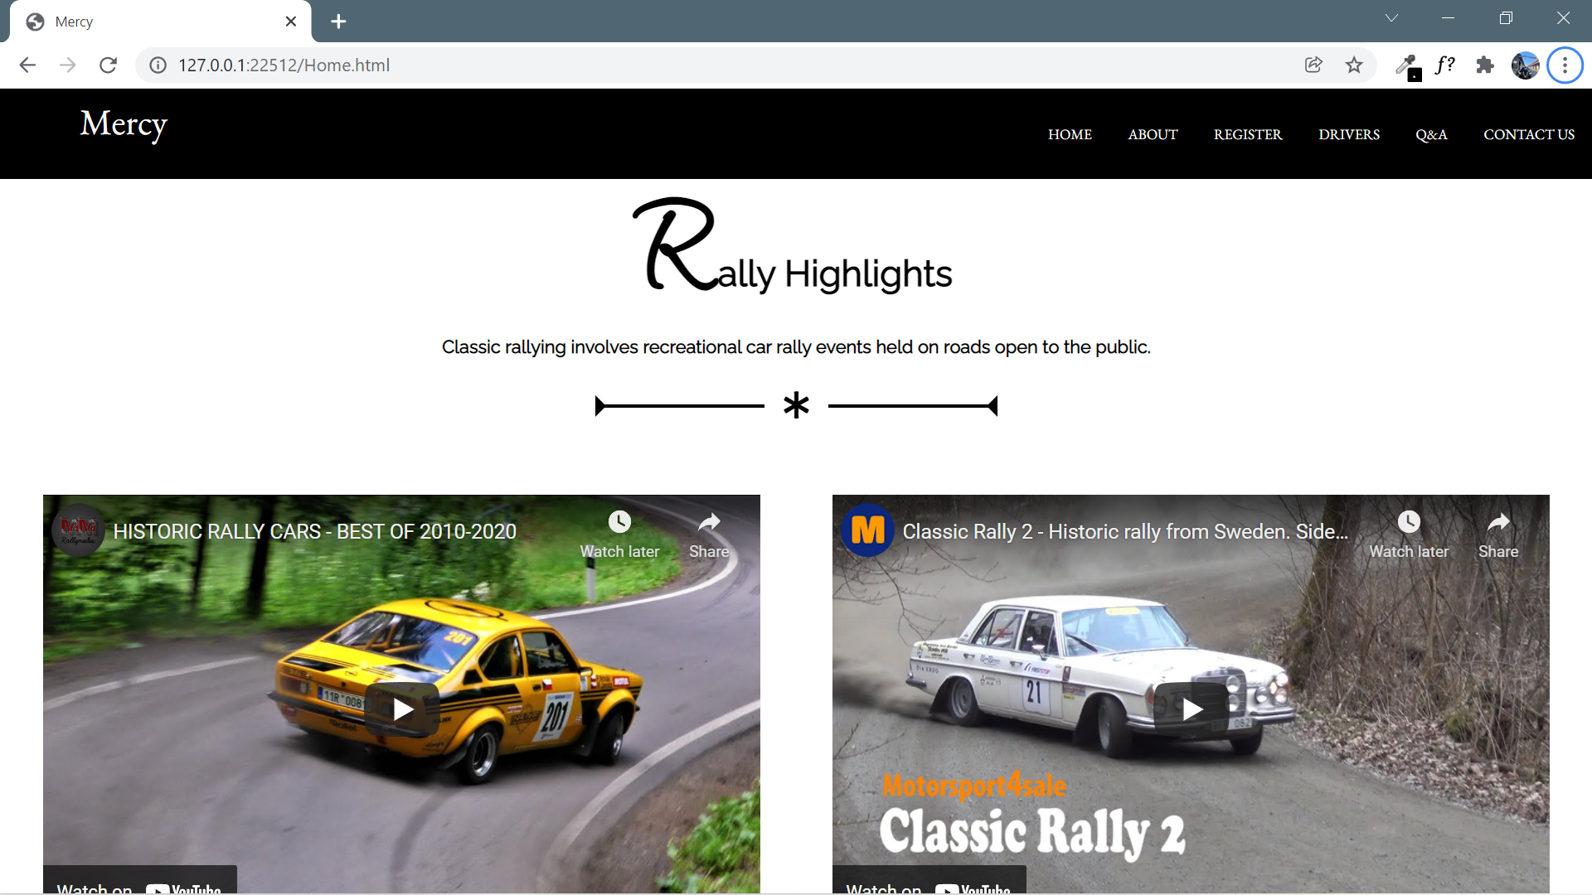

Figure 31 Home page in Chrome

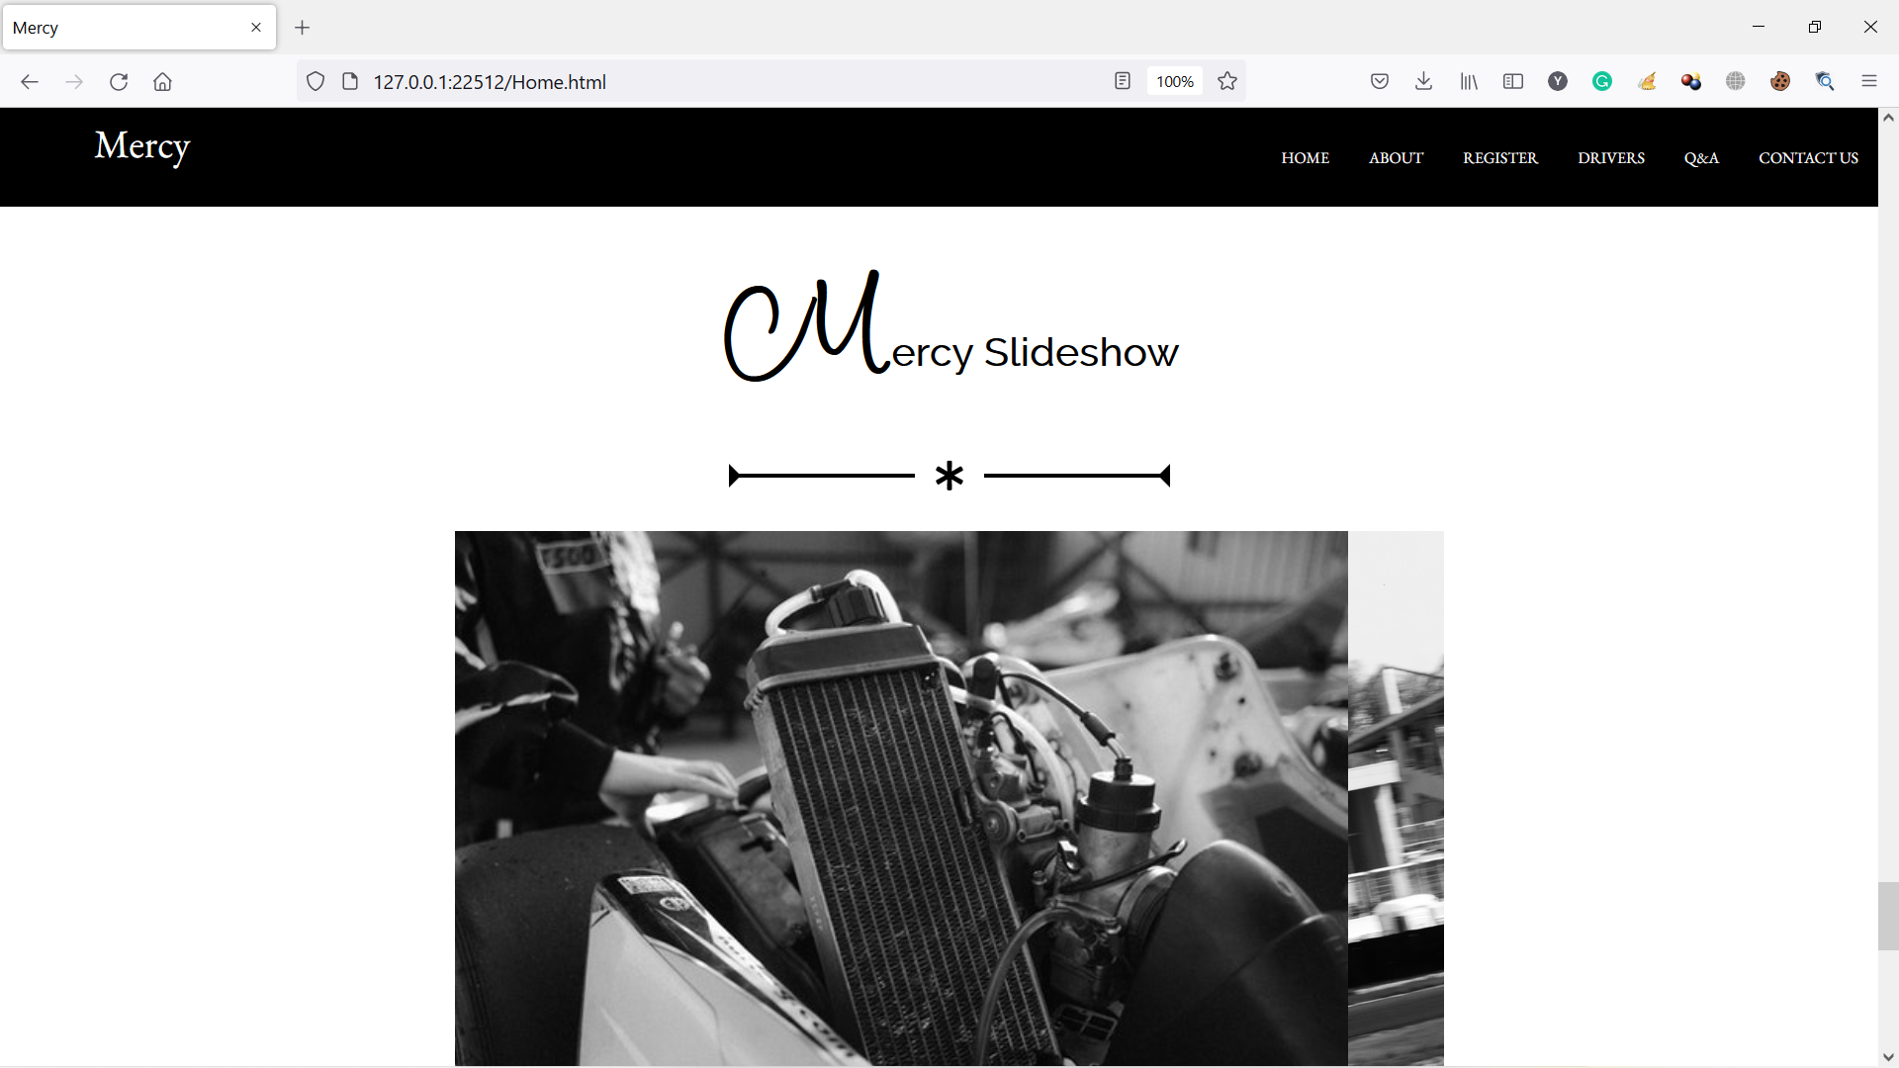

Figure 32 Home page in Firefox

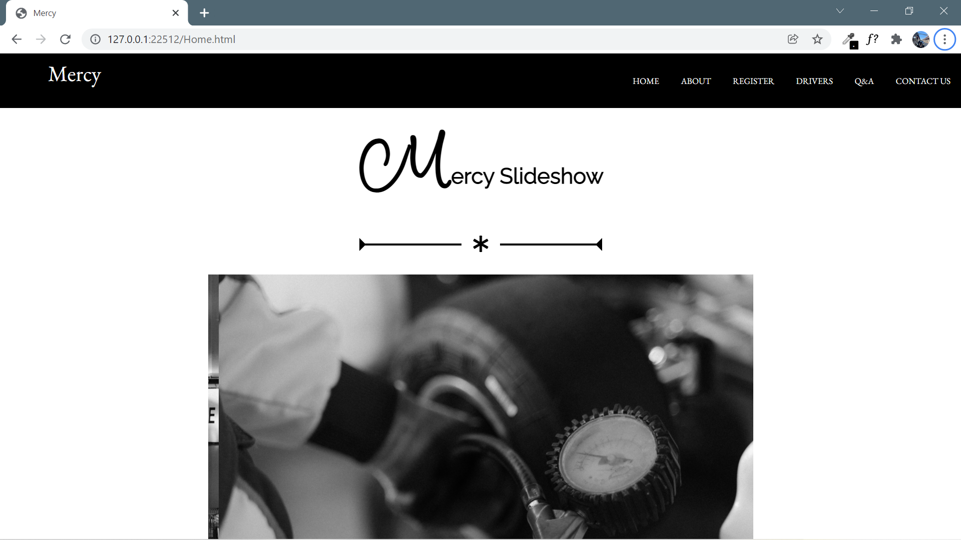

Figure 33 Home page in Chrome

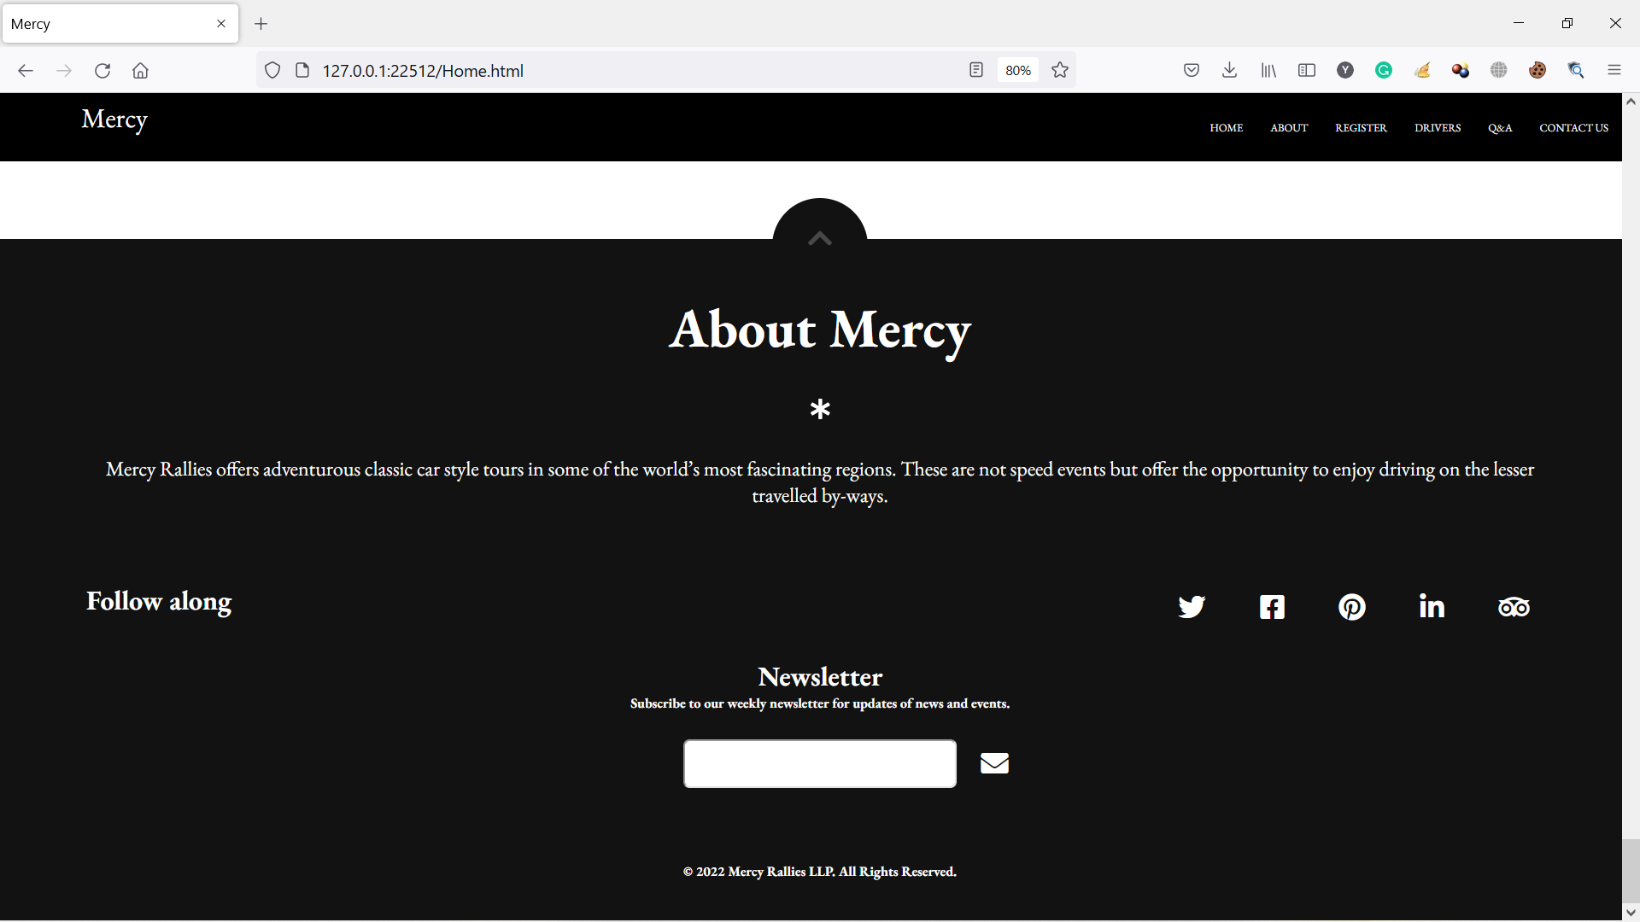

Figure 34 Home page in Firefox

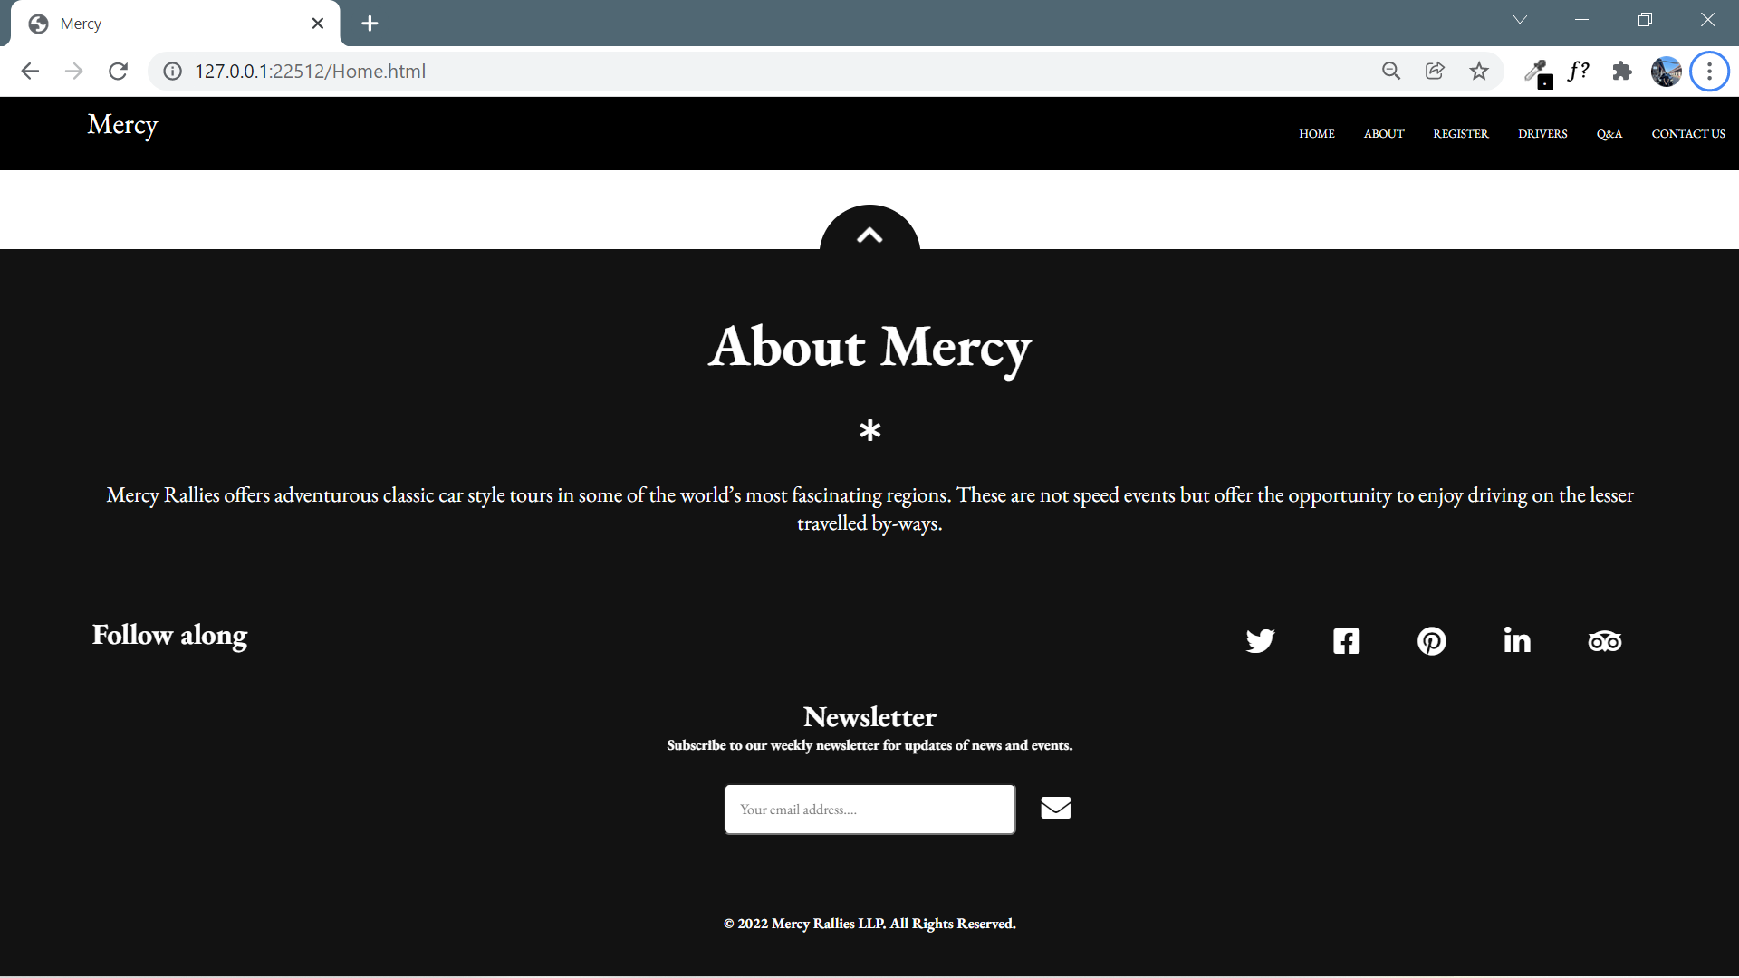

Figure 35 Home page in Chrome

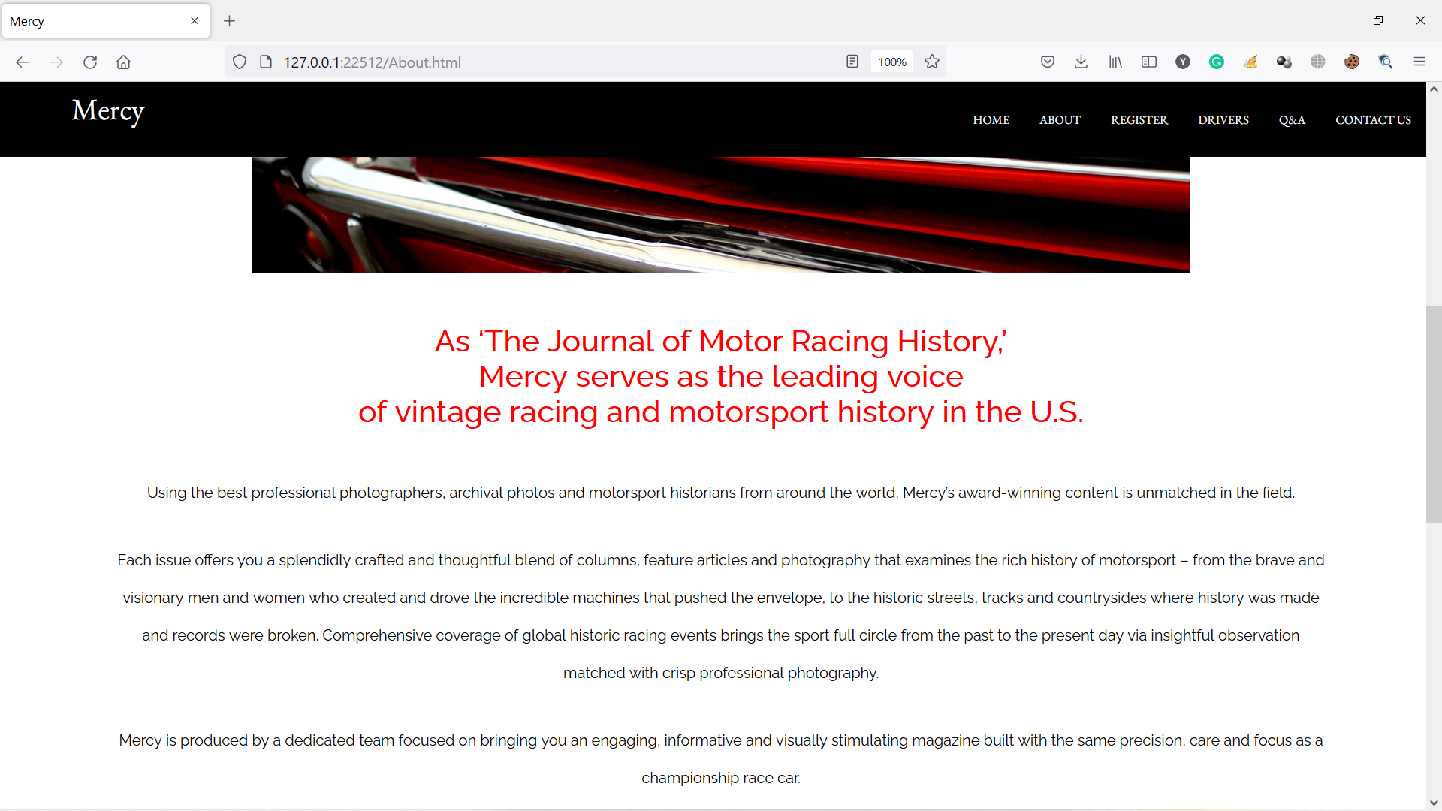

Figure 36 About page in Firefox

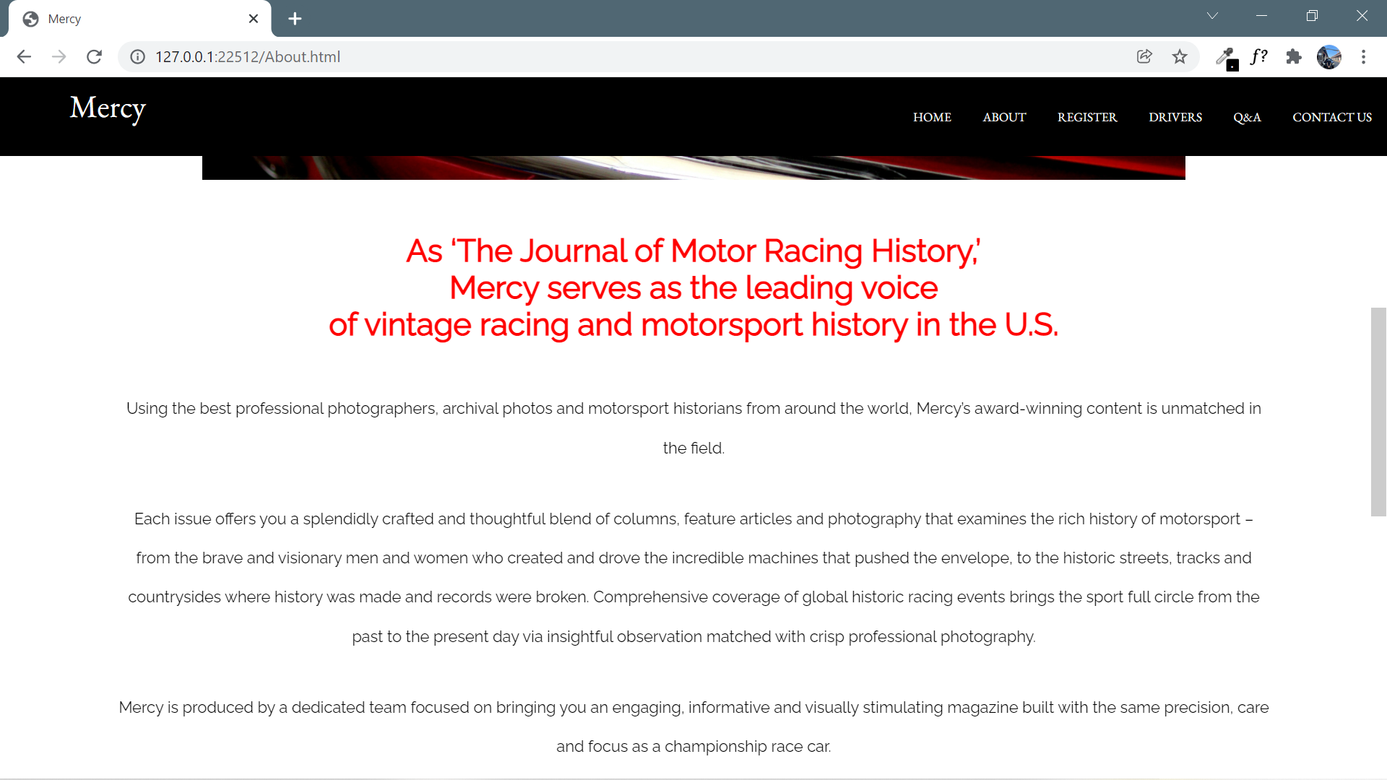

Figure 37 About page in Chrome

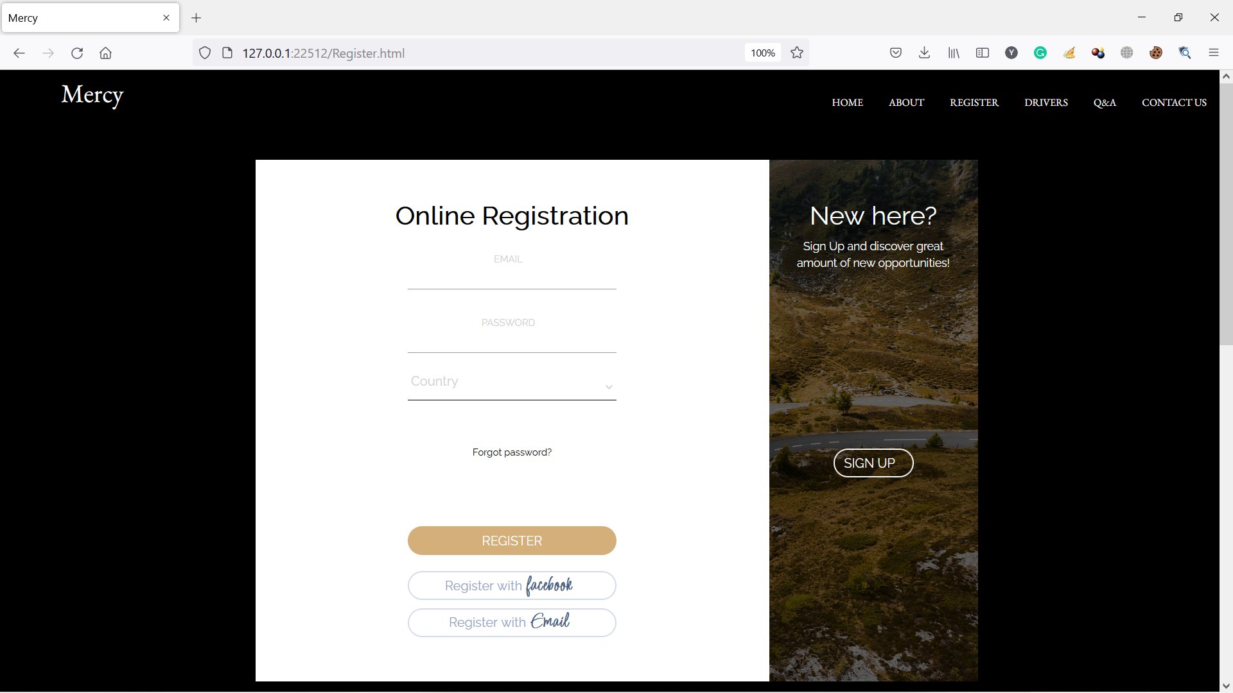

Figure 38 Register page in Firefox

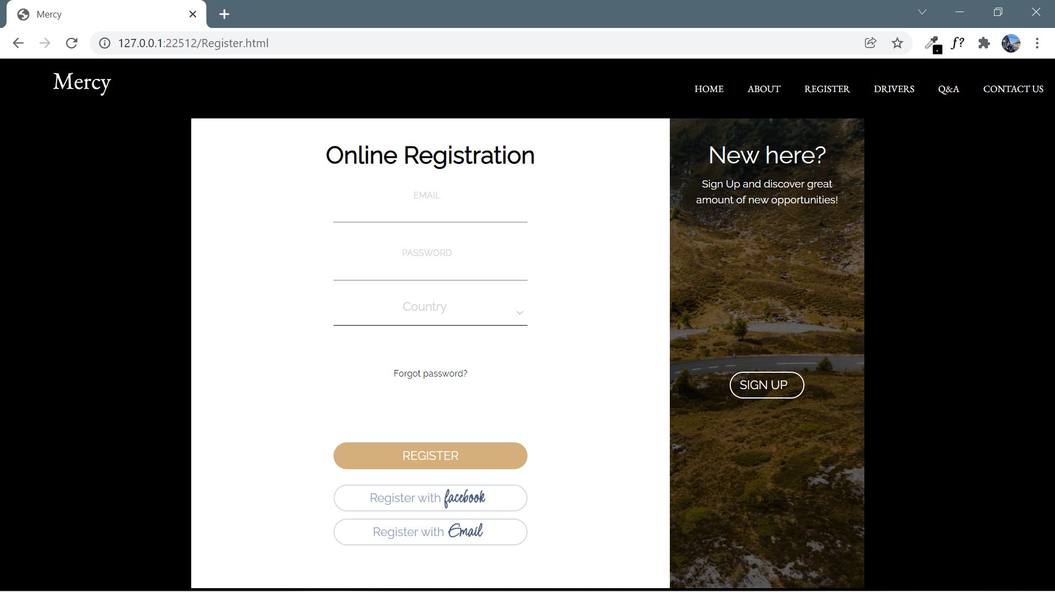

Figure 39 Register page in Chrome

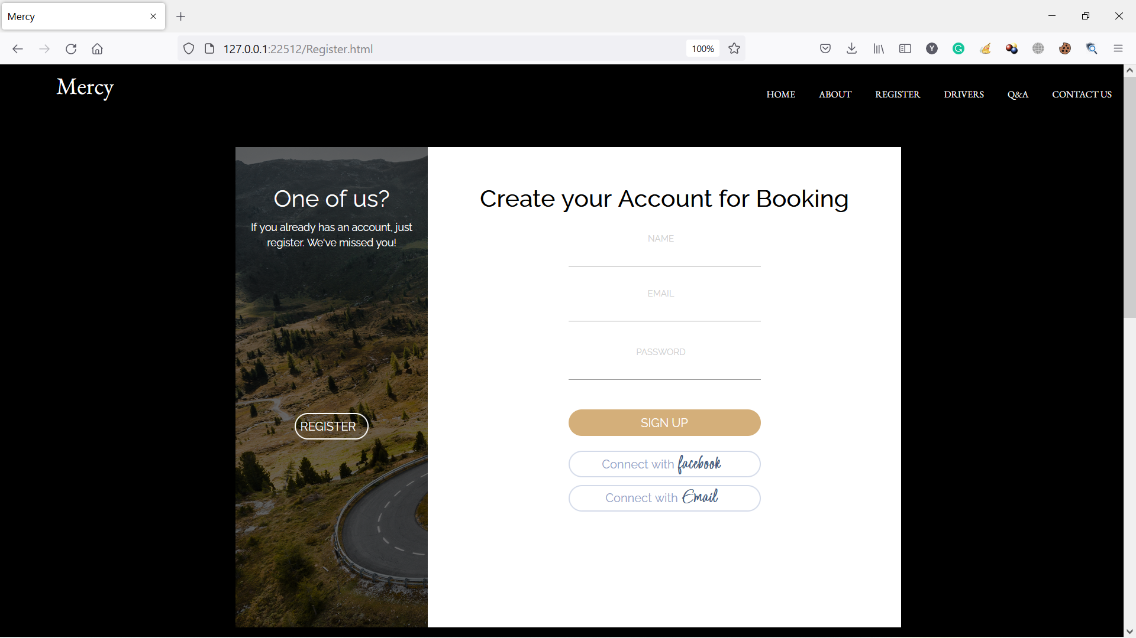

Figure 40 Register page in Firefox

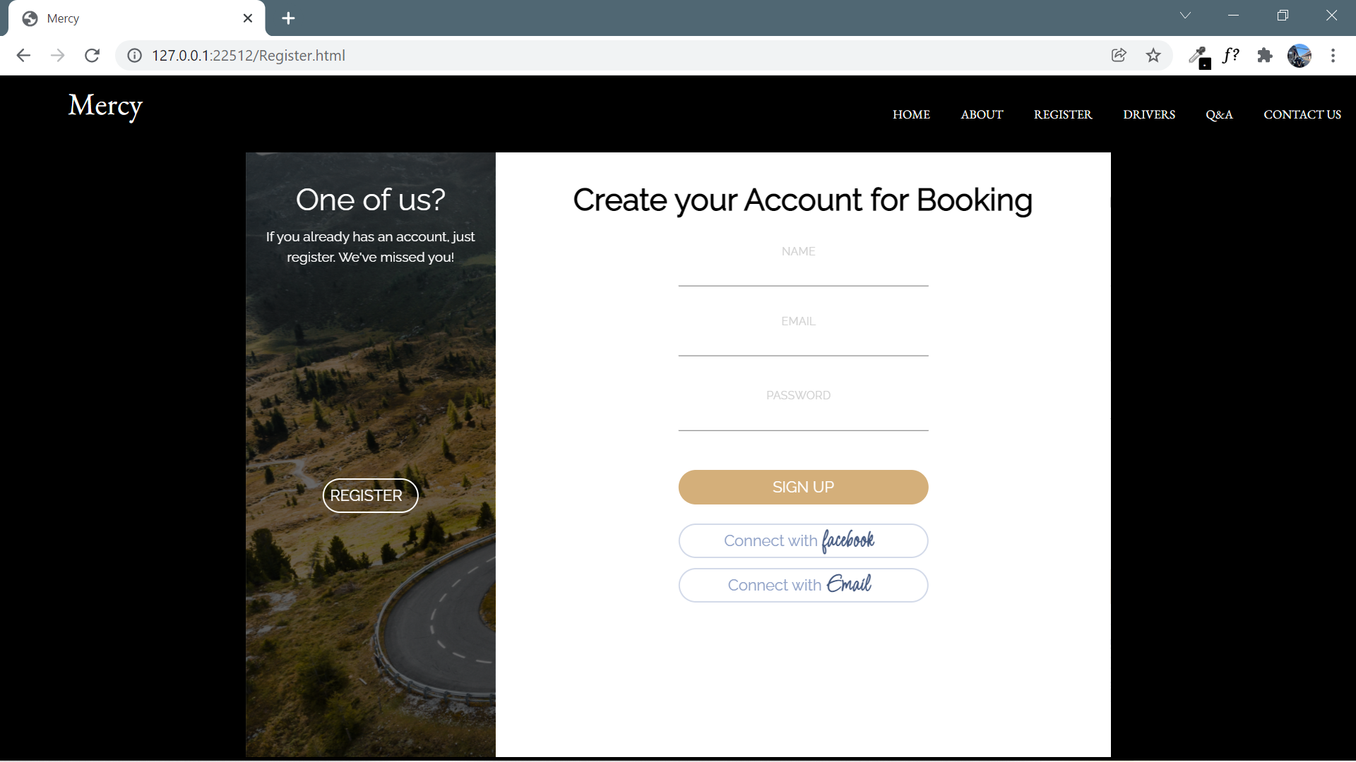

Figure 41 Register page in Chrome

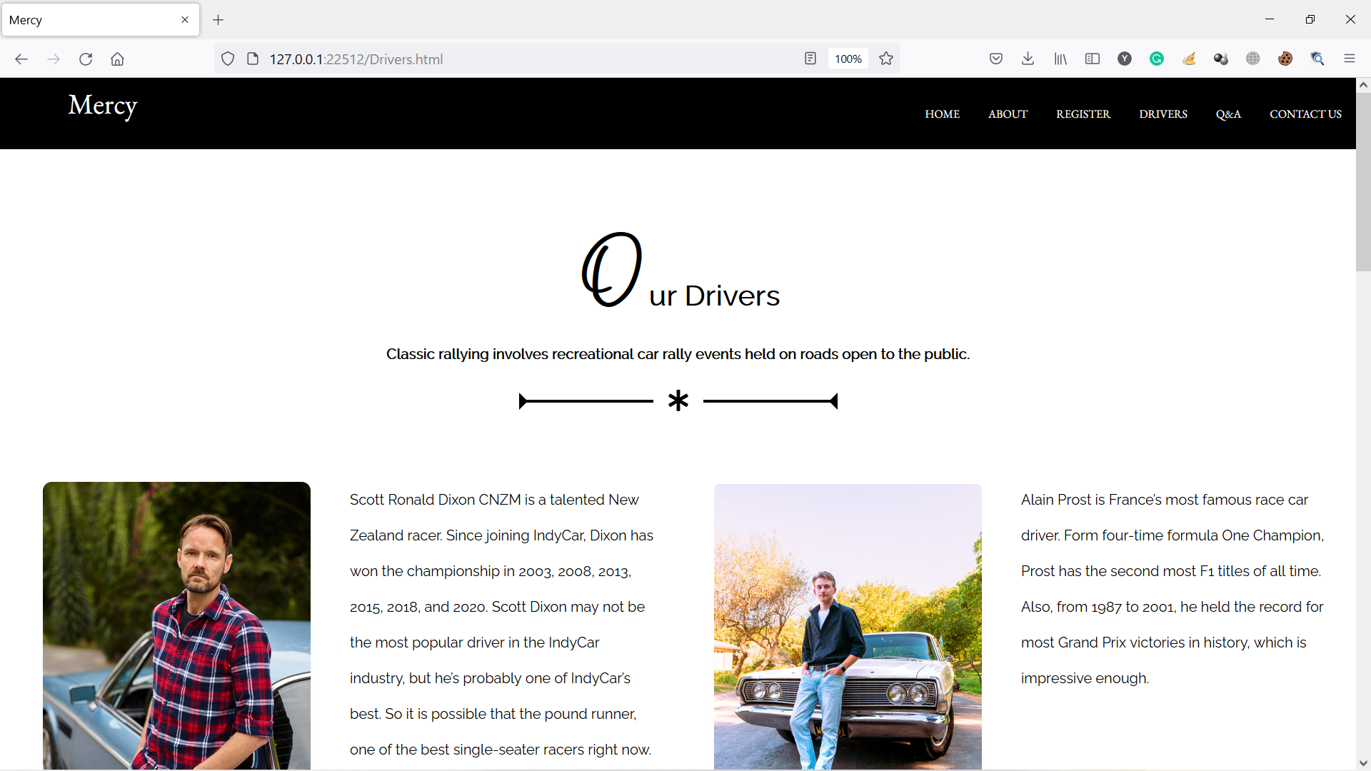

Figure 42 Drivers page in Firefox

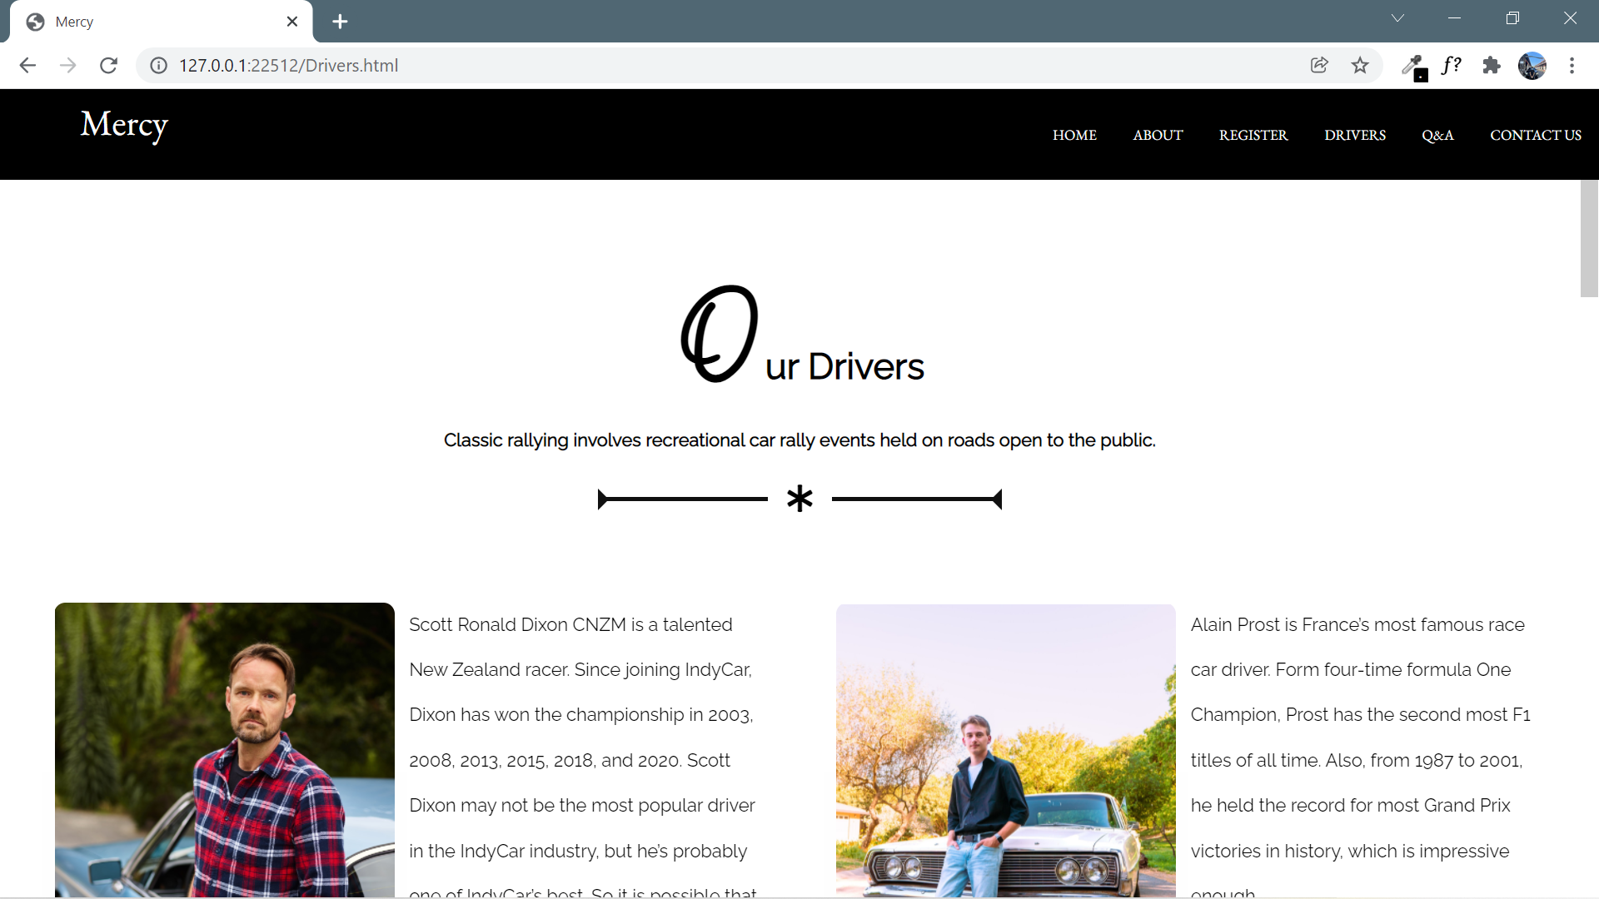

Figure 43 Drivers page in Chrome

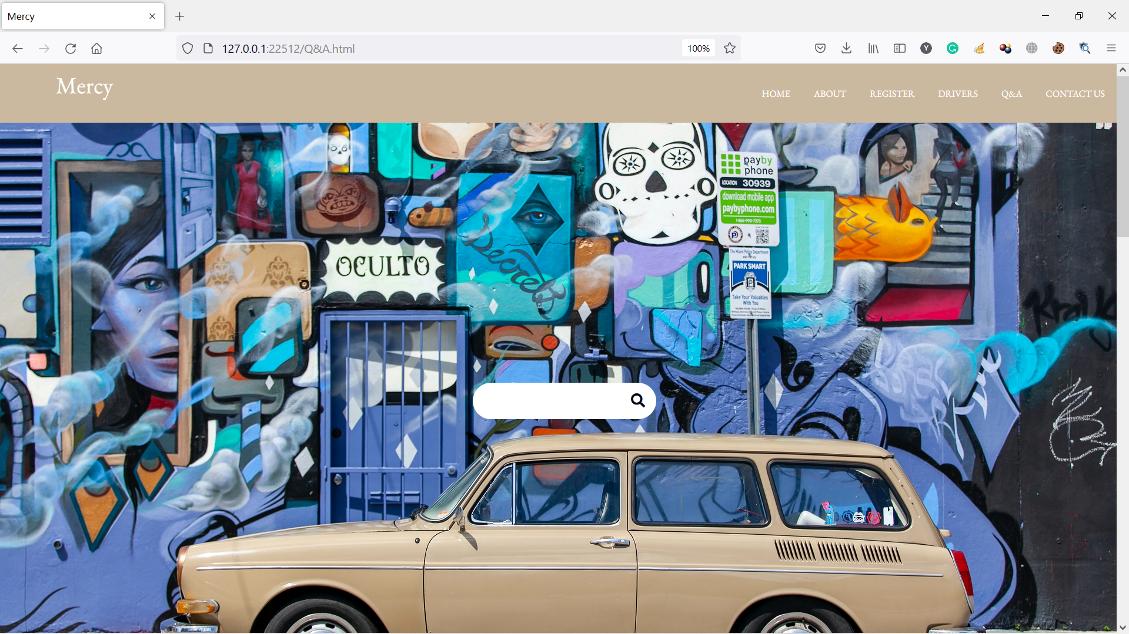

Figure 44 Q&A page in Firefox

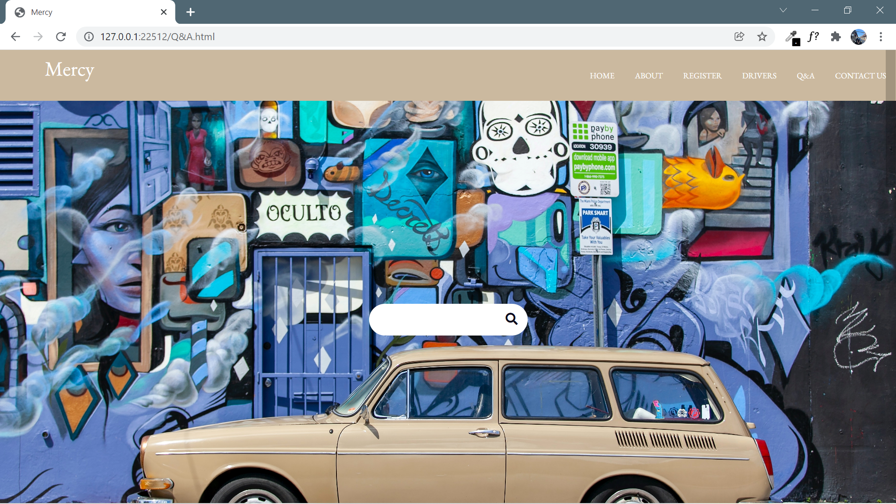

Figure 45 Q&A page in Chrome

However, there is only one difference in placeholder color. Chrome does not support the color which the Firefox does.

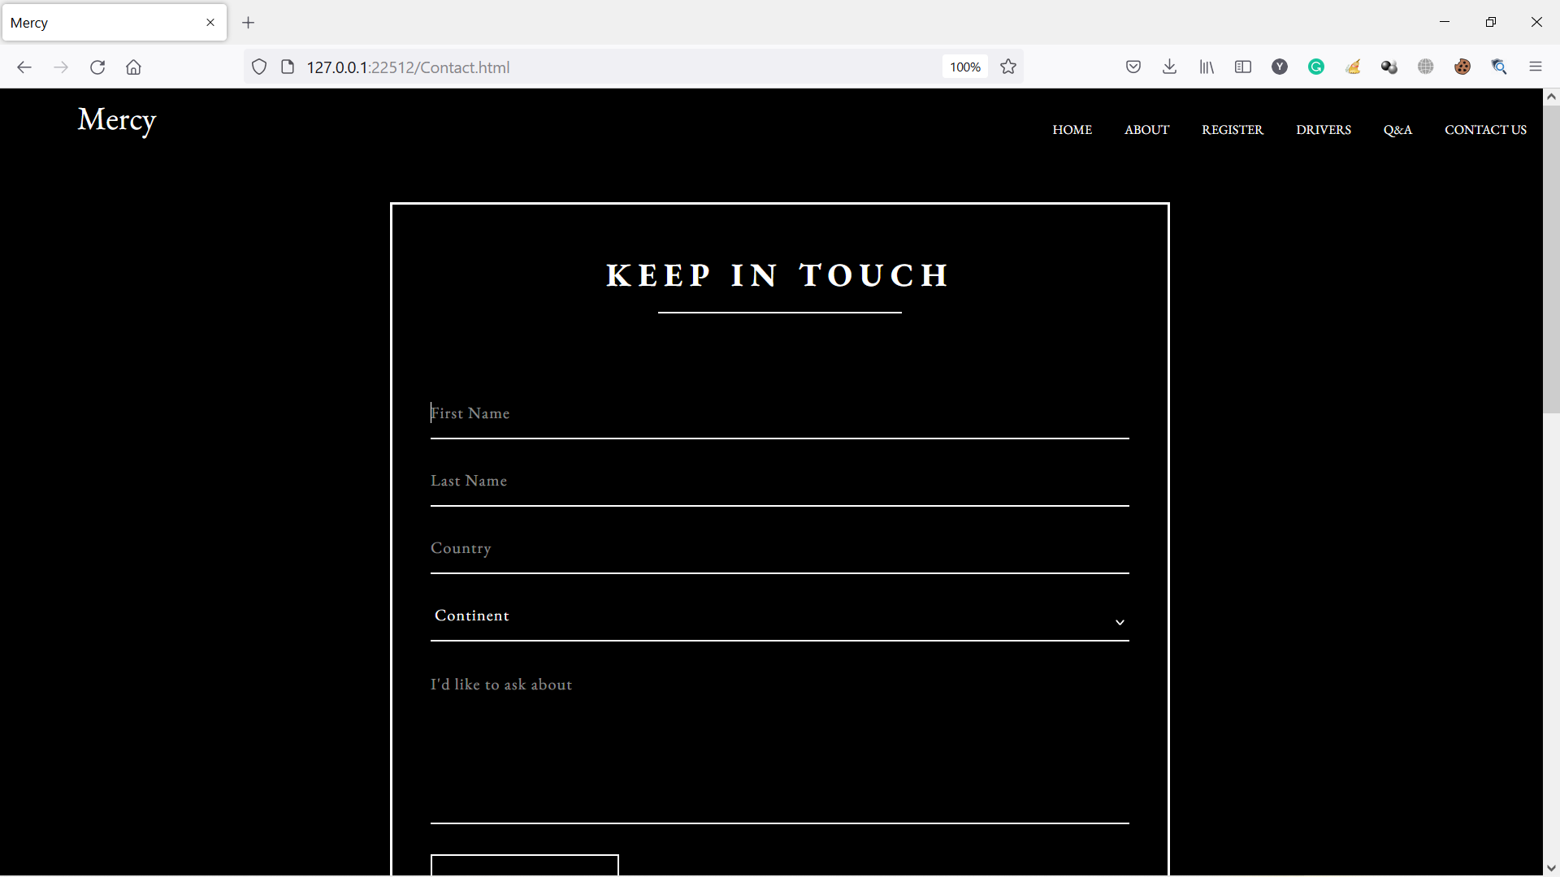

Figure 46 Contact page in Firefox

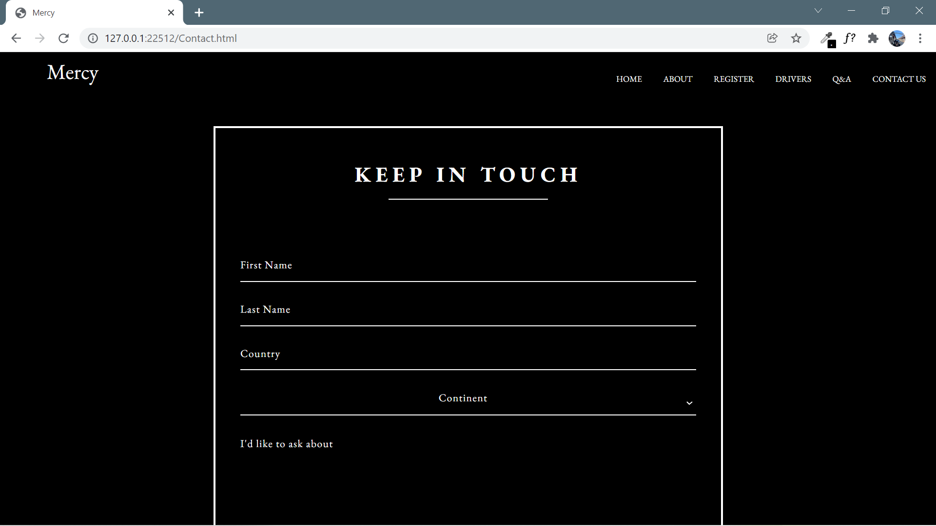

Figure 47 Contact page in Chrome

## Test Report

While creating webpages, I faced some issues in design concepts and coding phase. I had to explore a plenty of high-quality images of vintage cars for web designs. The next problem is about choosing the suitable color for the website to elicit the vintage emotion. I used black and white composition in most webpages aiming for the good look and clean text. W3C validator does not prefer the H1 heading so I had to remove them, which made me cumbersome. I created the index page as a default one which is exactly the same as the home page in case no other page was specified when users requested the website.

When testing with W3C validator, I had to fix some minor error. For the highlight video, I inserted the Mercy Club’s YouTube videos with iframe HTML element. However, I got the error that the frameborder of this element is obsolete. Therefore, I had to use the *border-style* property to set the style of iframe element’s four borders.

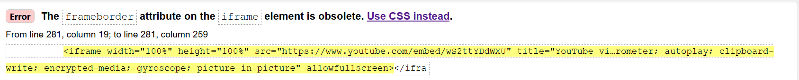

Figure 48

A URL is needed in the form action to accept the form-data when the form submitted. However, my website is a static one without any database design so that there will be no information in filling up the form action. Therefore, I only add the “#” sign in this attribute.



Figure 49

In the option tag, the “value” attribute has to be added either 1 or empty. So, I add some value to the “value” attributes.

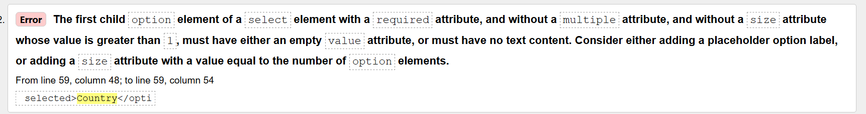

Figure 50

## Role of W3C

**World Wide Web Consortium was established for the World Wide Web to regulate the development of the web. It creates and publishes standards for websites, web applications, web scripting and dynamic contents. W3C leads the World Wide Web by developing protocols and guidelines for the sake of long-run growth of the Web. W3C values three principles in web protocol designs such as extensibility, simplicity and modularity. The W3C’s summarized concepts of web accessibility are that the web content has to be robust, perceivable, understandable and operable. W3C standardizes the websites so that they provide the consistency and defined appearance (W3C, n.d) (GeeksforGeeks, 2020) (University of Washington, n.d).**

**Task 4**

# Task-4 Critical Evaluation (500)

## Accessibility features of my own website.

1. Colour combination with good contrast

On the home page, I made a color colour contrast between background colour and text using black and white composition.

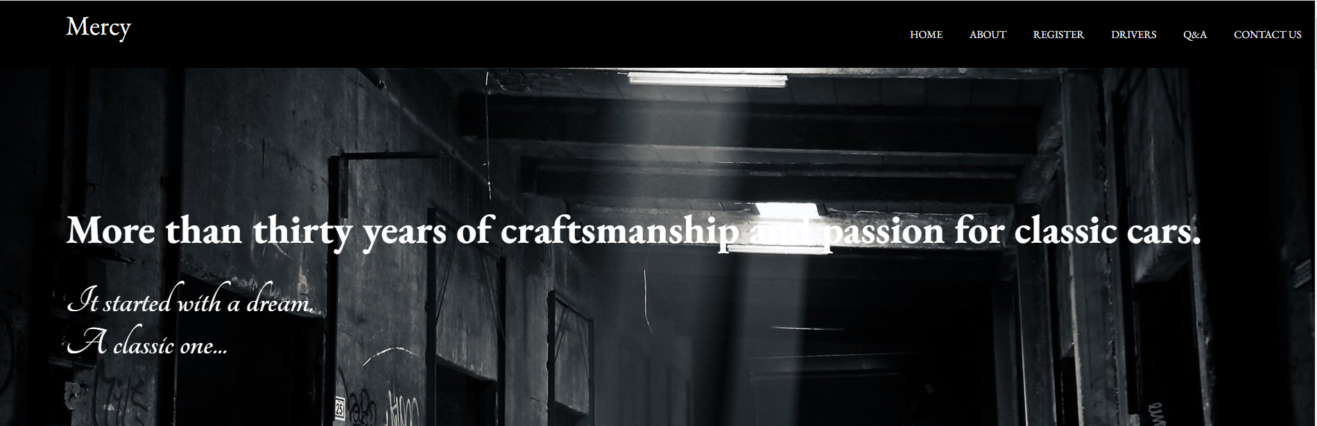

Figure 51

In the Rally event section, I adapted the background color of description boxes to the color of vintage cars.

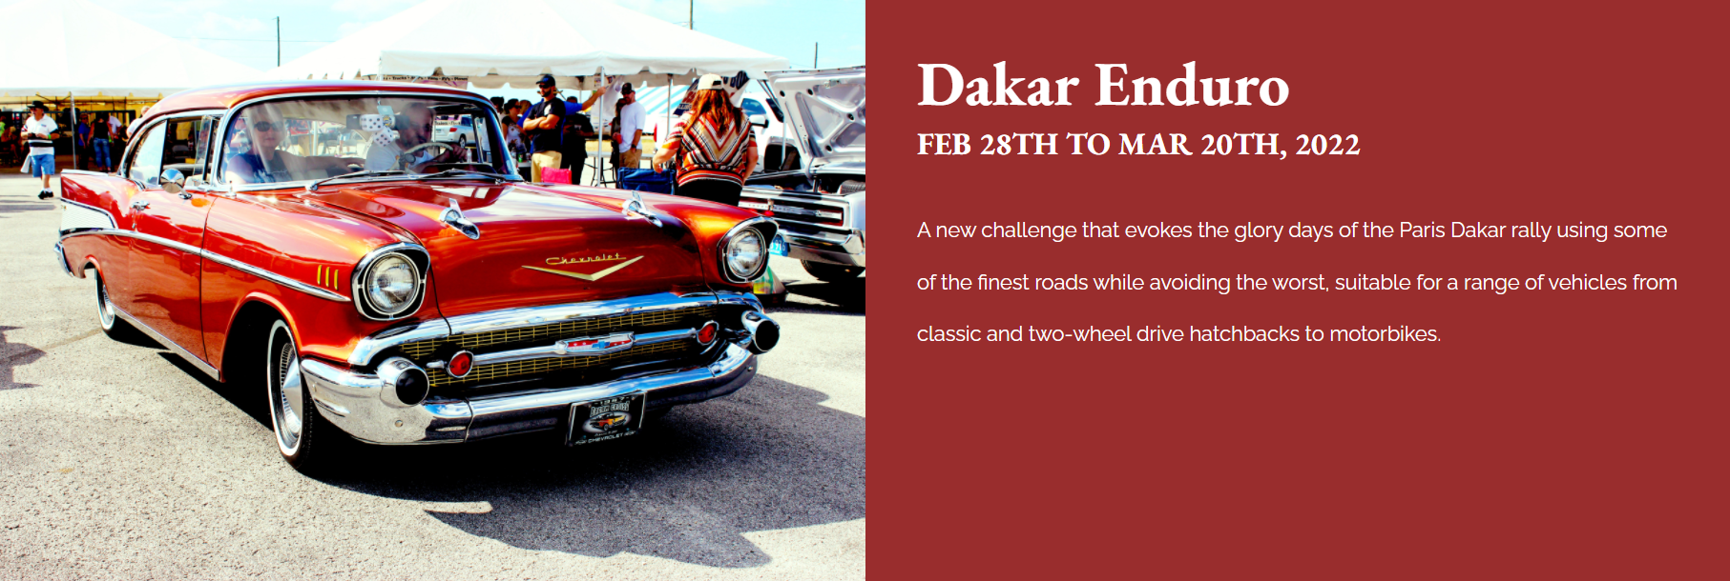

Figure 52

Since the vintage car is yellow color, I changed the description box color to yellow.

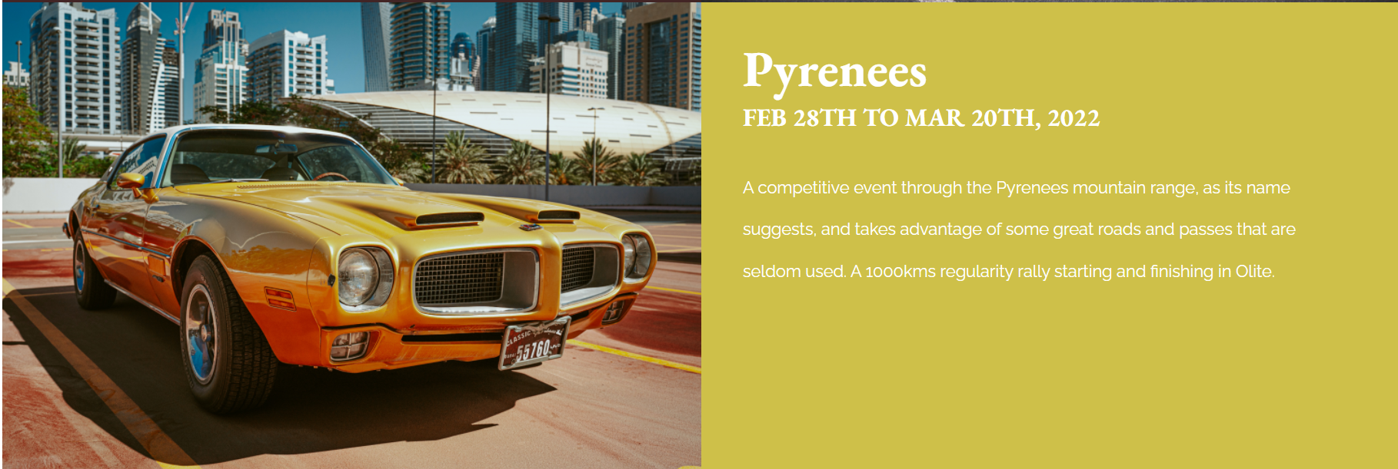

Figure 53

In the Racing cars section, white texts on black background are used for great color contrast.

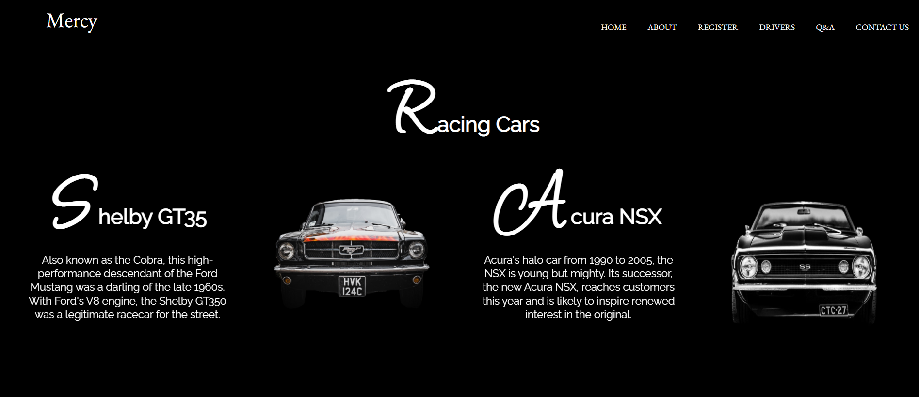

Figure 54

In the Q&A page, I changed the colour of navigation bar to that of vintage car.

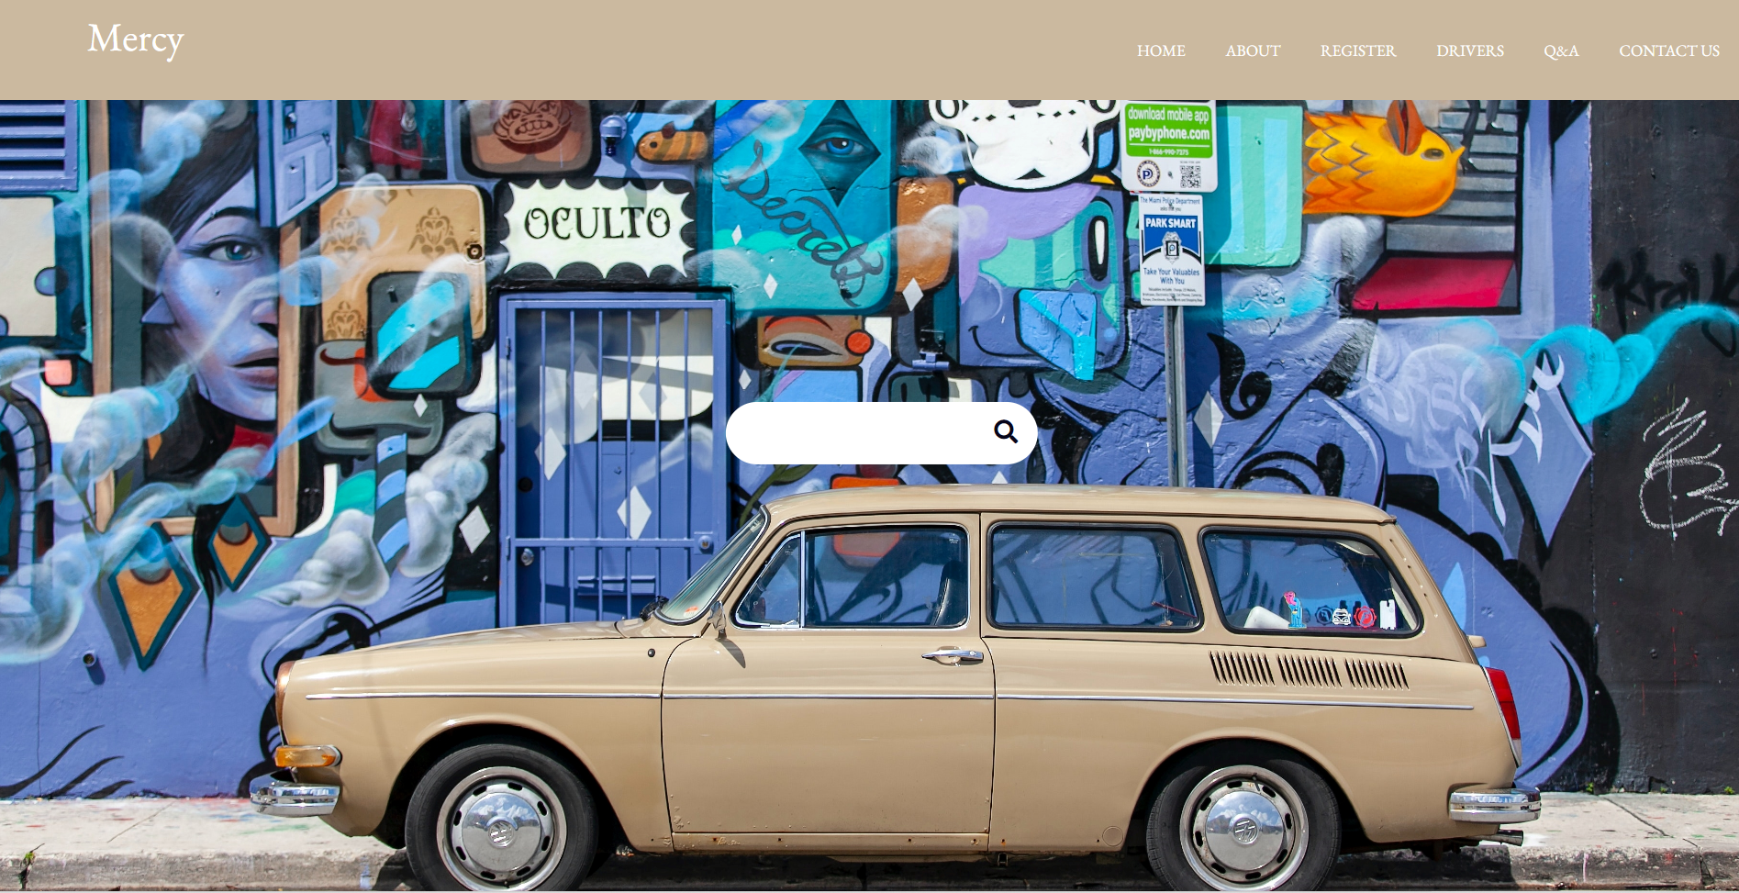

Figure 55

1. Plain English structure

I described my website contents in plain English without complex language, metaphors, acronyms and inferred meaning. Consequently, the low-literate users will be able to comprehend the contents. Moreover, the people who tend to read in a rush will be comfortable (Bird, 2021).



Figure 56



Figure 57



Figure 58



Figure 59



Figure 60

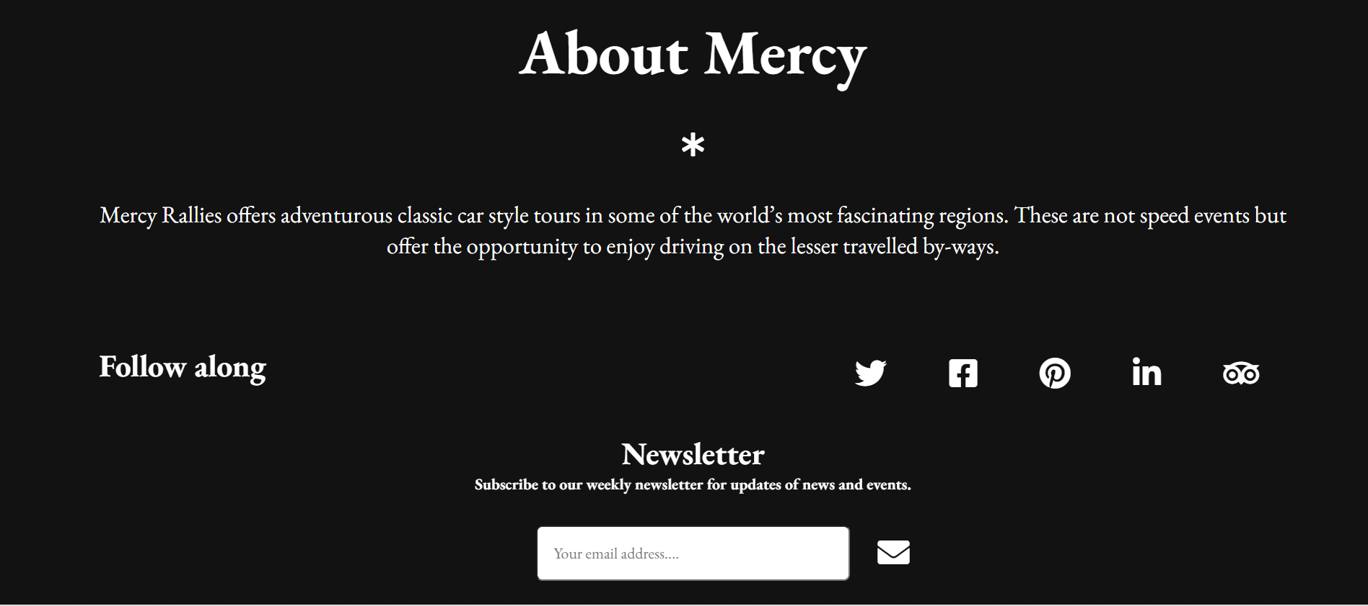

Figure 61

1. Keyboard navigation

My website is also set up for keyboard navigation accessibility. Individuals with motor impairments can use tab key can be used to navigate through elements on webpages instead of a mouse. The red colour will show the navigation.

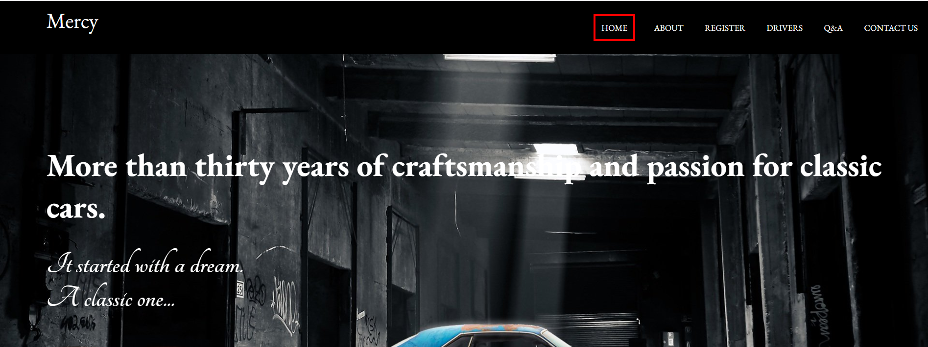

Figure 62

1. Large links and buttons

Large buttons, links and icons are used to help the elder and non-skillful people.

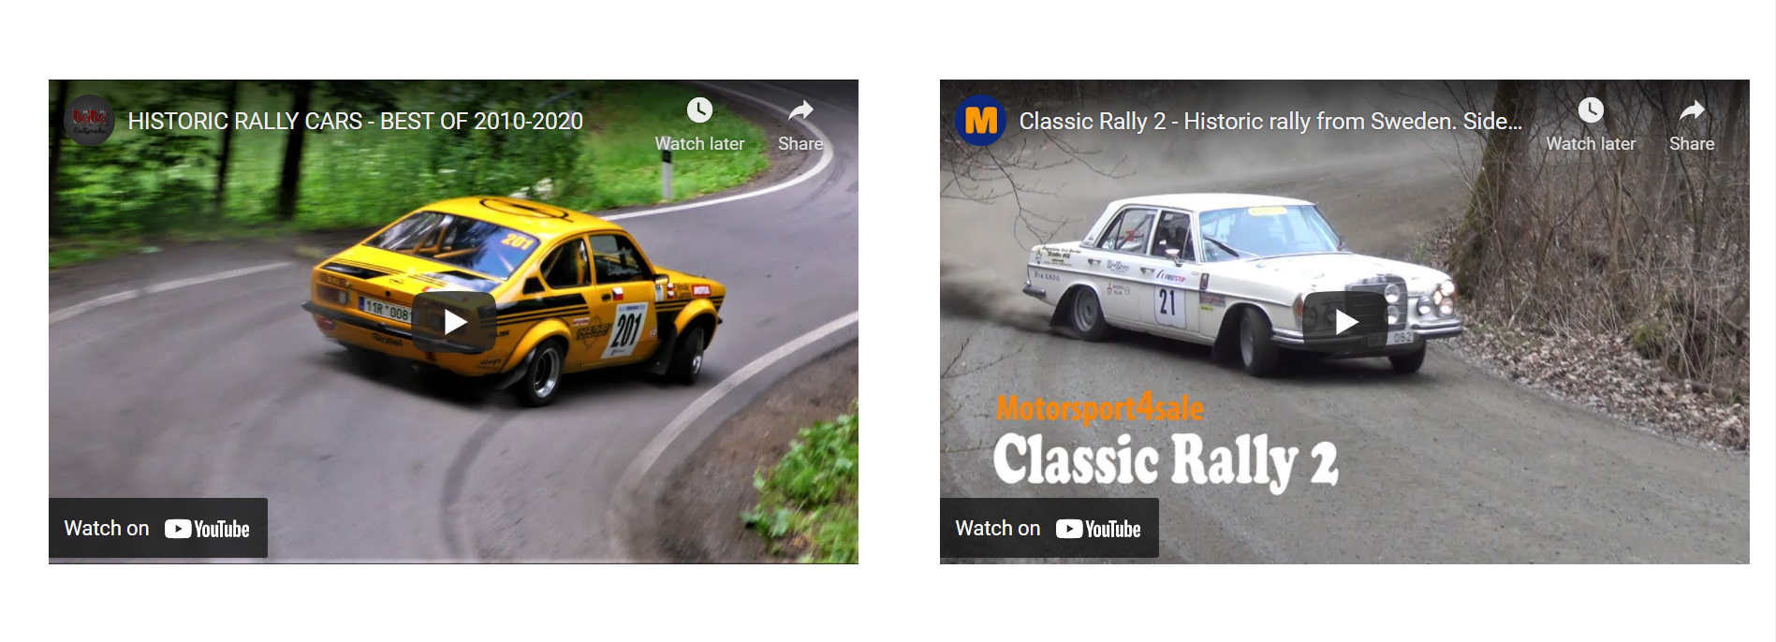

Figure 63



Figure 64



Figure 65

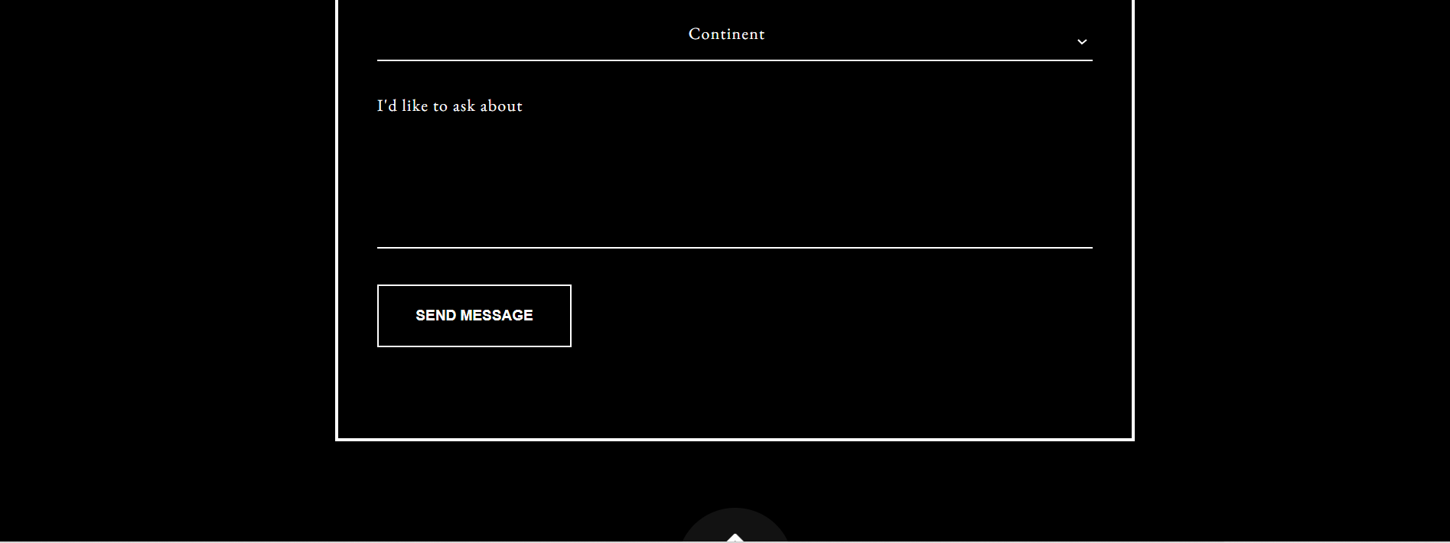

Figure 66

1. Responsive design

I designed the website as a responsive one which automatically adjusts for different screen sizes and viewports.

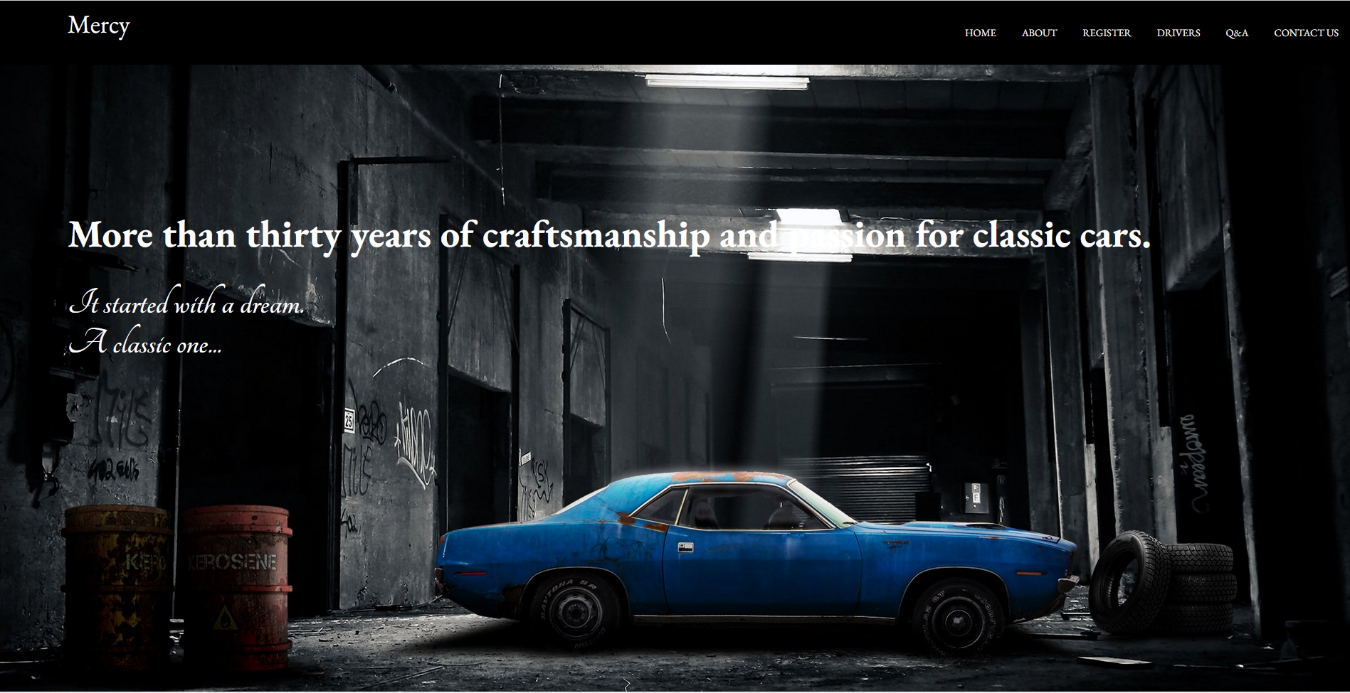

Figure 67 Large screen view

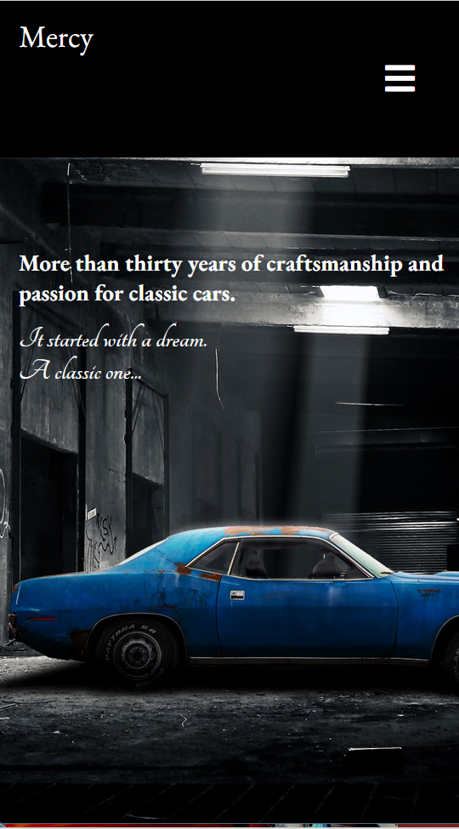

Figure 68 small screen view

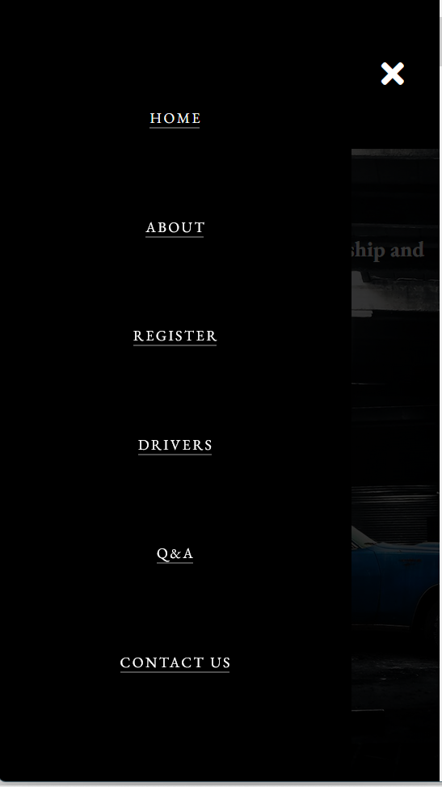

Figure 69 small screen view

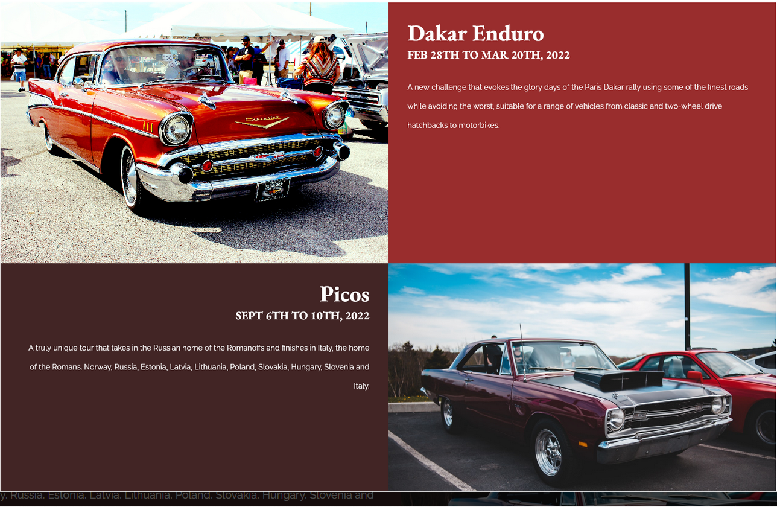

Figure 70 large screen view

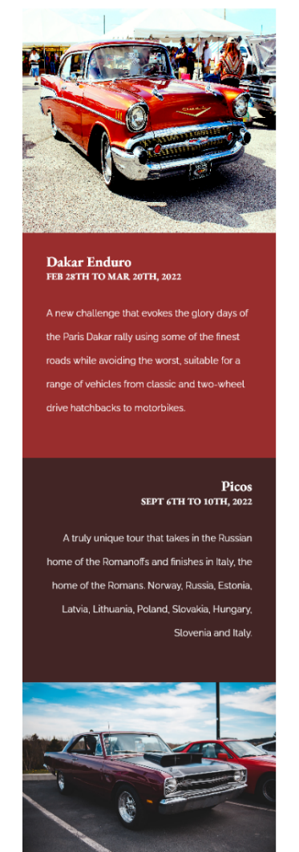

Figure 71 small screen view

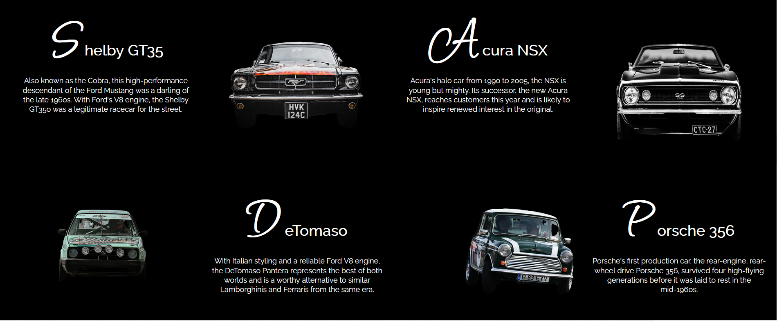

Figure 72 large screen view

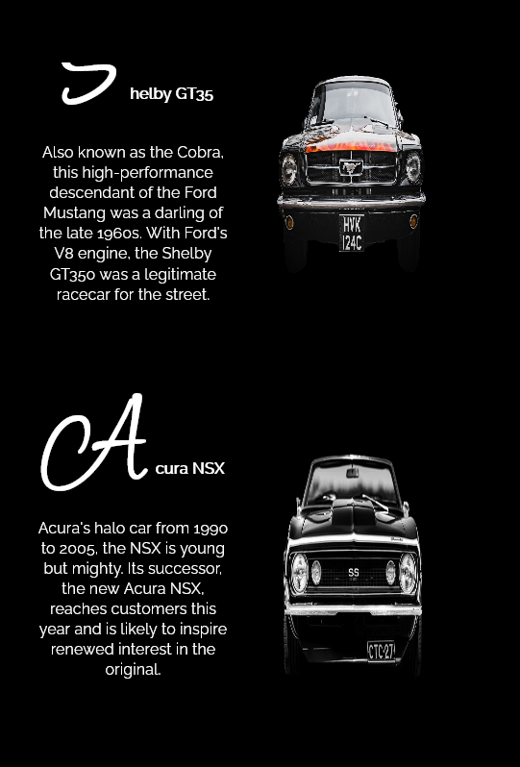

Figure 73 small screen view

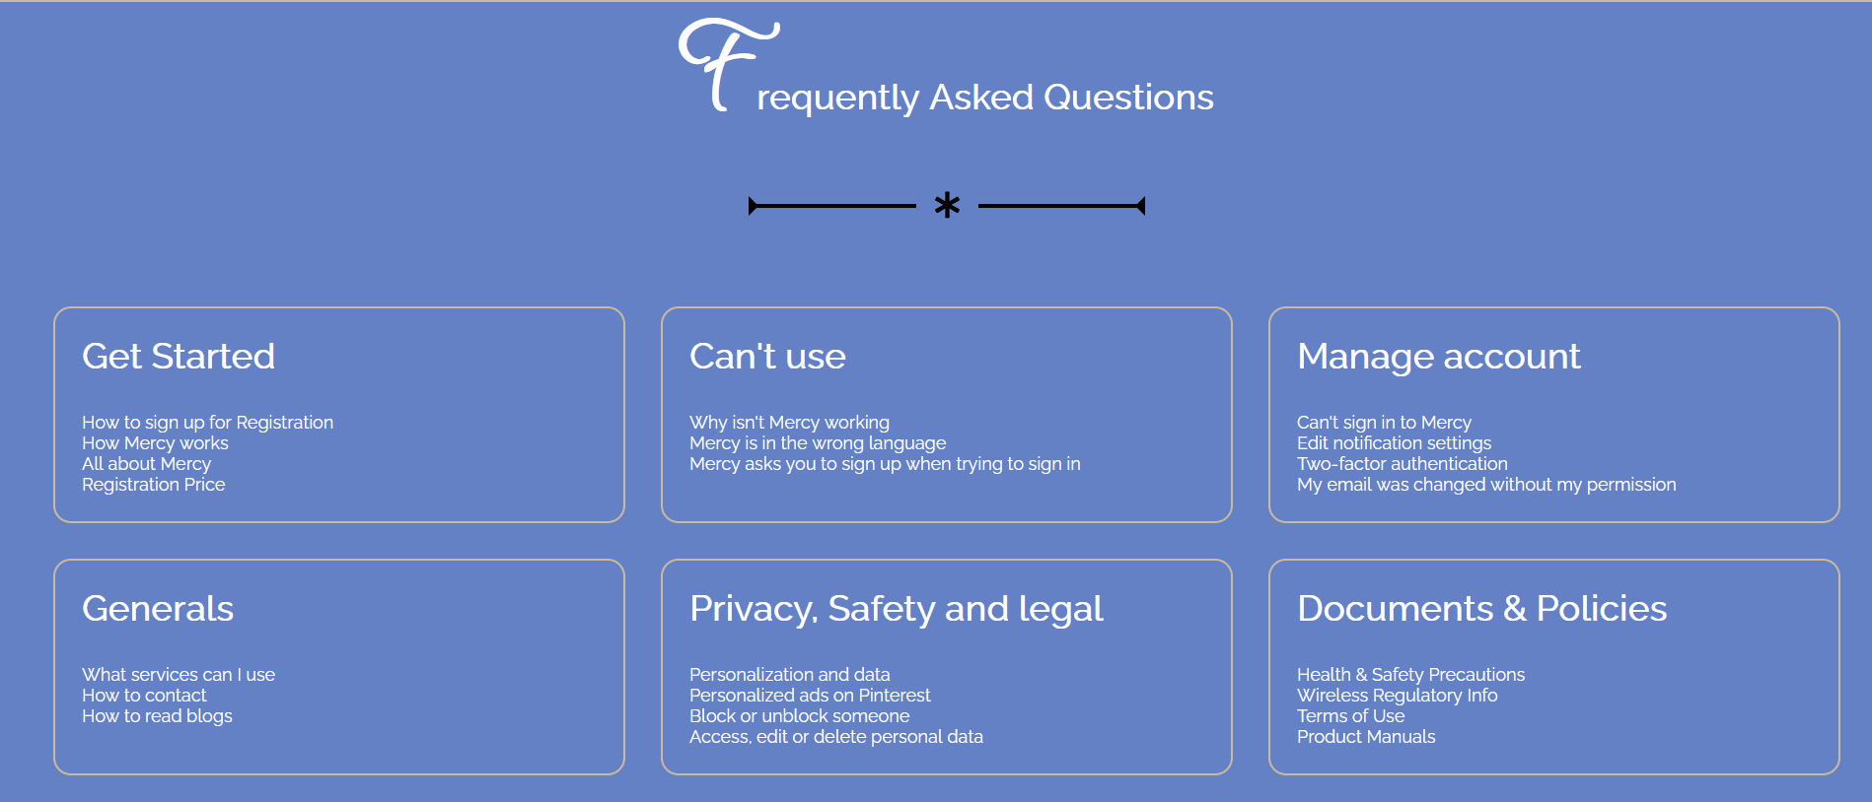

Figure 74 large screen view

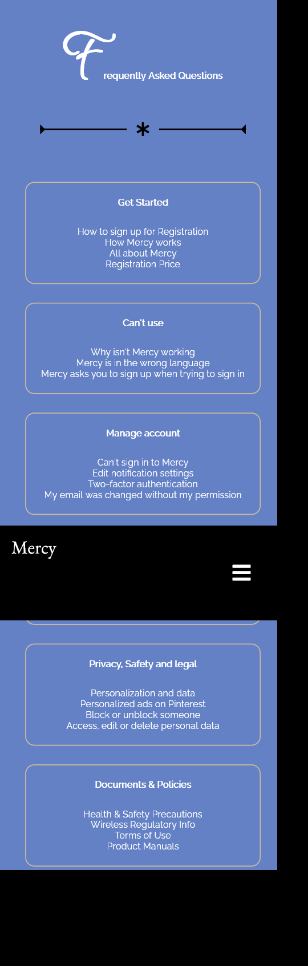

Figure 75 small screen view

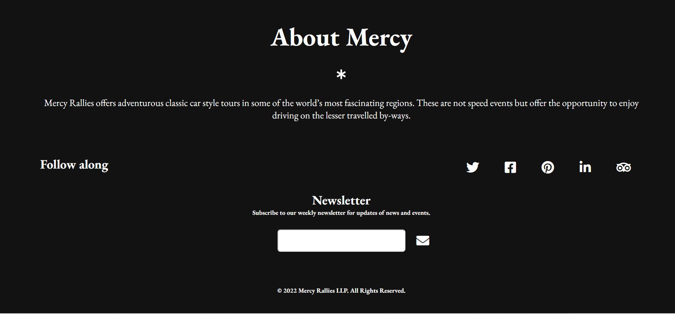

Figure 76 large screen view

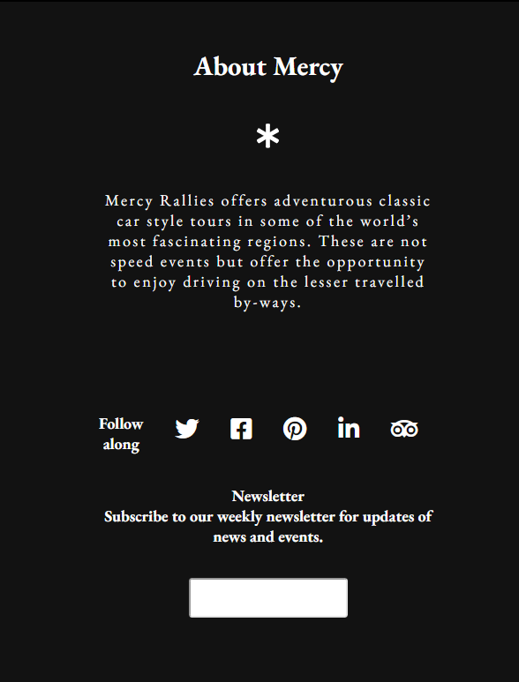

Figure 77 small screen view

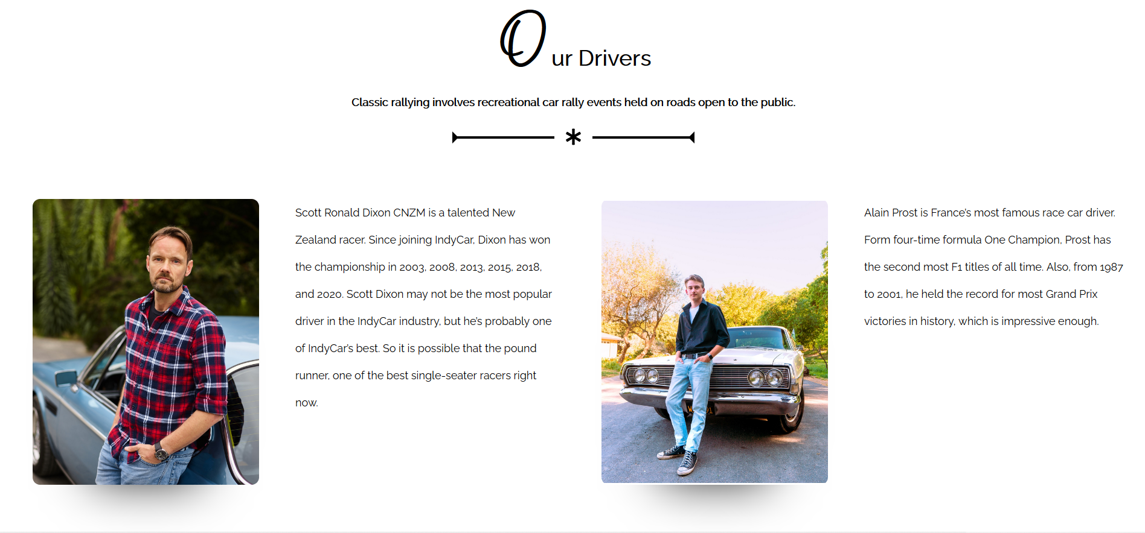

Figure 78 small screen view

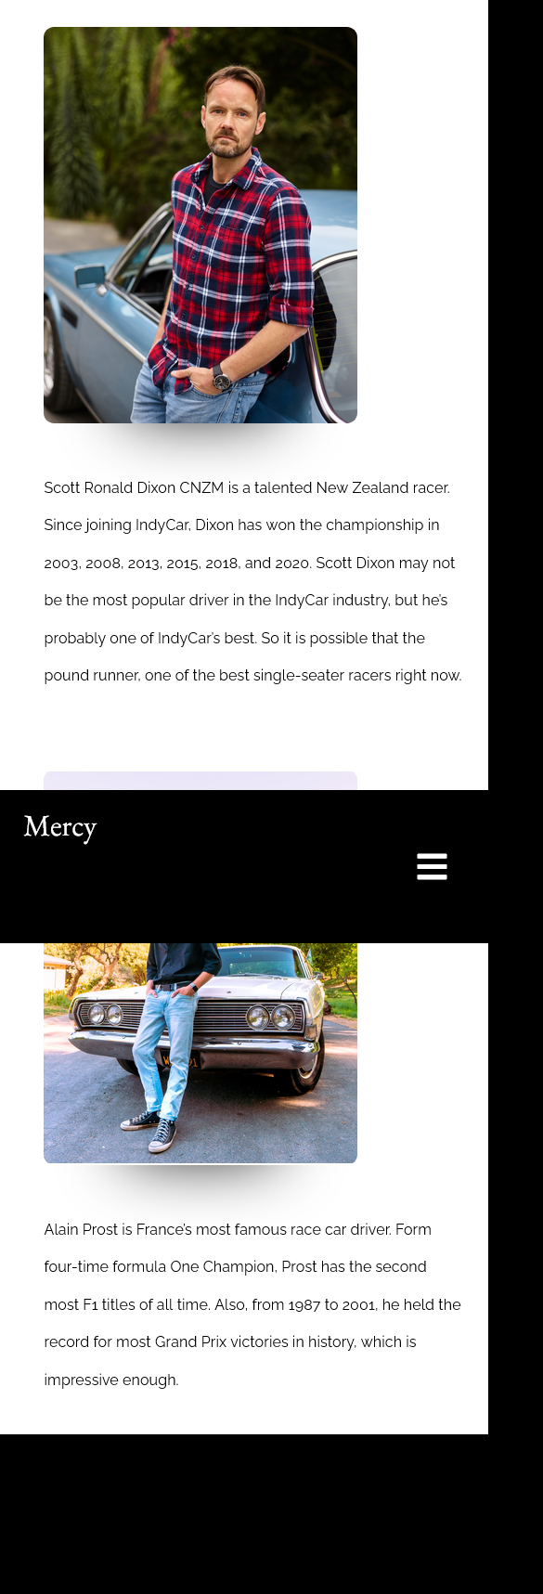

Figure 79 small screen view

## Functional multimedia components the website have

JPEG images – are used to small image file size. They are commonly used in websites and digital cameras. JPEG files carry exchangeable image file format (EXIF) information and even exposure and shutter speed details. They end in the extension “.jpeg” or “.jpg.” It is supported by most common browsers (Hopping, 2019).

PNG images – are the common favored in web design with lossy compression for efficient compression and high color depths. However, it consumes more space than other image files because of support to grey scale, the 24-bit RGB and 32-bit RGBA colour spaces. However, they are not compatible with CMYK models. All major browsers support PNG whereas the IE versions 4-5 does not (Mozilla, no date) (Hopping, 2019).

Videos – are used to share our vintage rally club story and to engage our customers with our content. It is one of the convenient multimedia components for attention grabbing and interconnection between us and our clients (Walker-Ford, 2017).

Web Fonts – are designed specifically for use on the web, and can be loaded with CSS code. They are accessible by search engines like Google. Using web fonts provides the consistent look across all media from print to online regardless of screen size (Mrozek, 2016).

Icons – are used to avoid language barriers and emphasize the web content rather than the text alone. Users can get bogged down in the huge chucks of text so icons are the most appropriate communication the core idea in a visual method (Fouche, 2018).

## Discussion on how the Internet and Web can be used for the Vintage Rally Club as a business tool

Since the website allows online registration, the customers can easily do online-booking from our Mercy club’s registration page. The 24/7 website accessibility without holidays and weekends is a huge advantage to the customers. The website offers online visibility and enhanced recognition, which makes our business credible. Promoting our business on the internet and our website is much effective than face-to-face method. Our business looks reliable and authoritative when sponsored ads and promoted posts are linked to the website (WishDesk, 2018).

## Further development for the website.

Our website will be able take the payment information and send them through a payment processor that validates the payment in the future. The “Thank you” page will be added to enable the customers to download our annual reports, get coupon code and upload their videos. Our Mercy club will invest in professional photography for quality photo on website instead of hiring the in-house photographers. The website will be fixed for faster speed to get better ranking on search engines (Gant, 2015) (Campbell, 2019).

# References

Bird, D. (2021) *6 web accessibility features that benefit more people than you think*, *The Big Hack*. Available at: https://bighack.org/6-web-accessibility-features-that-benefit-more-people-than-you-think-global-accessibility-awareness-day/ (Accessed: January 27, 2022).

Campbell, A. (2019) *7 ways to improve your website homepage*, *7 Ways to Improve Your Website Homepage*. Available at: https://www.sba.gov/blog/7-ways-improve-your-website-homepage (Accessed: January 31, 2022).

Dudharejia, M. (2020) *How to incorporate accessibility in your website*, *Search Engine Journal*. Available at: https://www.searchenginejournal.com/make-website-more-accessible/347450/ (Accessed: January 27, 2022).

Fouche, K. (2018) *Top 4 Benefits of Using Icons in Web Design*, *Com.au*. Available at: https://blog.pixelfish.com.au/benefits-of-using-icons-in-web-design (Accessed: January 31, 2022).

Gant, A. (2015) *How to improve your website: 15 ways to fix your site immediately*, *Orbit Media Studios*. Available at: https://www.orbitmedia.com/blog/ways-to-improve-your-website/ (Accessed: January 31, 2022).

GeeksforGeeks (2020) *W3C full form*, *GeeksforGeeks*. Available at: https://www.geeksforgeeks.org/w3c-full-form/ (Accessed: January 27, 2022).

Hopping, C. (2019) *What is a PNG file?*, *IT Pro*. Available at: https://www.itpro.co.uk/web-browser/30247/what-is-a-png-file (Accessed: January 31, 2022).

Monus, A. (2018) *Keyboard accessibility tips using HTML and CSS*, *Web Design Envato Tuts+*. Envato Tuts. Available at: https://webdesign.tutsplus.com/articles/keyboard-accessibility-tips-using-html-and-css--cms-31966 (Accessed: January 27, 2022).

Mozilla (no date) *Image file type and format guide*, *Mozilla.org*. Available at: https://developer.mozilla.org/en-US/docs/Web/Media/Formats/Image_types (Accessed: January 31, 2022).

Mrozek, K. K. (2016) *What are the benefits of web fonts?*, *Windmill Strategy*. Available at: https://www.windmillstrategy.com/what-are-the-benefits-of-web-fonts/ (Accessed: January 31, 2022).

Siteimprove (no date) *Screen reader testing*, *Siteimprove*. Available at: https://siteimprove.com/en-gb/accessibility/screen-reader-testing/ (Accessed: January 27, 2022).

University of Washington (no date) *Developing accessible websites*, *University of Washington*. Available at: https://www.washington.edu/accessibility/web/ (Accessed: January 27, 2022).

W3C (no date) *W3C mission*, *W3C*. Available at: https://www.w3.org/Consortium/mission (Accessed: January 27, 2022).

Walker-Ford, M. (2017) *5 reasons you should use video on your website [infographic]*, *Social Media Today*. Available at: https://www.socialmediatoday.com/marketing/5-reasons-you-should-use-video-your-website-infographic (Accessed: January 31, 2022).

WishDesk (2018) *Benefits of having a website for your small business*, *WishDesk*. Available at: https://wishdesk.com/blog/benefits-website-for-small-business (Accessed: January 31, 2022).

Candidate checklist

|  |  |
| --- | --- |
| Have your read the NCC Education documents ‘What is Academic Misconduct? Guidance for Candidates’ and ‘Avoiding Plagiarism and Collusion: Guidance for Candidates’ and ensured that you have acknowledged all the sources that you have used in your word? |  |
| Have you completed the ‘Statement and Confirmation of Own Work’ form and attached it to your assignment? |  |
| Have you ensured that your work has not gone over or under the recommended word count by more than 10% |  |
| Have you ensured that your work does not contain viruses and can be run directly? |  |